1. [Roman to Integer](https://leetcode.com/problems/roman-to-integer/)

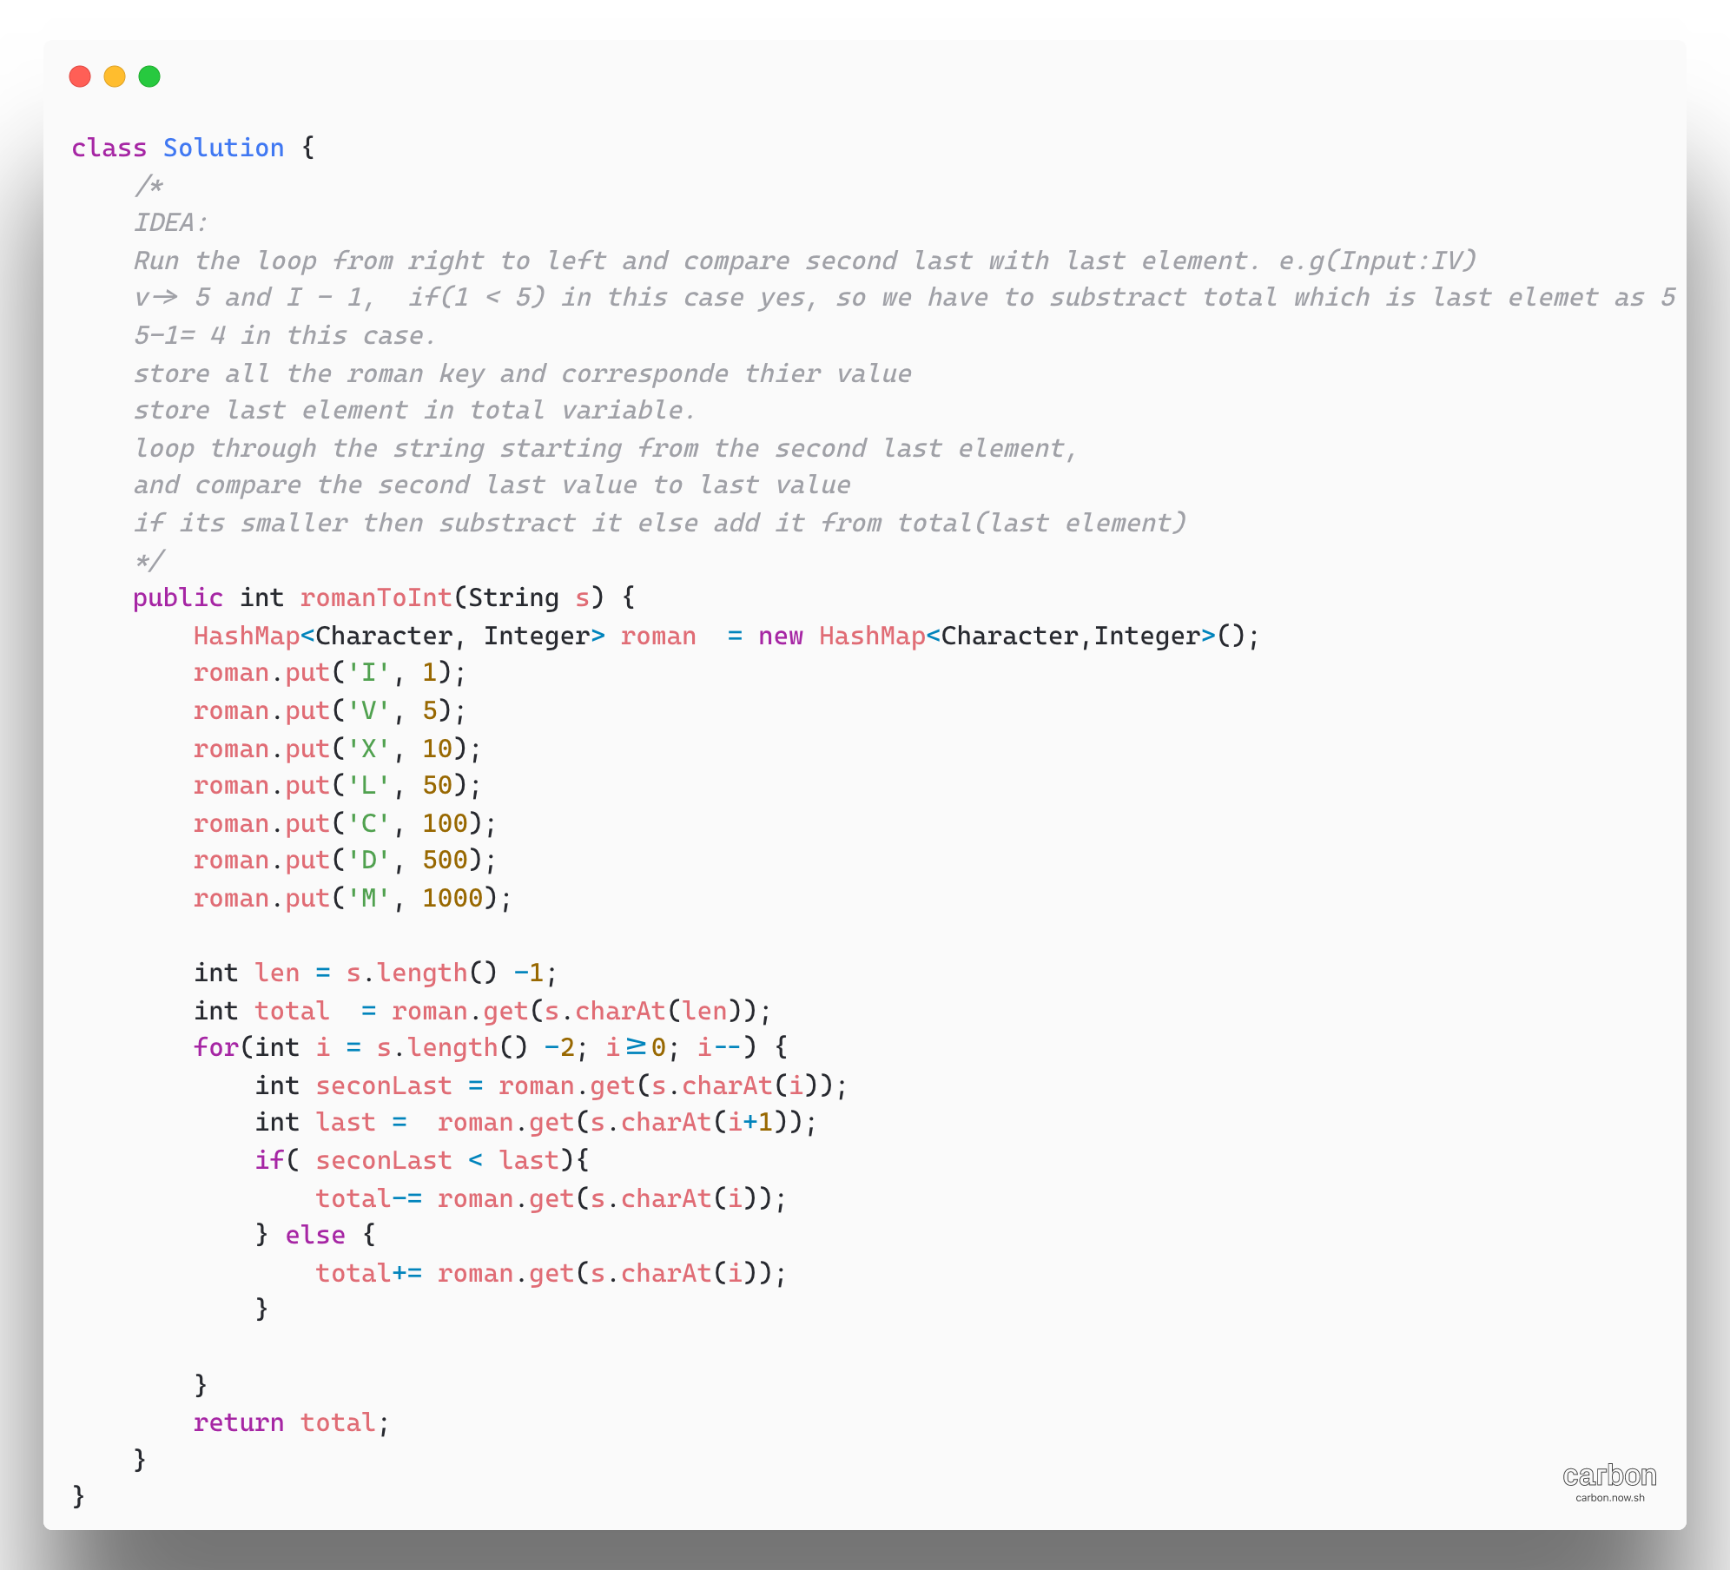

1. Merge Sort Top Down – [Sort an array](https://leetcode.com/problems/sort-an-array/)

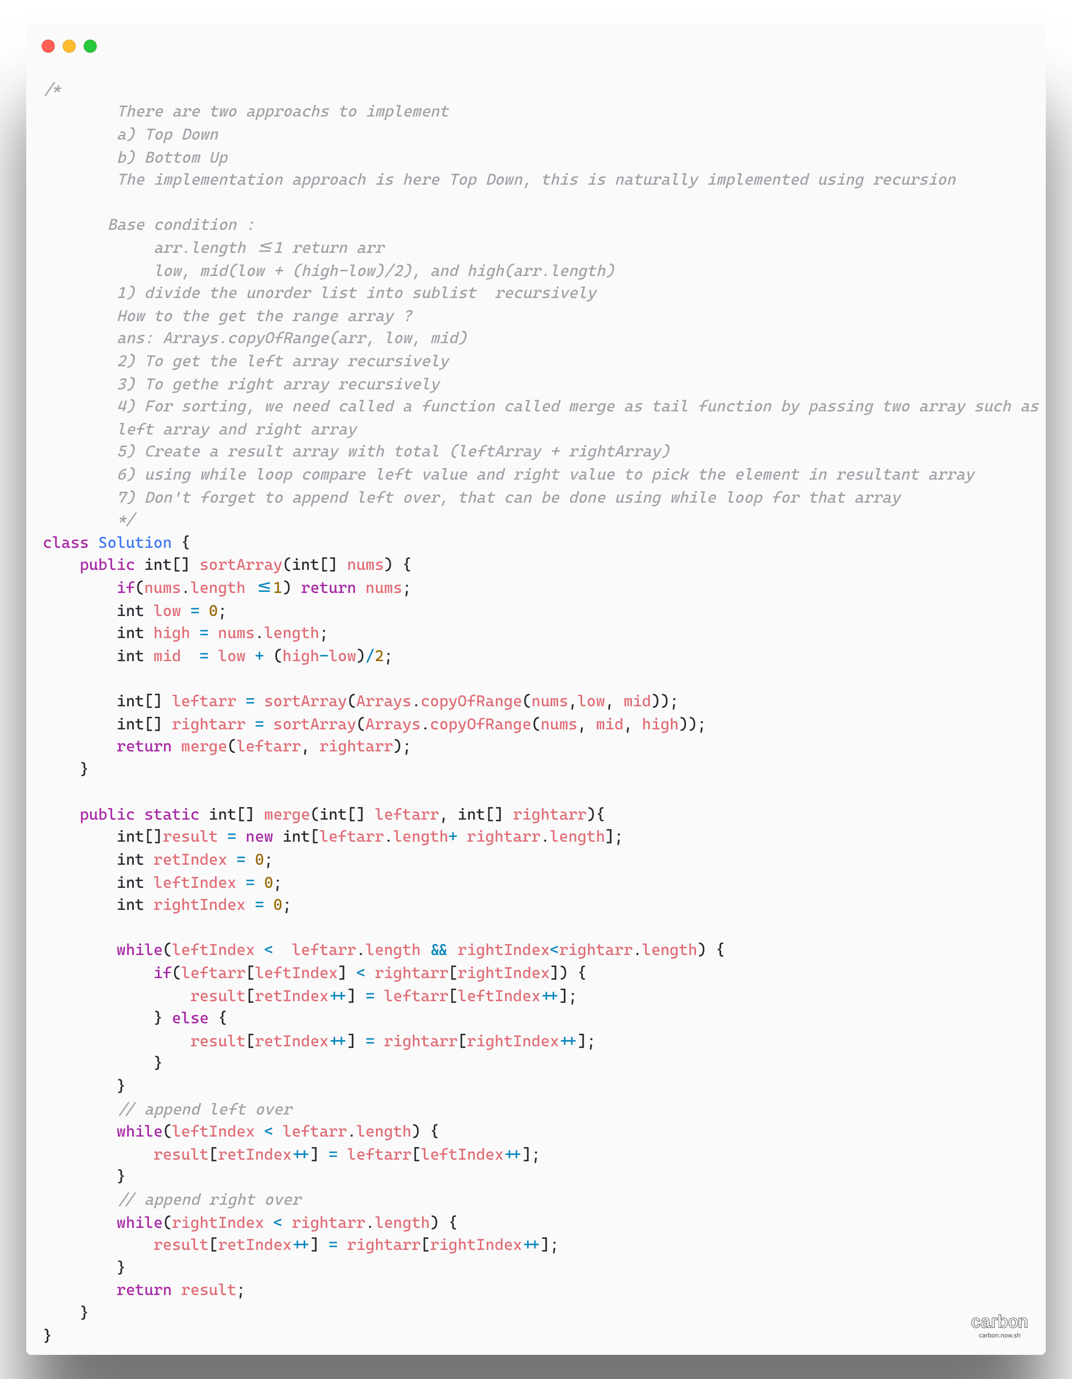

1. [Hamming Distance](https://leetcode.com/problems/hamming-distance/)

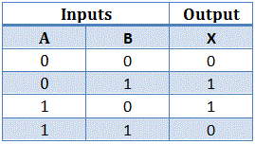

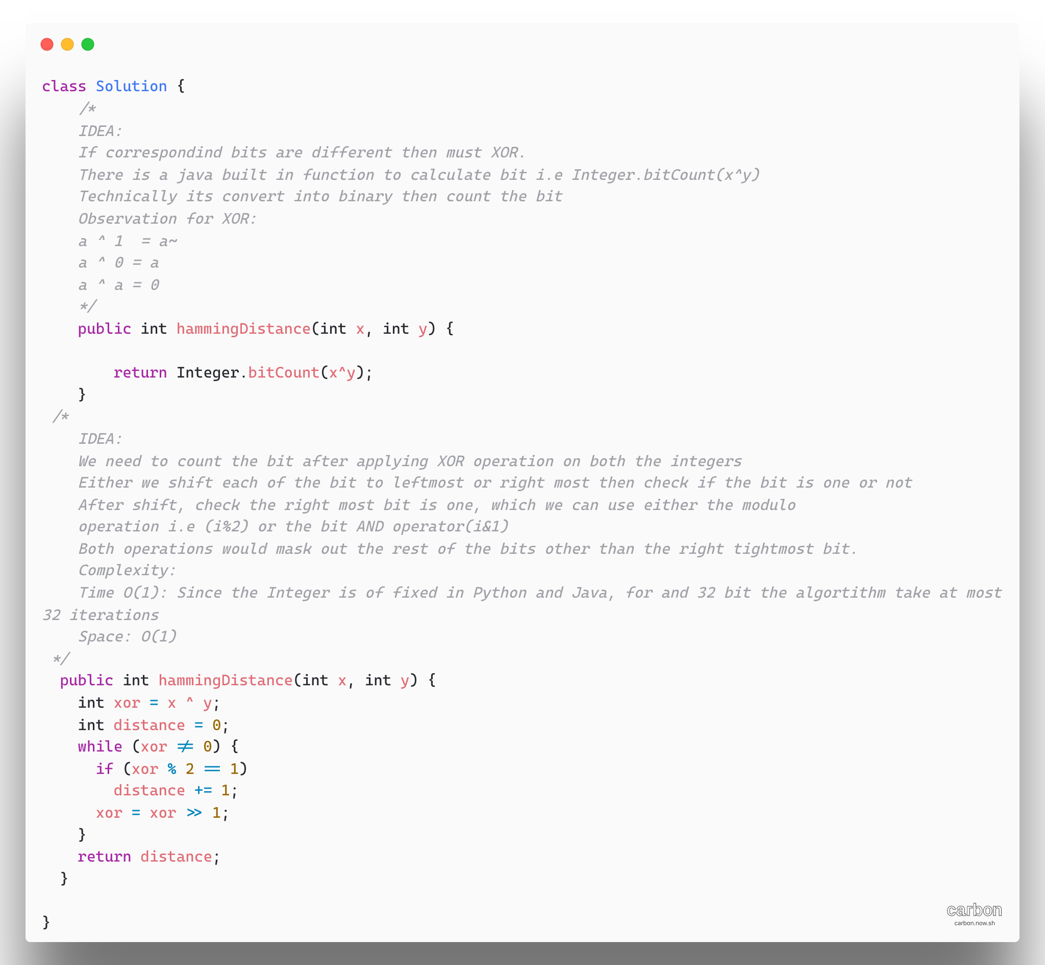

1. [Delete Node in BST](https://leetcode.com/problems/delete-node-in-a-bst/)

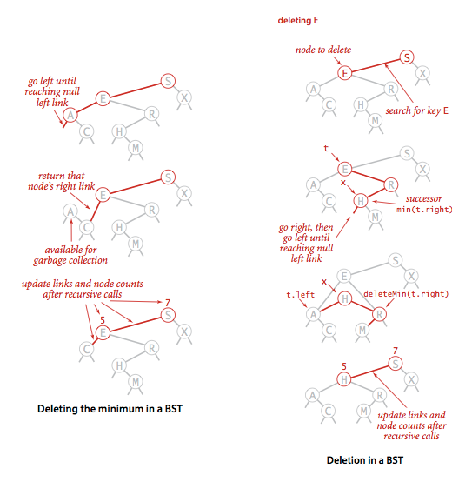

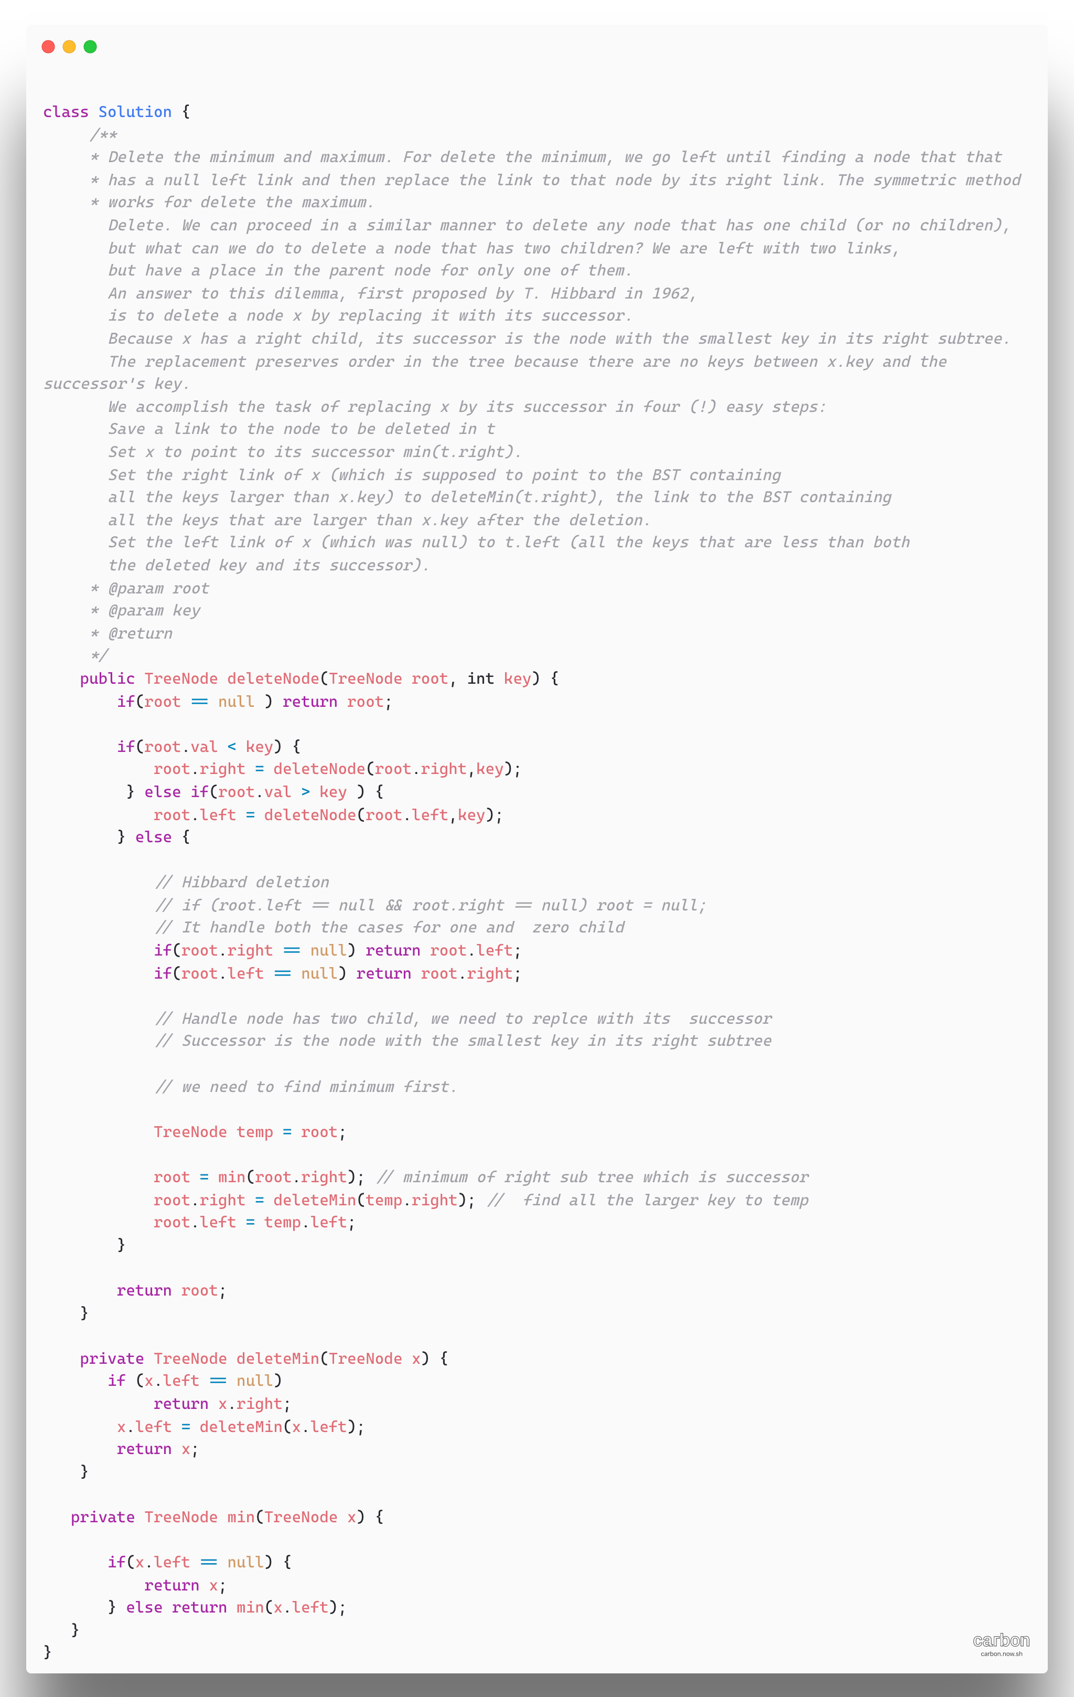

1. [Container with Most Water](https://leetcode.com/problems/container-with-most-water/)

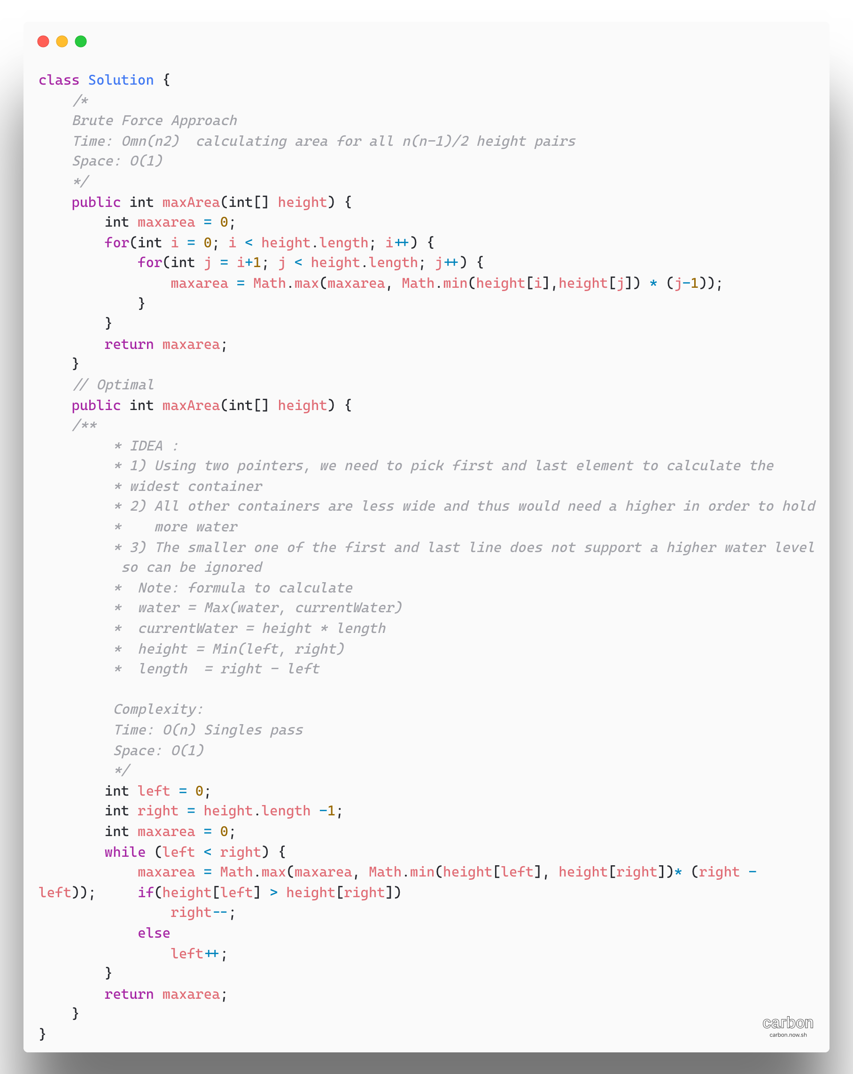

1. [**1362. Closest Divisors**](https://leetcode.com/problems/closest-divisors/)

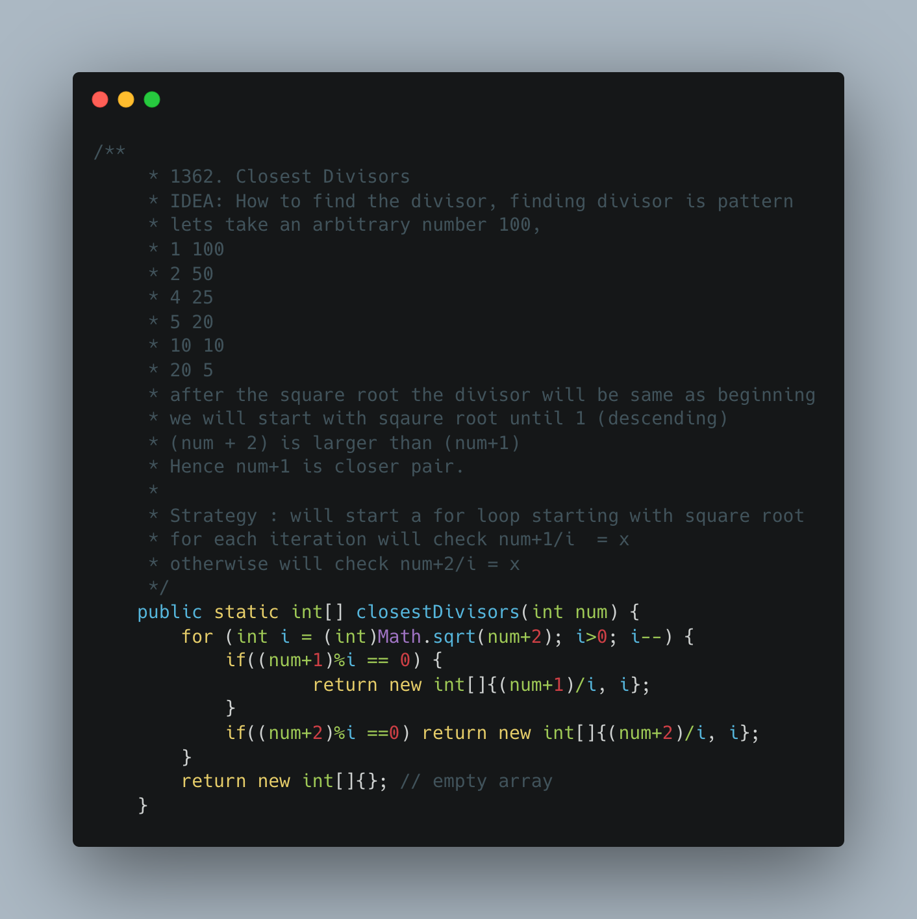

1. [**98. Validate Binary Search Tree**](https://leetcode.com/problems/validate-binary-search-tree/)

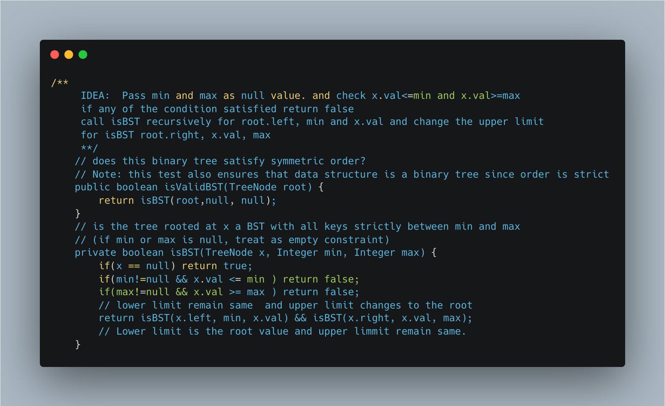

1. [Remove Sub folder from the file System](https://leetcode.com/problems/remove-sub-folders-from-the-filesystem/)

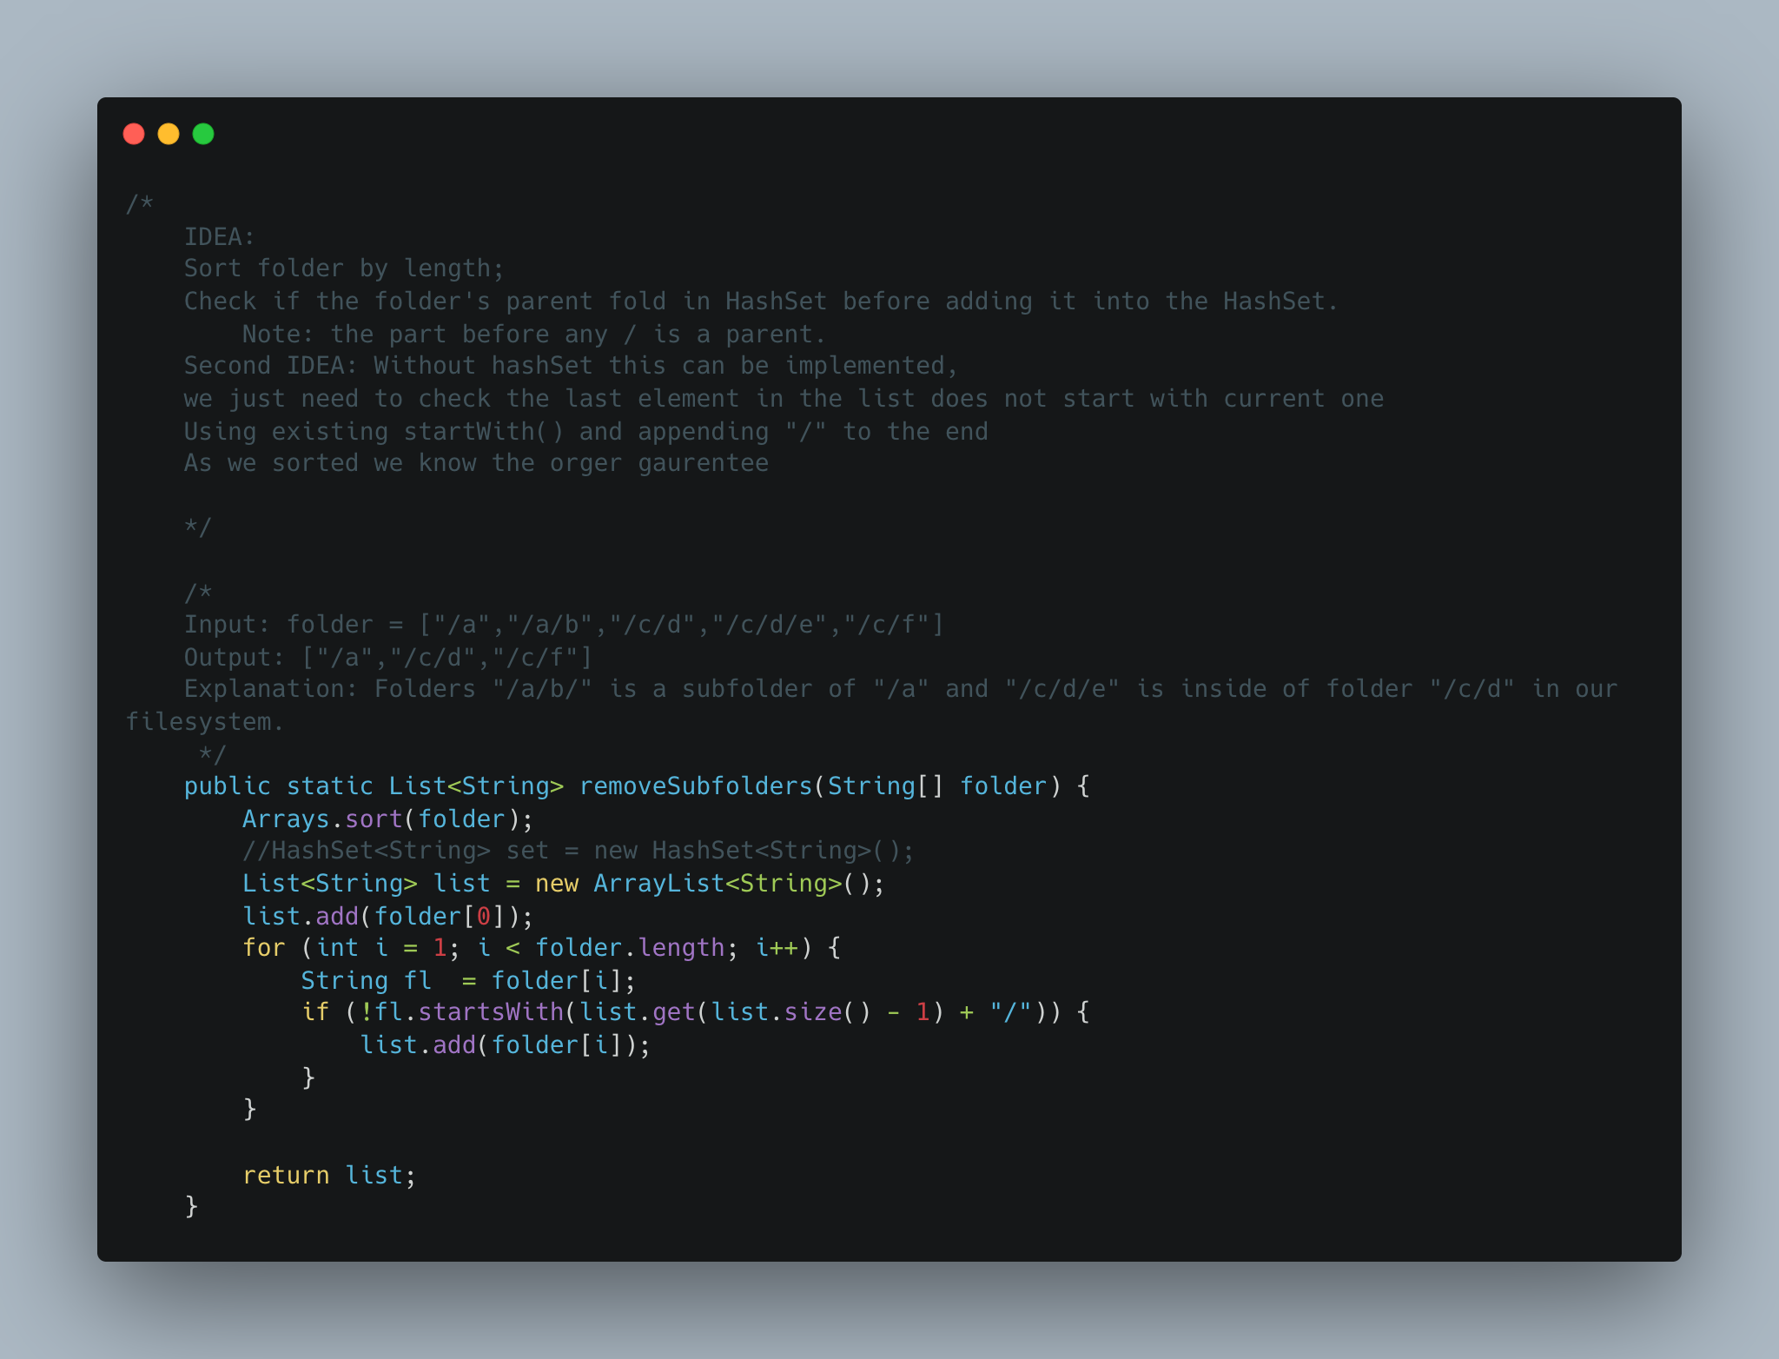

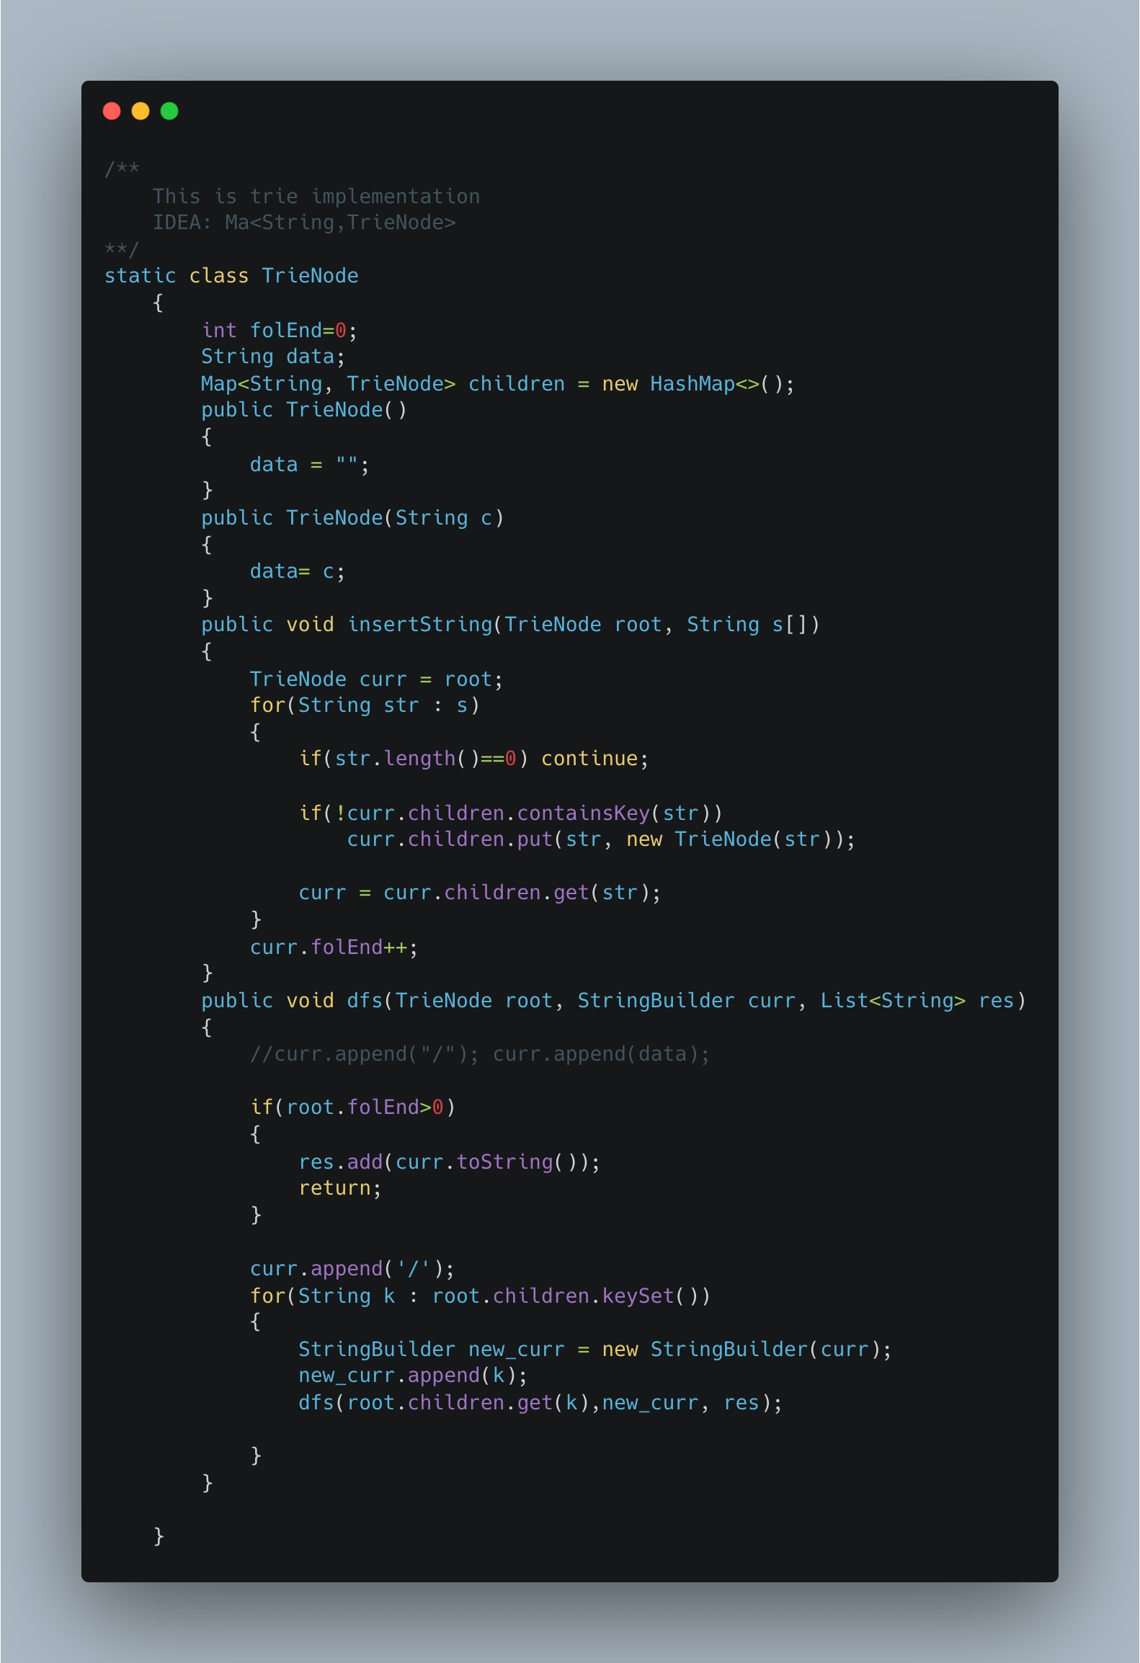

1. [**N-ary Tree Postorder Traversal**](https://leetcode.com/problems/n-ary-tree-postorder-traversal/)

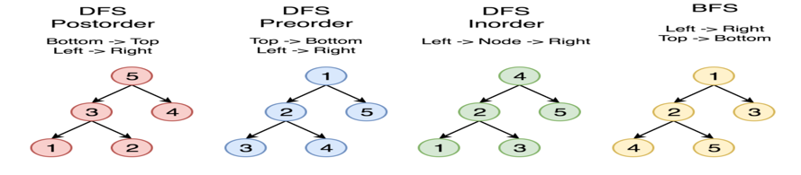

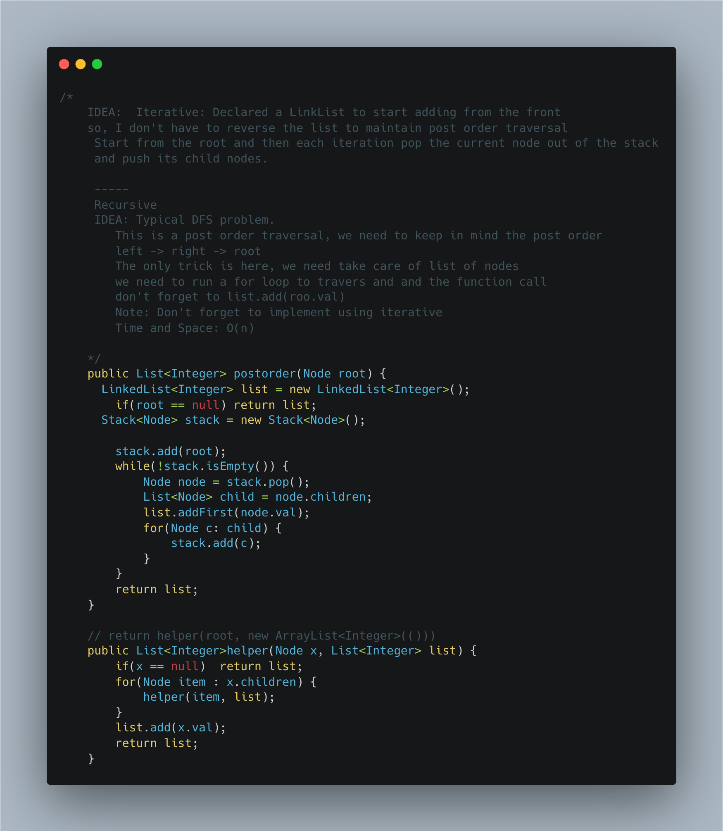

1. [Longest Substring Without Repeating Characters](https://leetcode.com/problems/longest-substring-without-repeating-characters/)

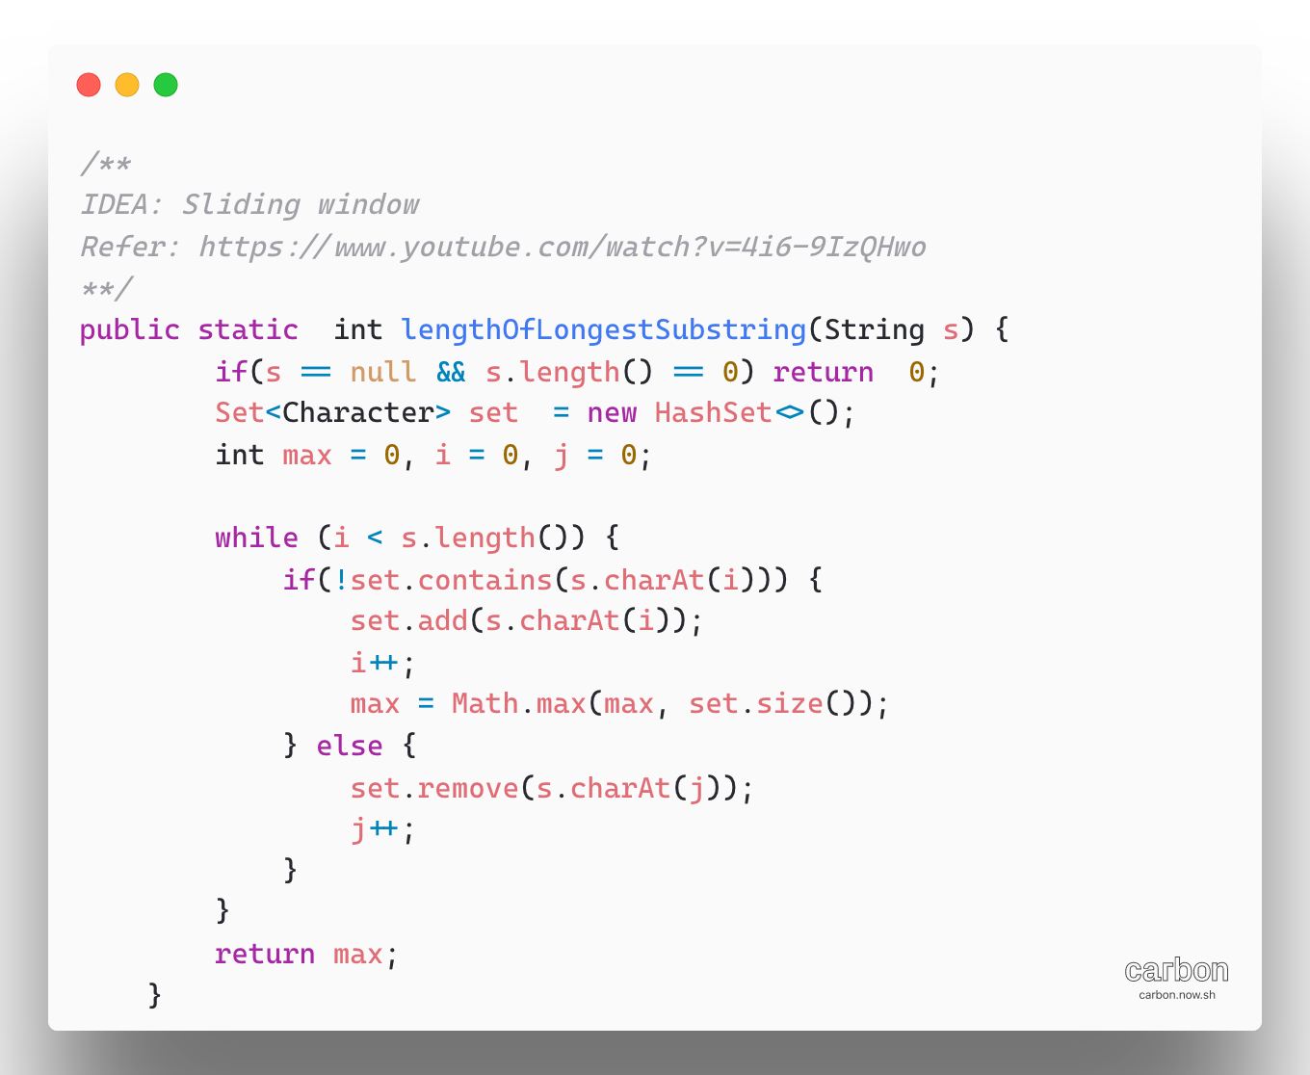

1. Palindrome String check using recursion.

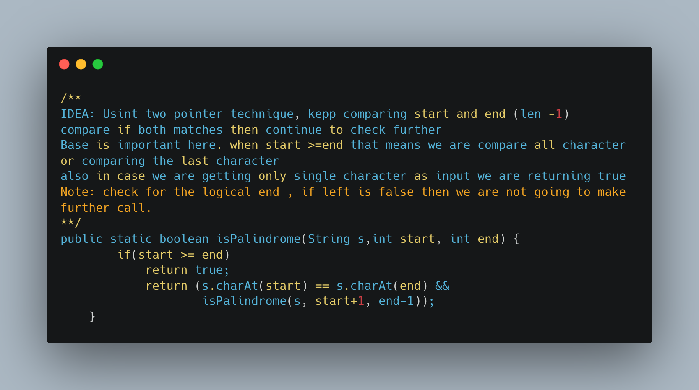

1. [Palindromic Substrings](https://leetcode.com/problems/palindromic-substrings/)

Palindromes are like onions, you remove the boundary characters and you’re left with another, smaller palindrome

Algorithm:

1. We choose all possible centers for potential palindromes:

* Every single character in the string is a center for possible odd-length palindromes
* Every pair of consecutive characters in the string is a center for possible even-length palindromes

1. For every center, we can expand around it as long as we get palindromes (i.e. the first and last characters should match)

**Complexity:** O(N^2) for input string of length N. The total time taken in this approach is dictated by two variables

* The number of possible palindromic center we process
* How much time we spend processing each center?

The number of possible palindromic centers is 2N-1; there are N single character center and N-1 consecutive pairs as centers.

Each center can potentially expand to the length of the string, so no time spent on each center is linear on average. Thus, total time spent is N.(2N-1) ~N^2

Space Complexity: O (1)

Refer:

* <https://www.youtube.com/watch?v=XmSOWnL6T_I>
* [Leetcode Solution Arrticle:](https://leetcode.com/problems/palindromic-substrings/solution/)

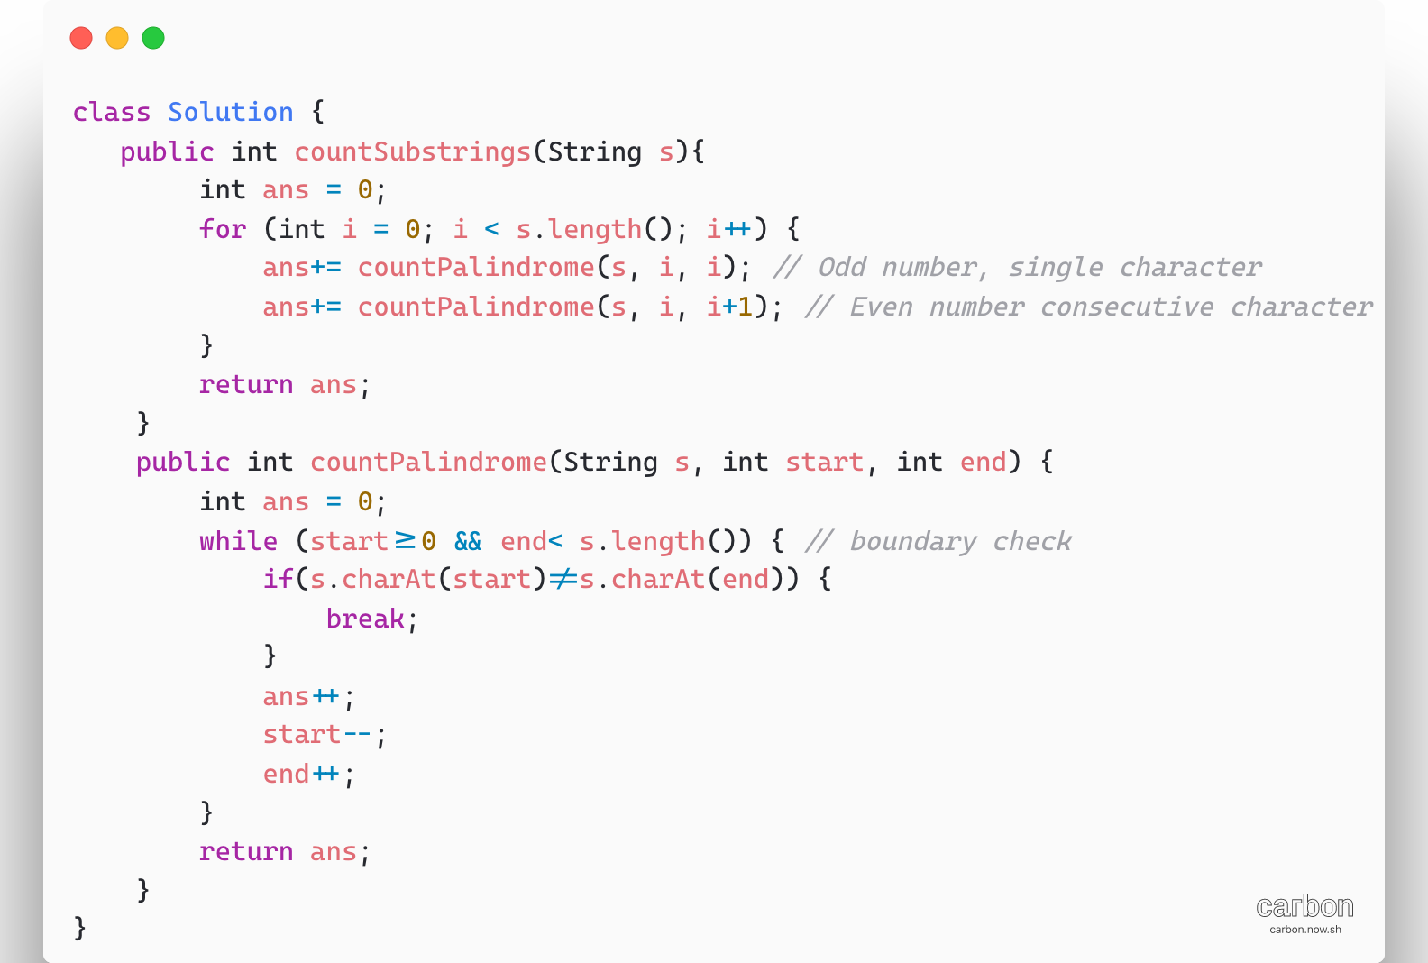

1. [Longest Palindromic Substring](https://leetcode.com/problems/longest-palindromic-substring/)

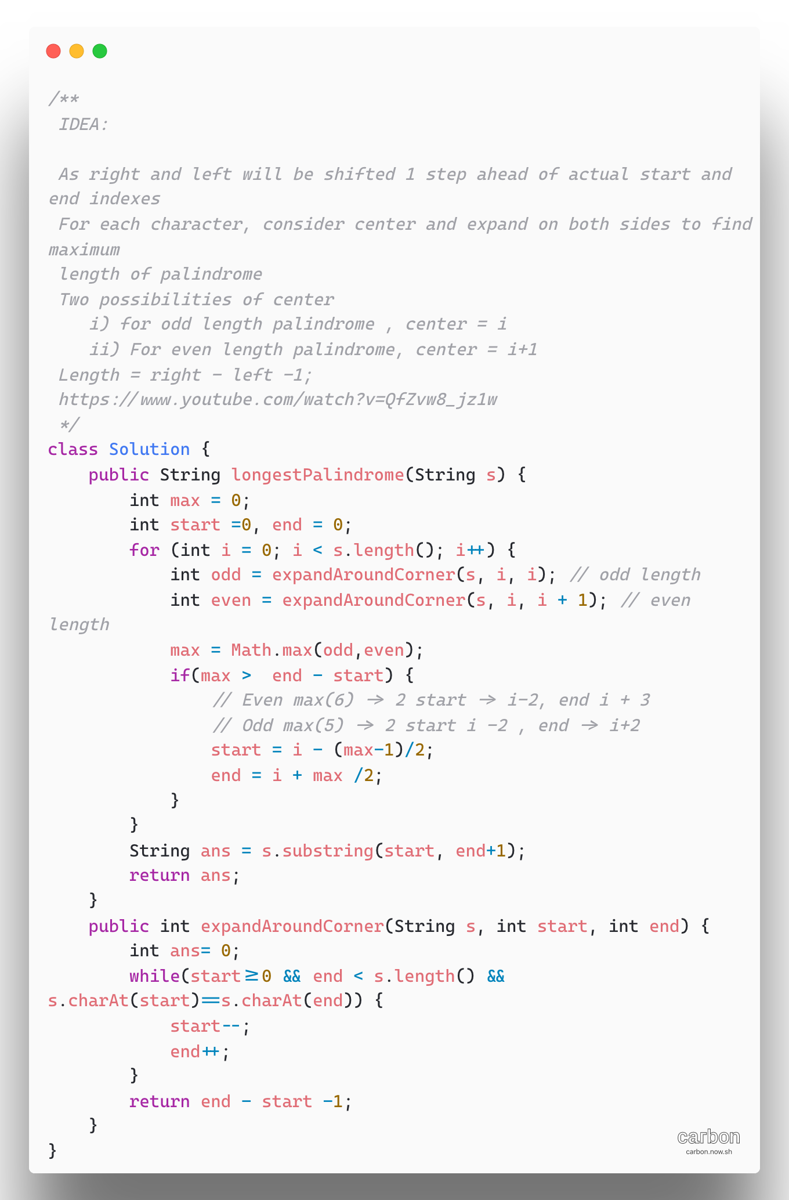

1. Cutting Rope Cutting

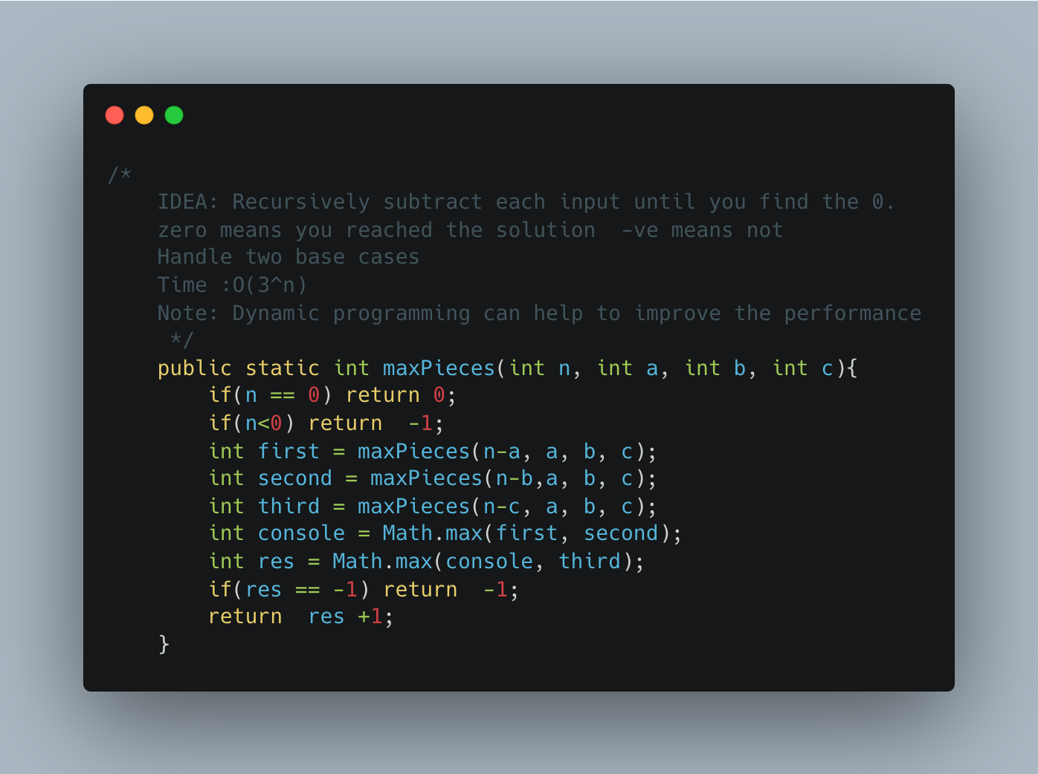

1. Generate Subsets of a given string

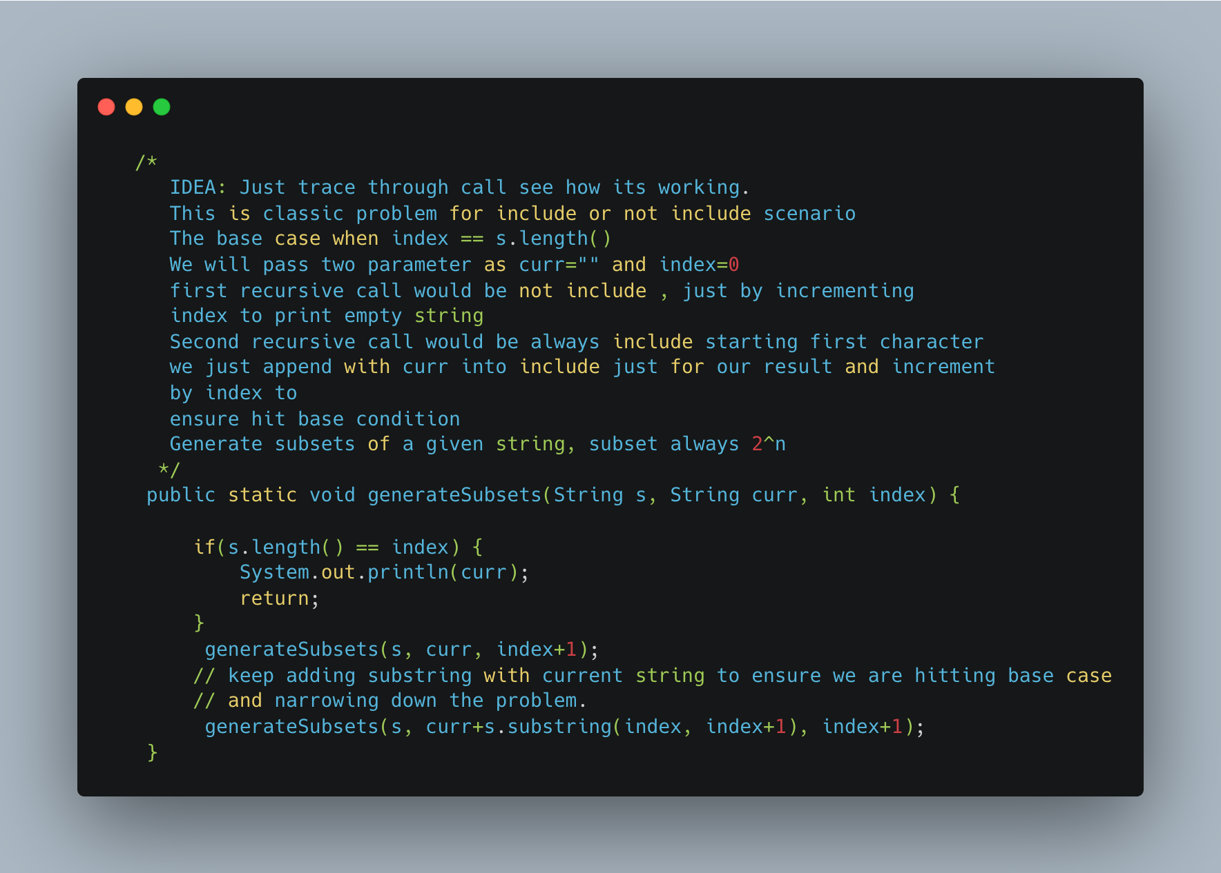

1. [Longest Repeating Character Replacement](https://leetcode.com/problems/longest-repeating-character-replacement/)

TBD- V.IMP

1. Array Dequeue

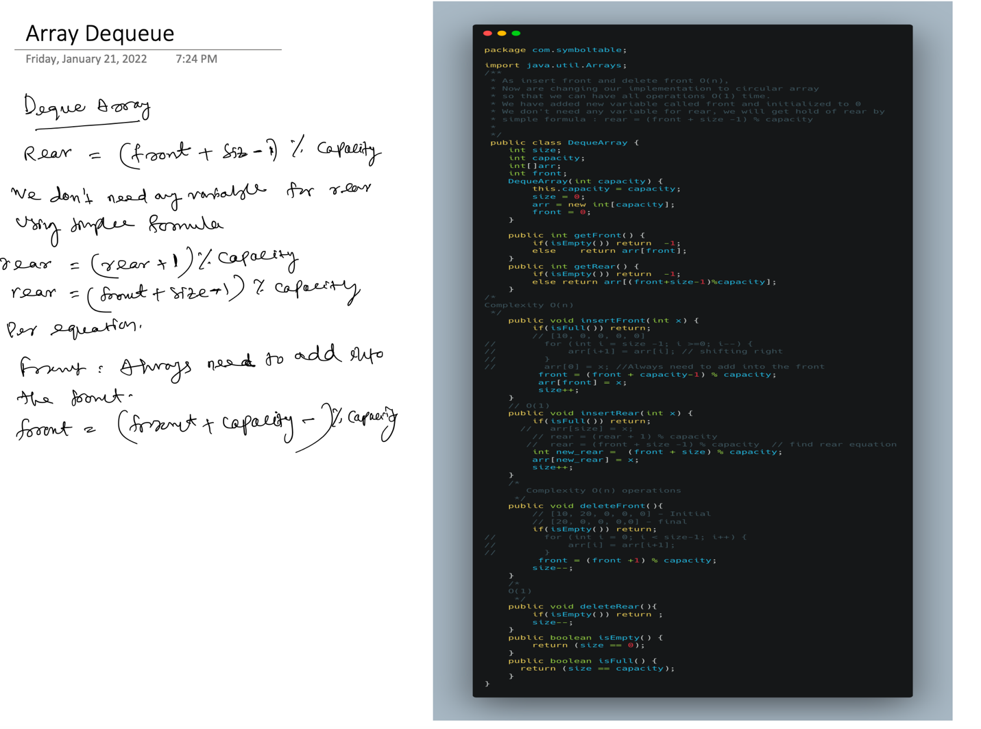

1. [Distant Barcodes](https://leetcode.com/problems/distant-barcodes/)

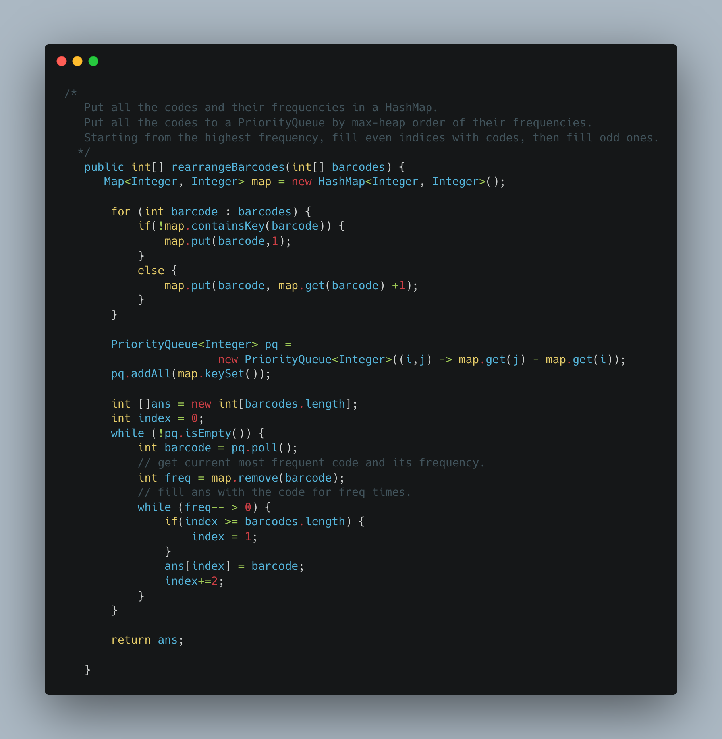

1. [Simplify Path](https://leetcode.com/problems/simplify-path/)

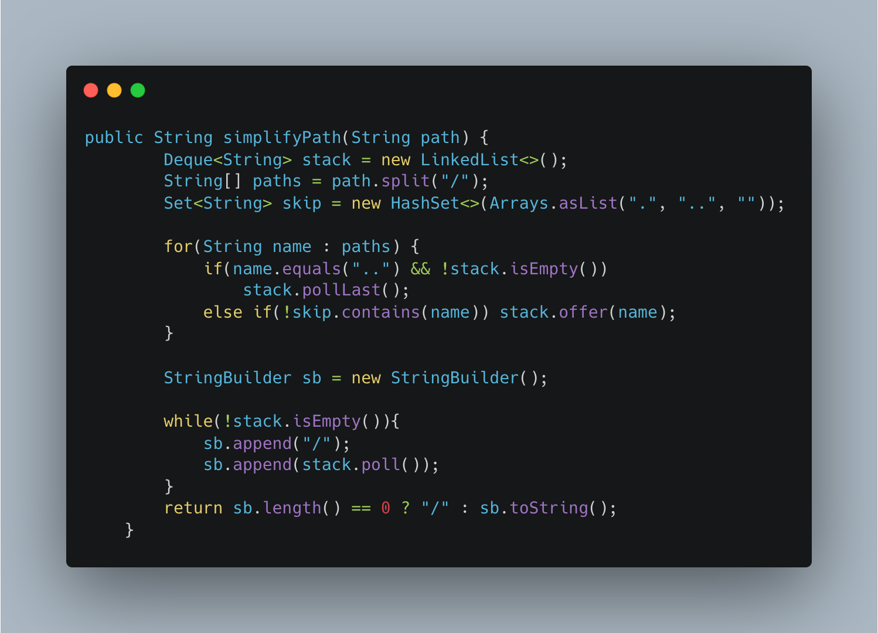

1. Maximum Activity – Greedy

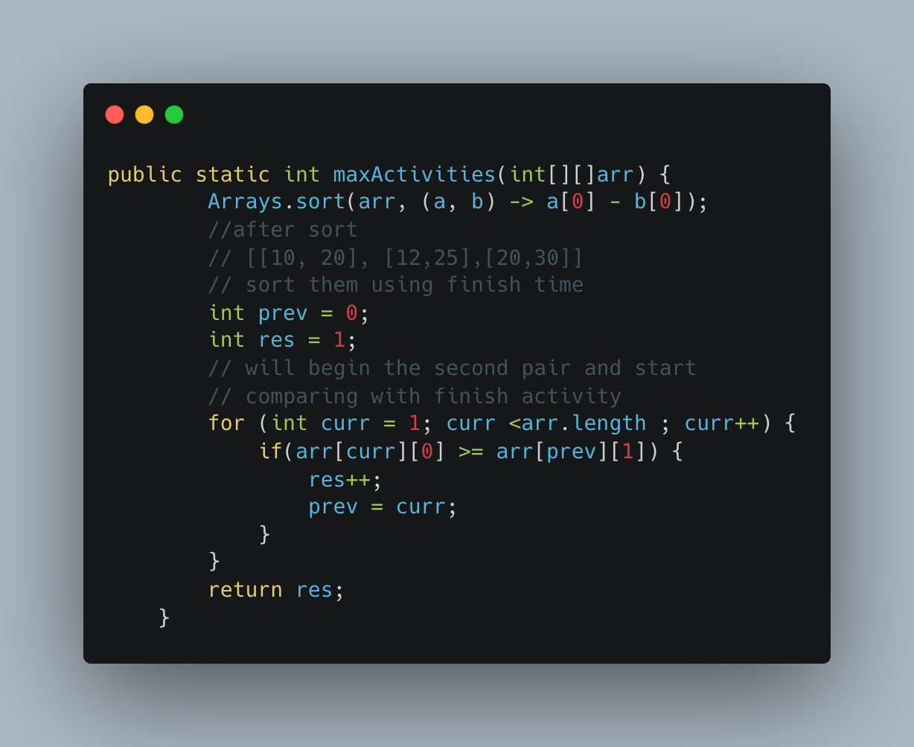

1. Another way of implementing

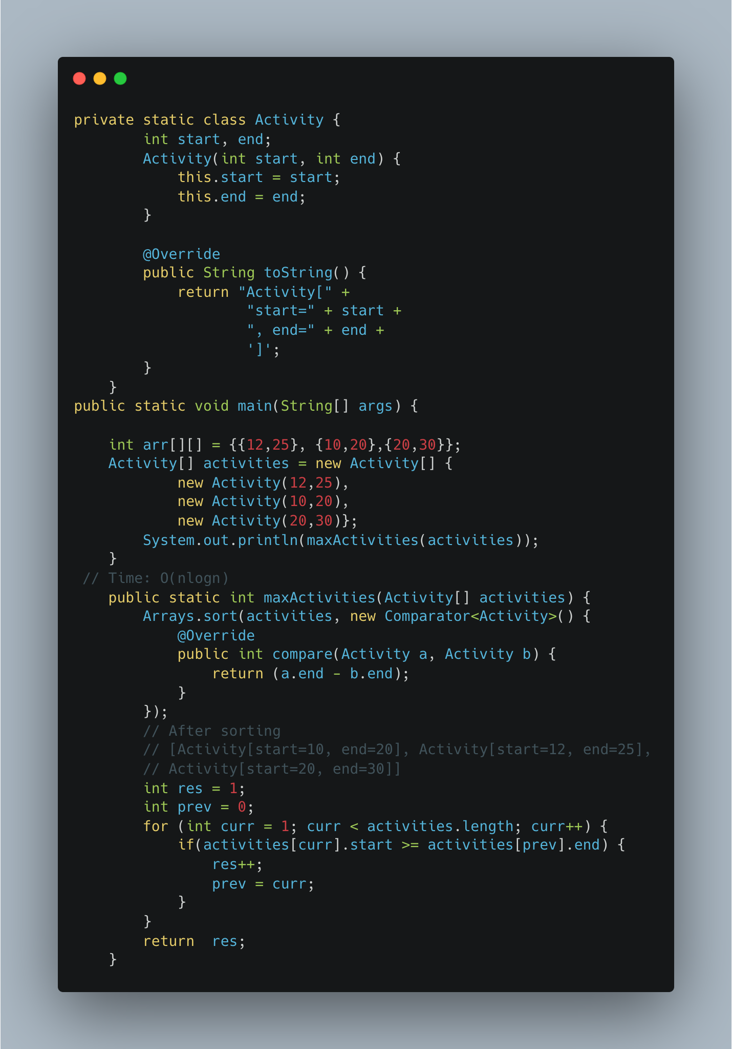

1. [Fractional Knapsack](https://www.geeksforgeeks.org/fractional-knapsack-problem/)

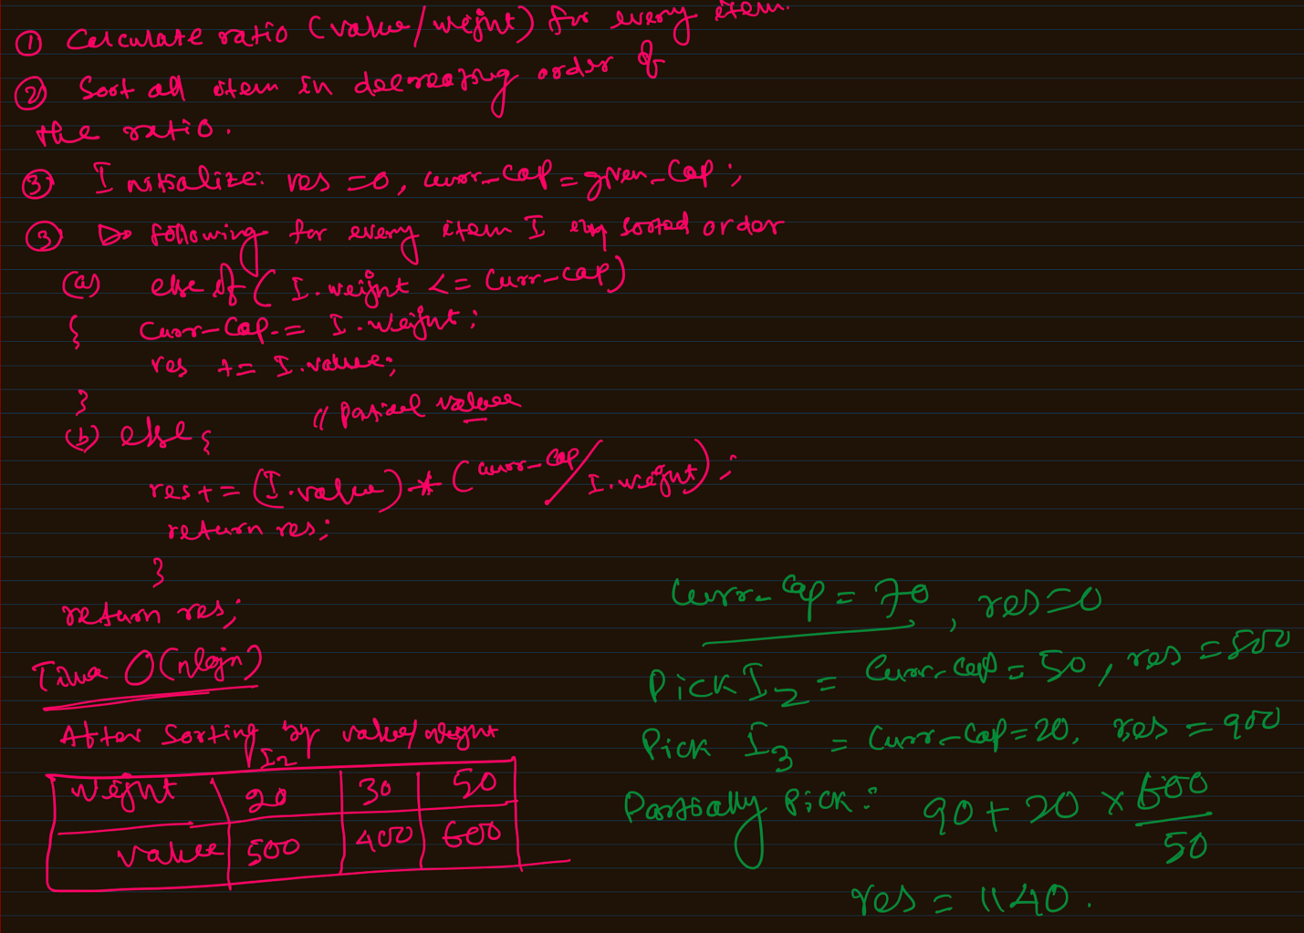

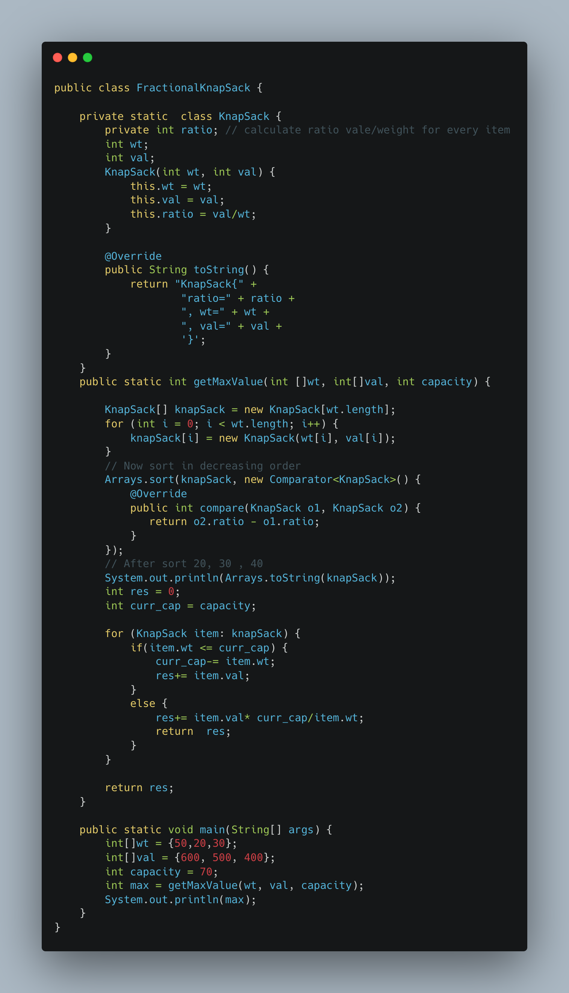

1. [Print Word Vertically](https://leetcode.com/problems/print-words-vertically/)

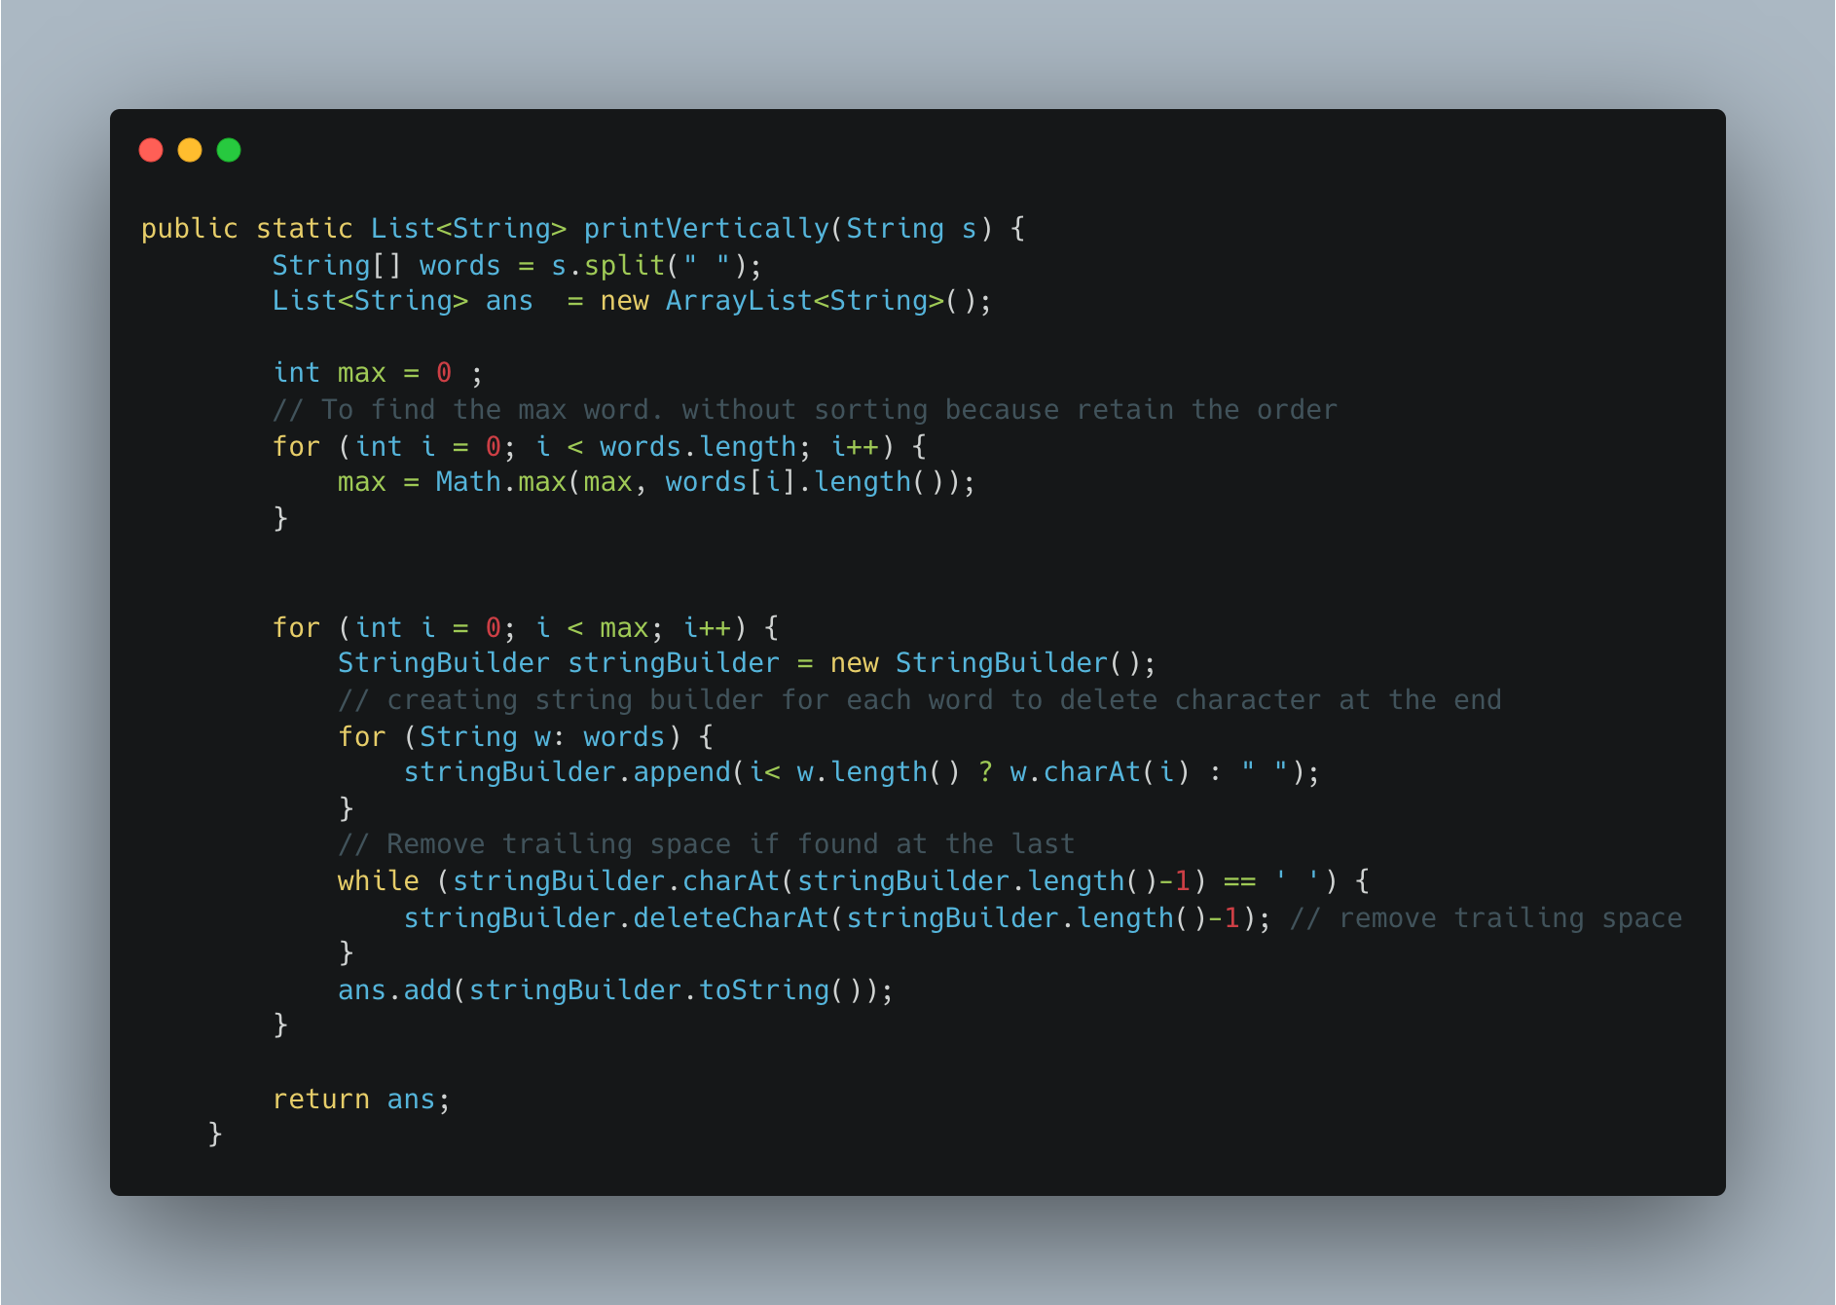

1. [Two Sum II Array is Sorted](https://leetcode.com/problems/two-sum-ii-input-array-is-sorted/)

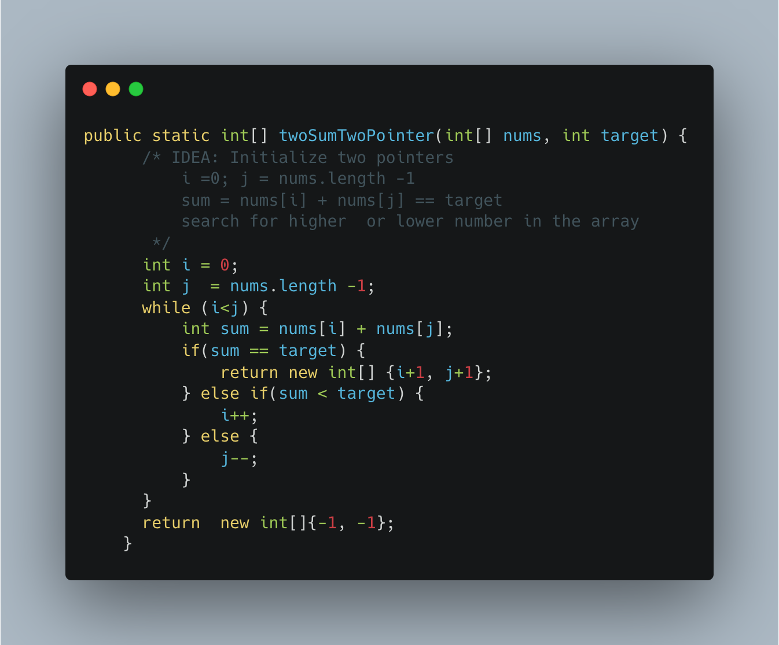

1. [Minimum Moves to Equal Array elements II](https://leetcode.com/problems/minimum-moves-to-equal-array-elements-ii/)

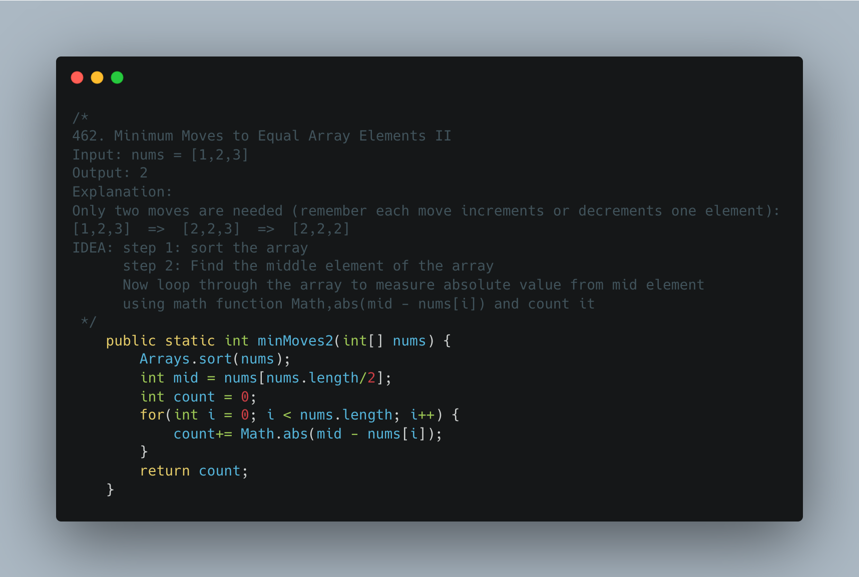

1. [Same Tree](https://leetcode.com/problems/same-tree/)

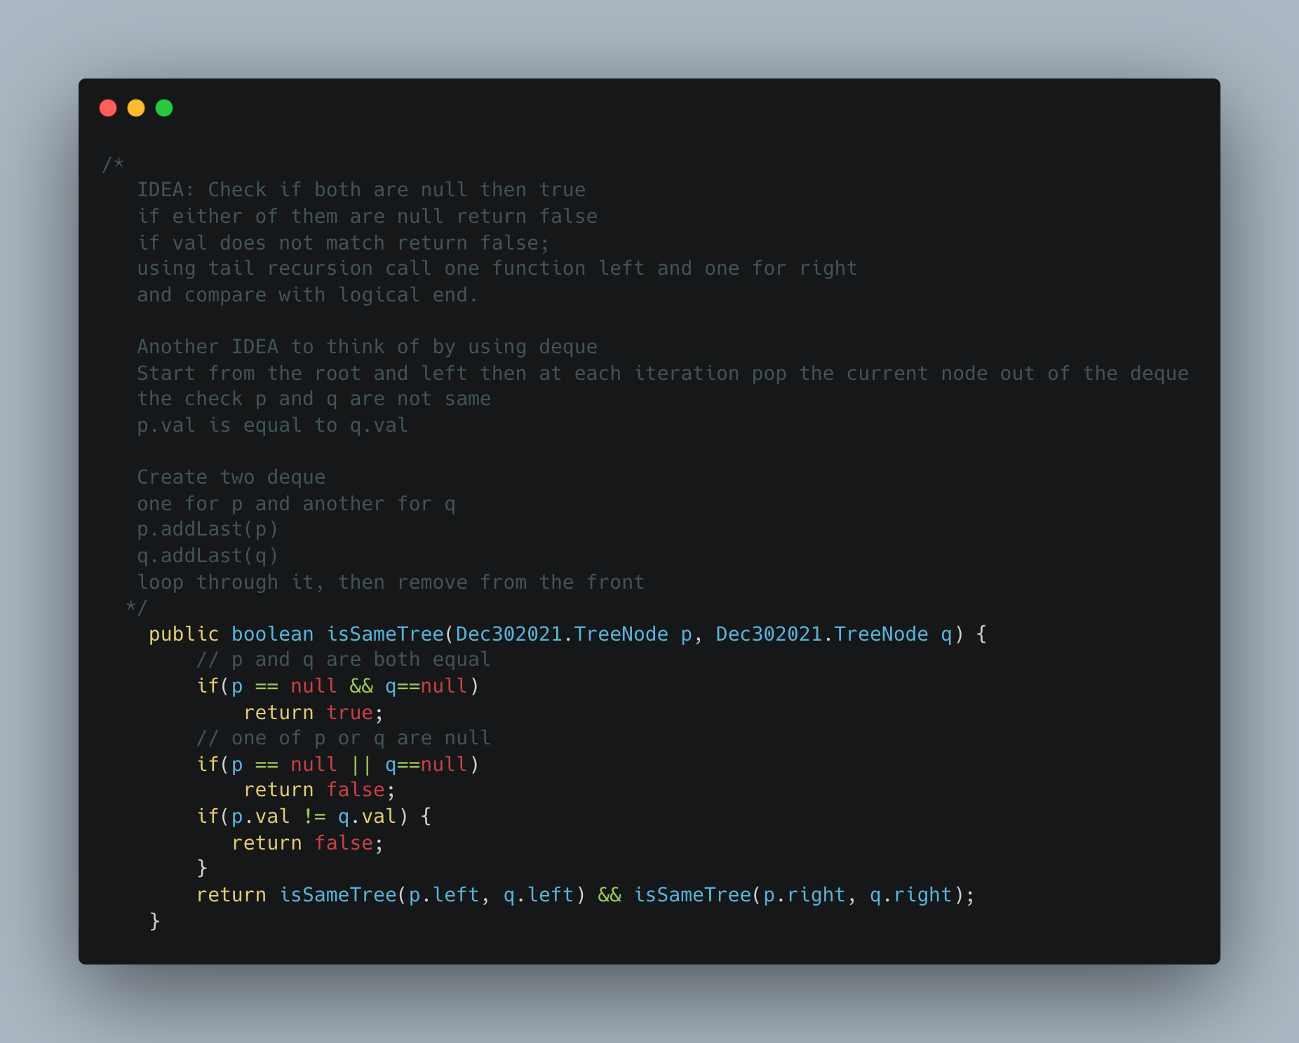

1. Maximize the number of toys that can be purchased with amount K using min Heap

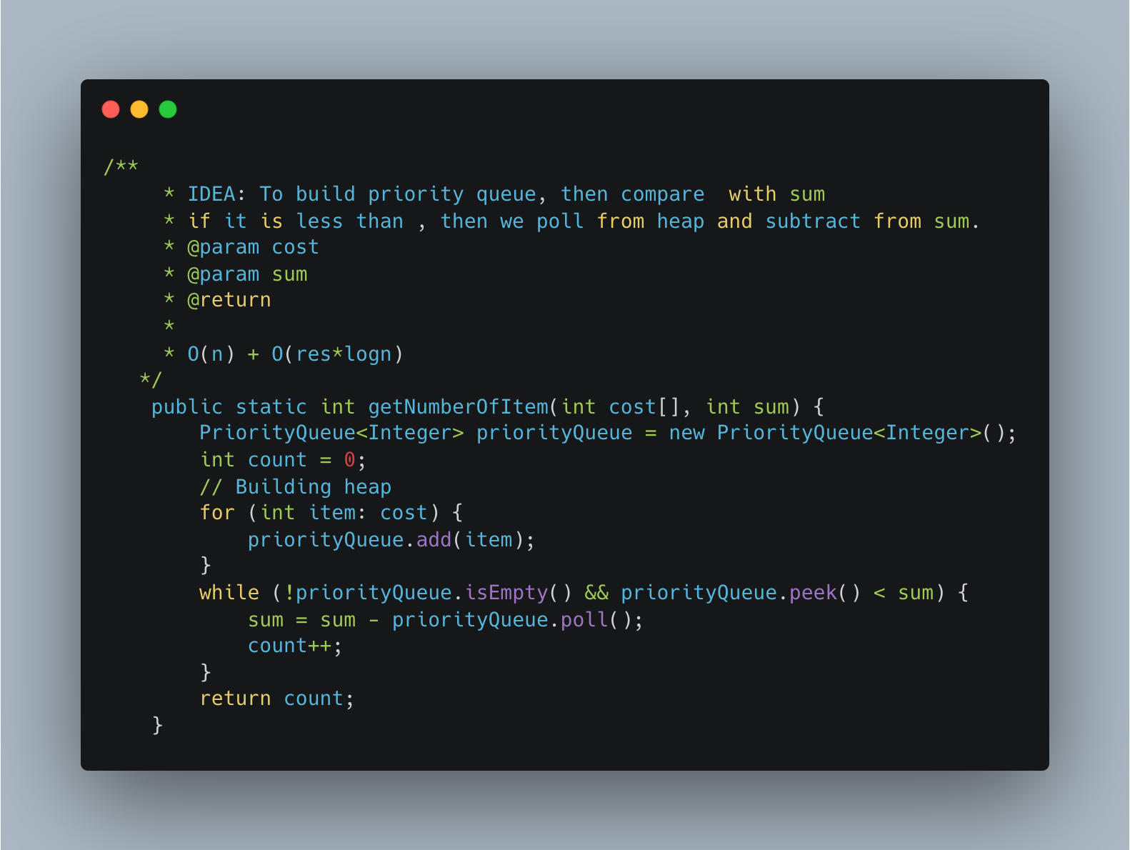

1. [Find K Closest Elements](https://leetcode.com/problems/find-k-closest-elements/)

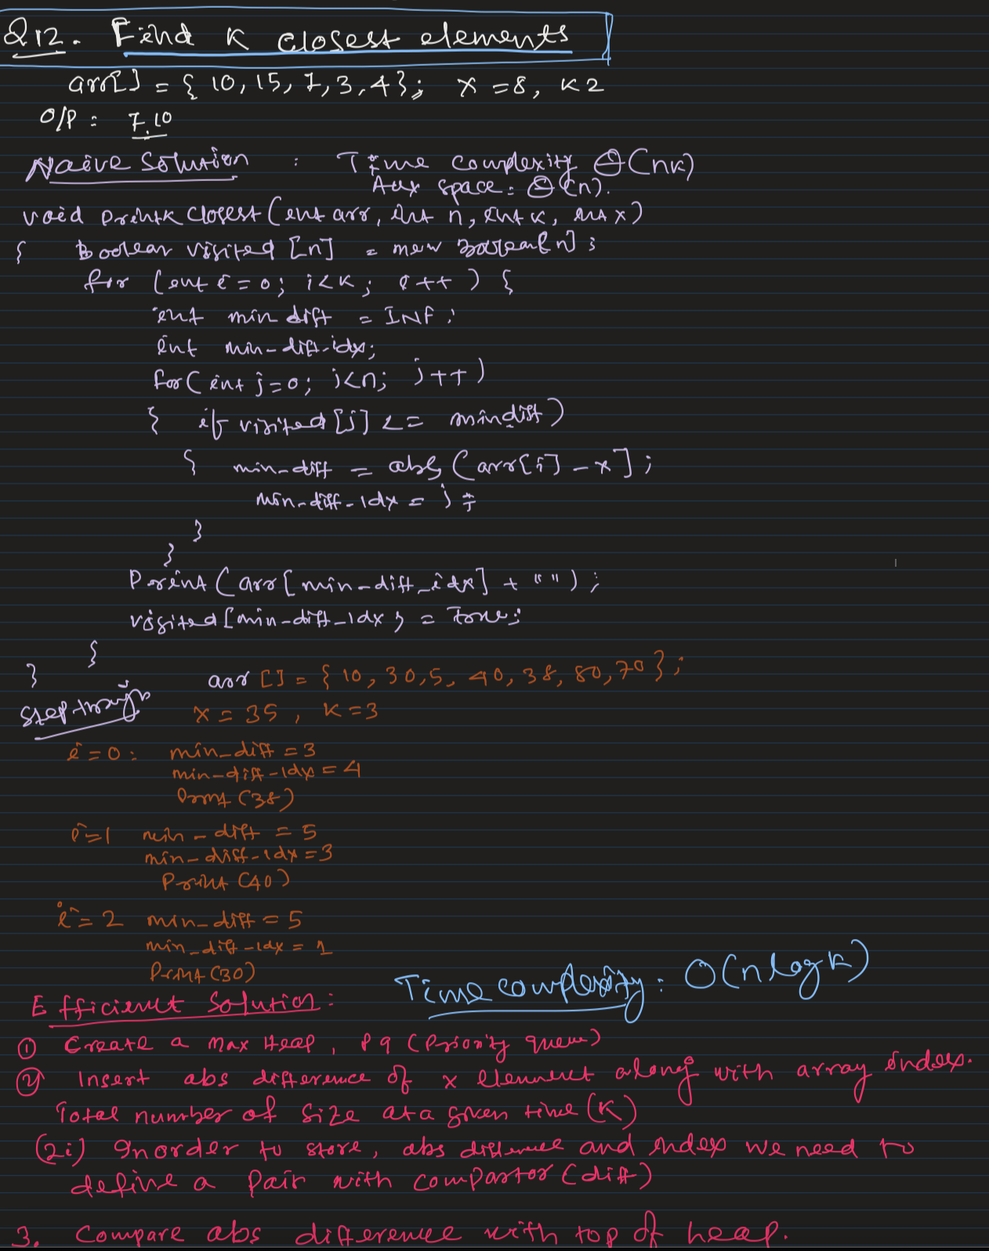

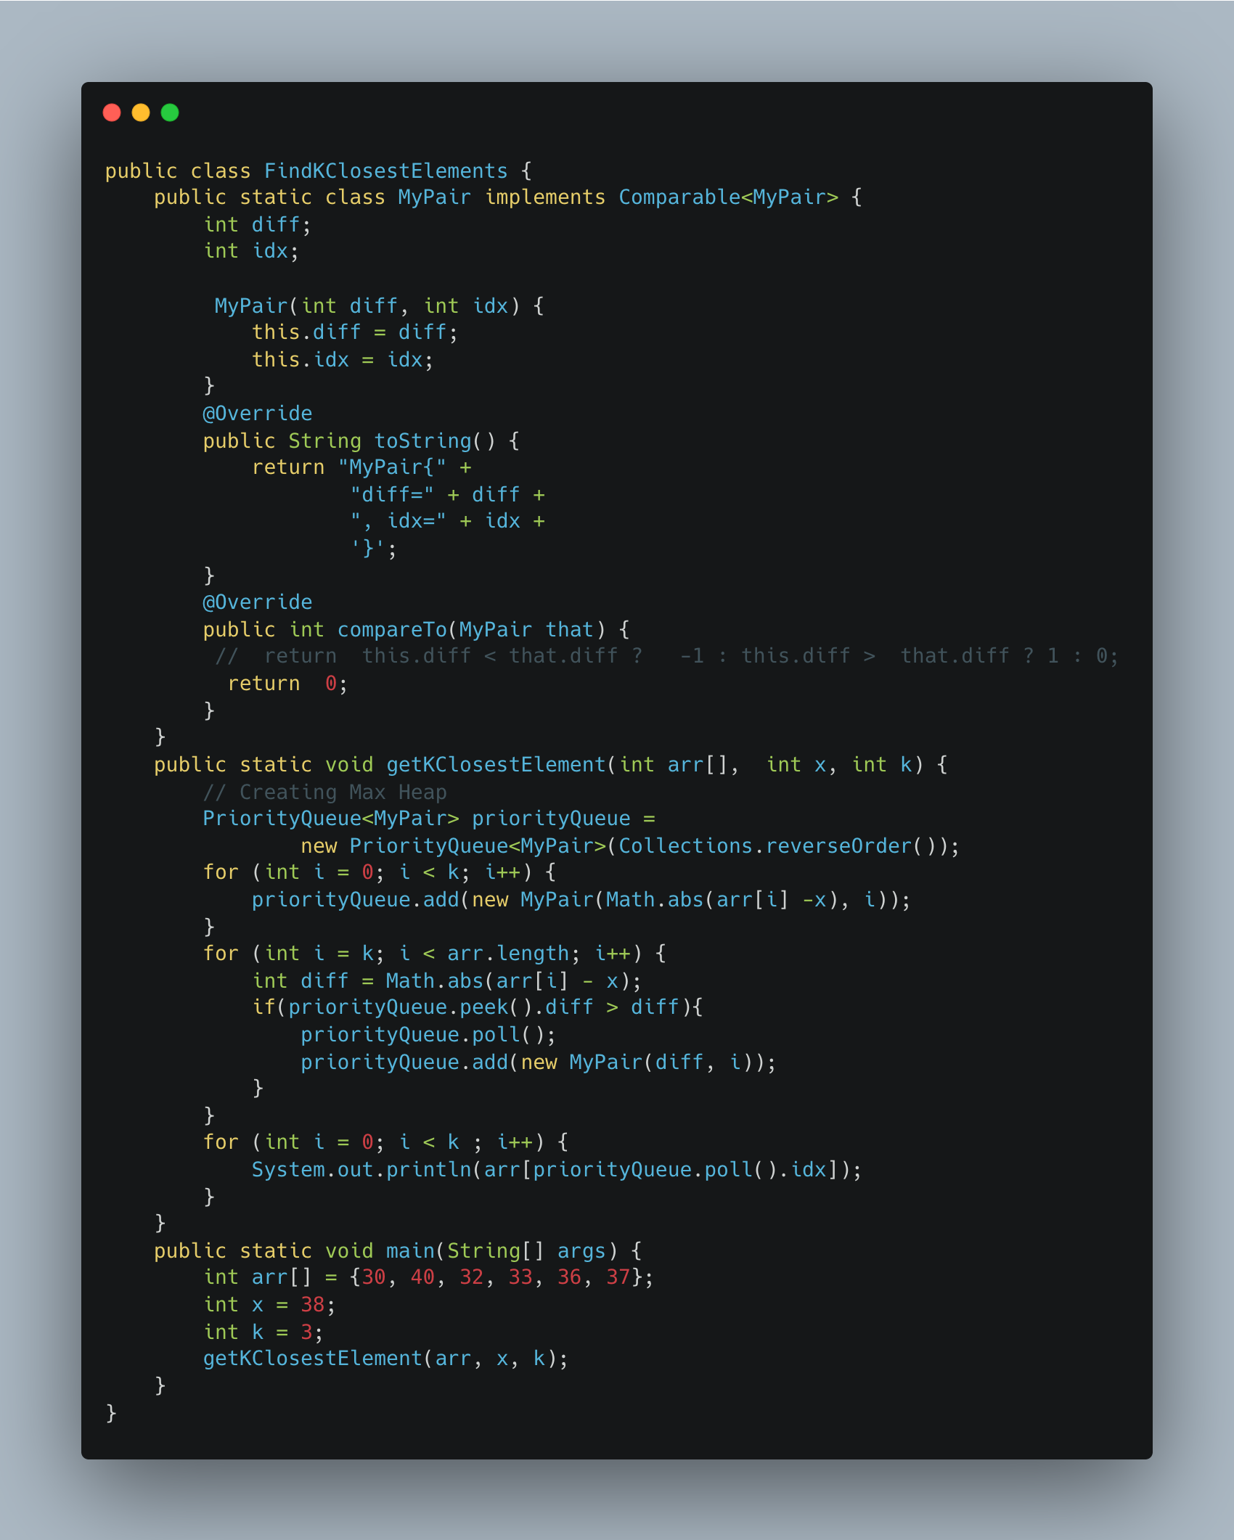

1. [Partition into Minimum Number of Deci -Binary Numbers](https://leetcode.com/problems/partitioning-into-minimum-number-of-deci-binary-numbers/)

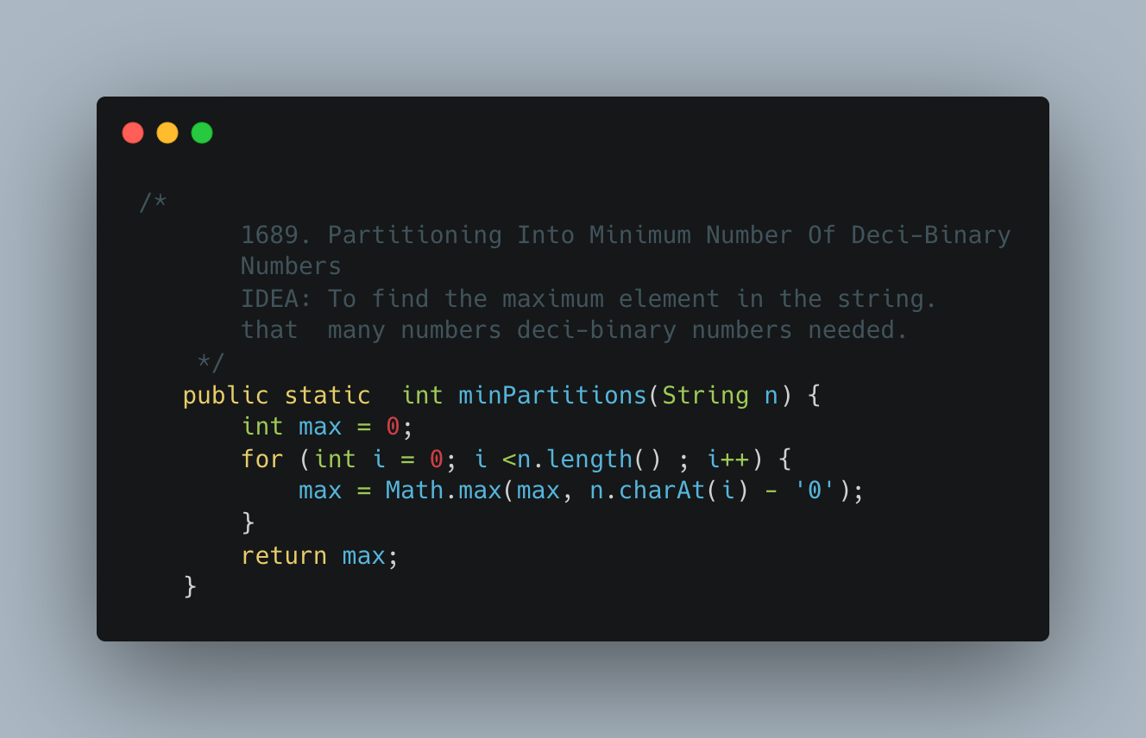

1. [Number of Closed Islands](https://leetcode.com/problems/number-of-closed-islands/)

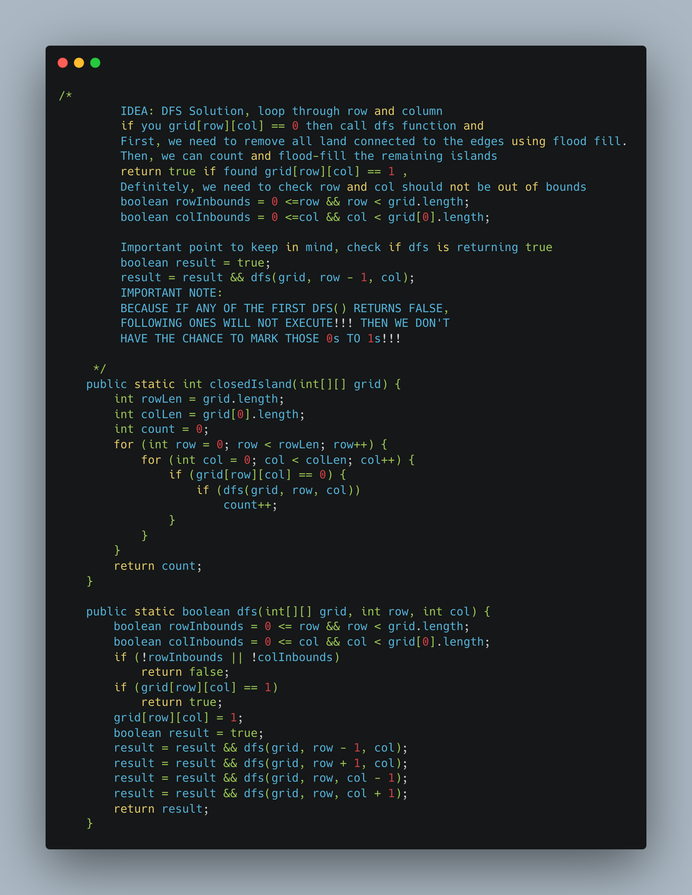

1. [Rank Transform of an Array](https://leetcode.com/problems/rank-transform-of-an-array/)

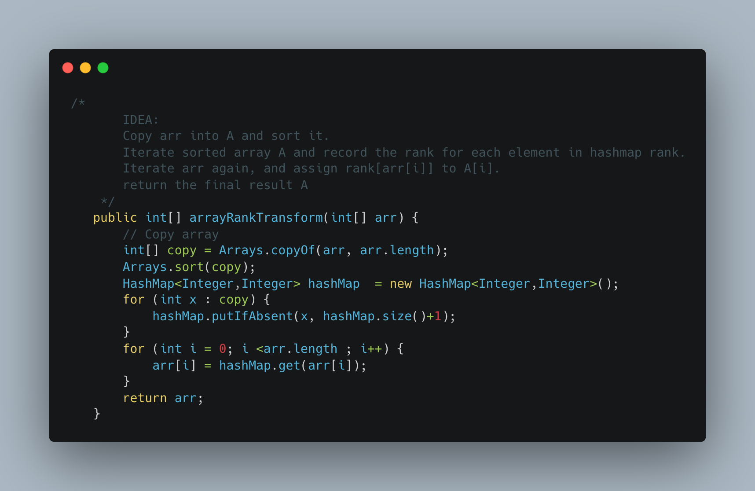

1. [Numbers with Same consecutive differences](https://leetcode.com/problems/numbers-with-same-consecutive-differences/)

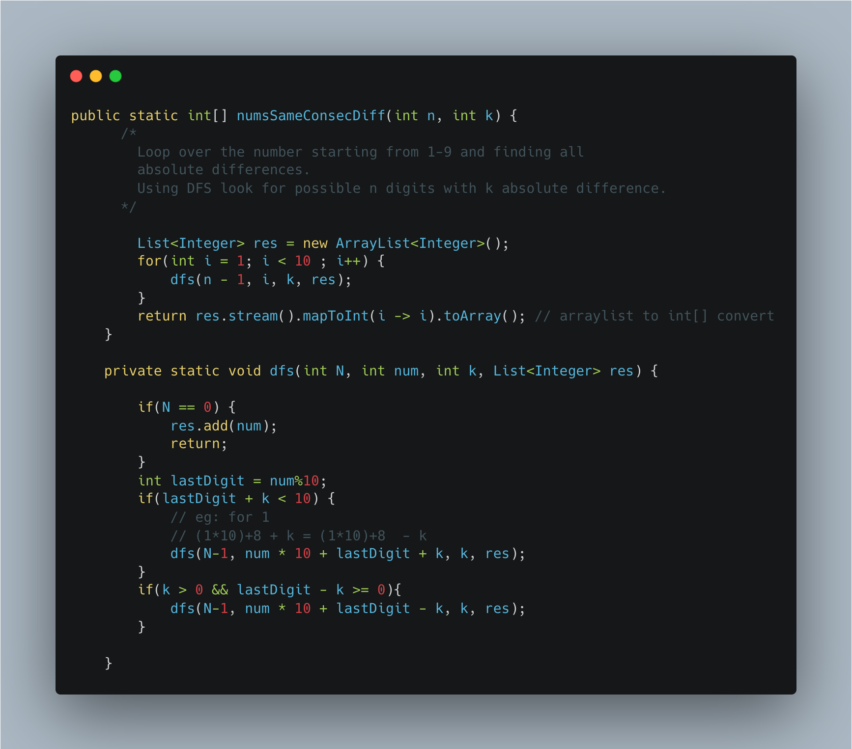

1. [Word Search](https://leetcode.com/problems/word-search/submissions/)

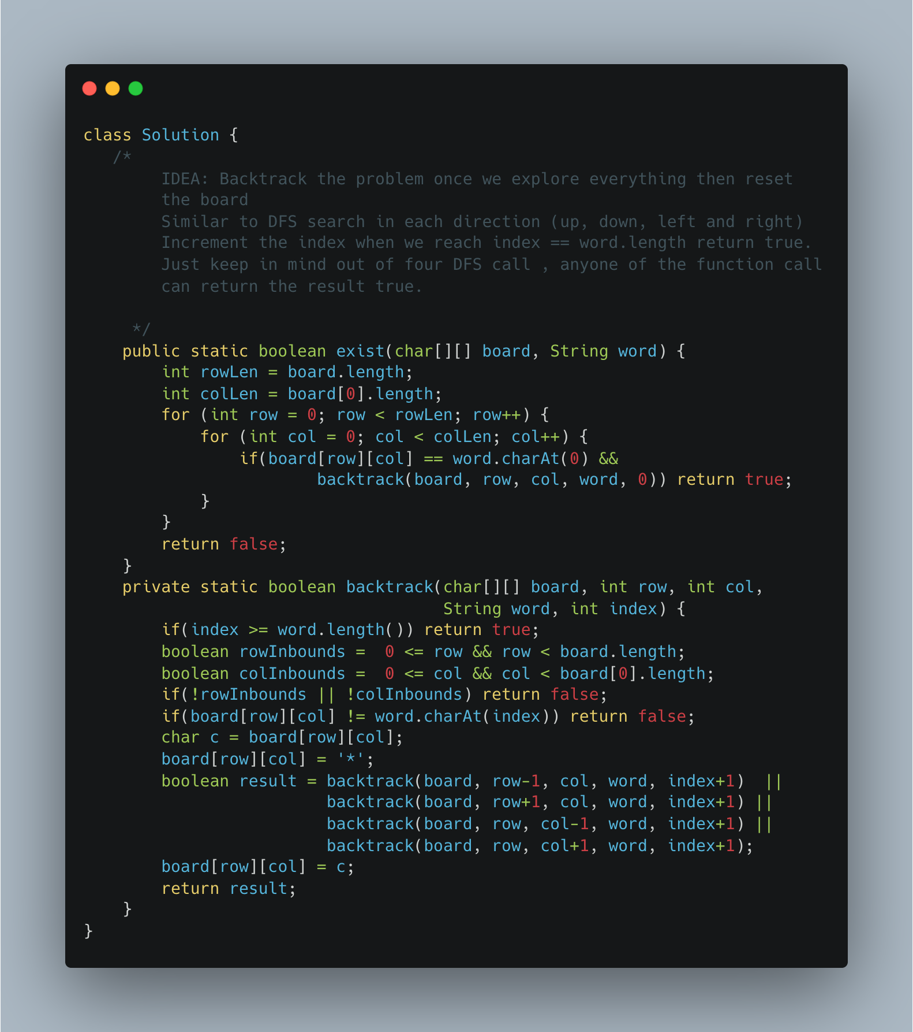

1. [Find Minimum in Rotated Sorted Array](https://leetcode.com/problems/find-minimum-in-rotated-sorted-array/)

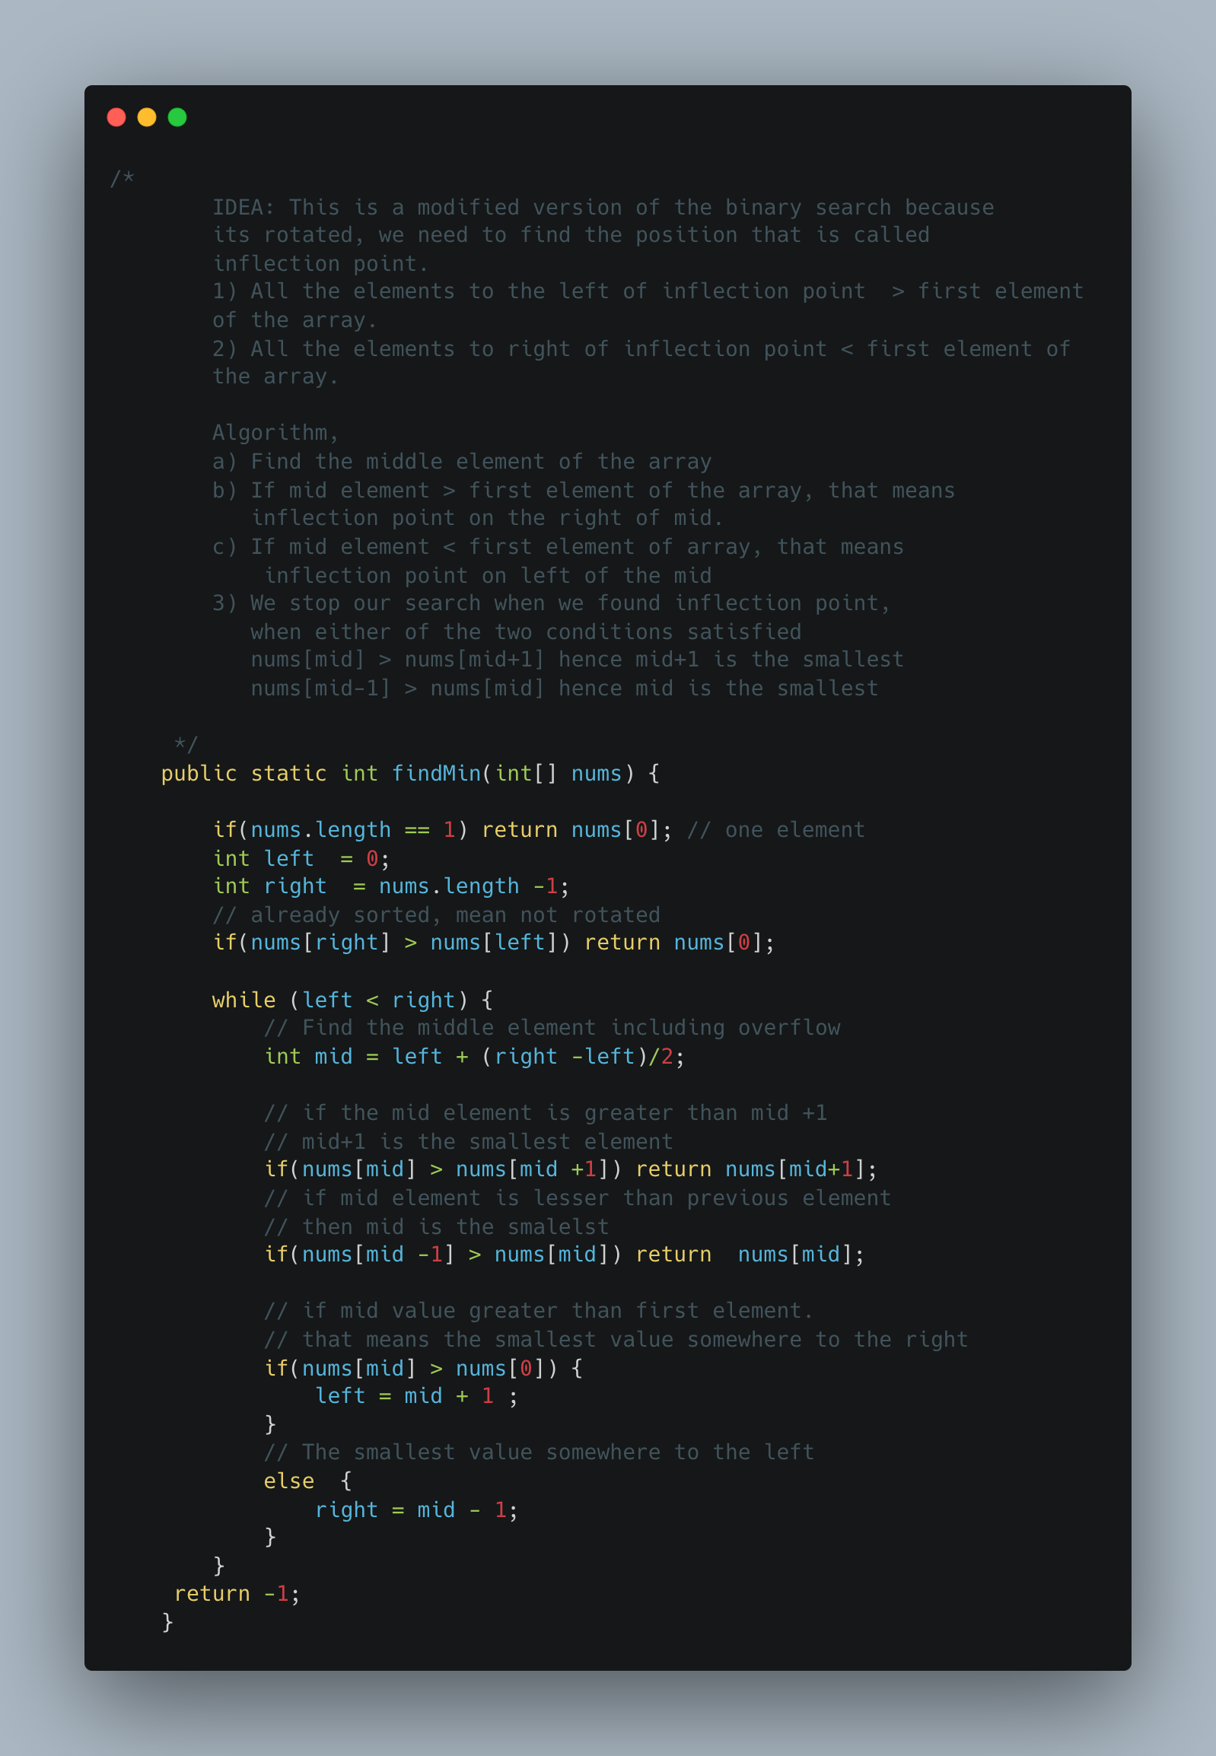

1. [Relative Sort Array](https://leetcode.com/problems/relative-sort-array/)

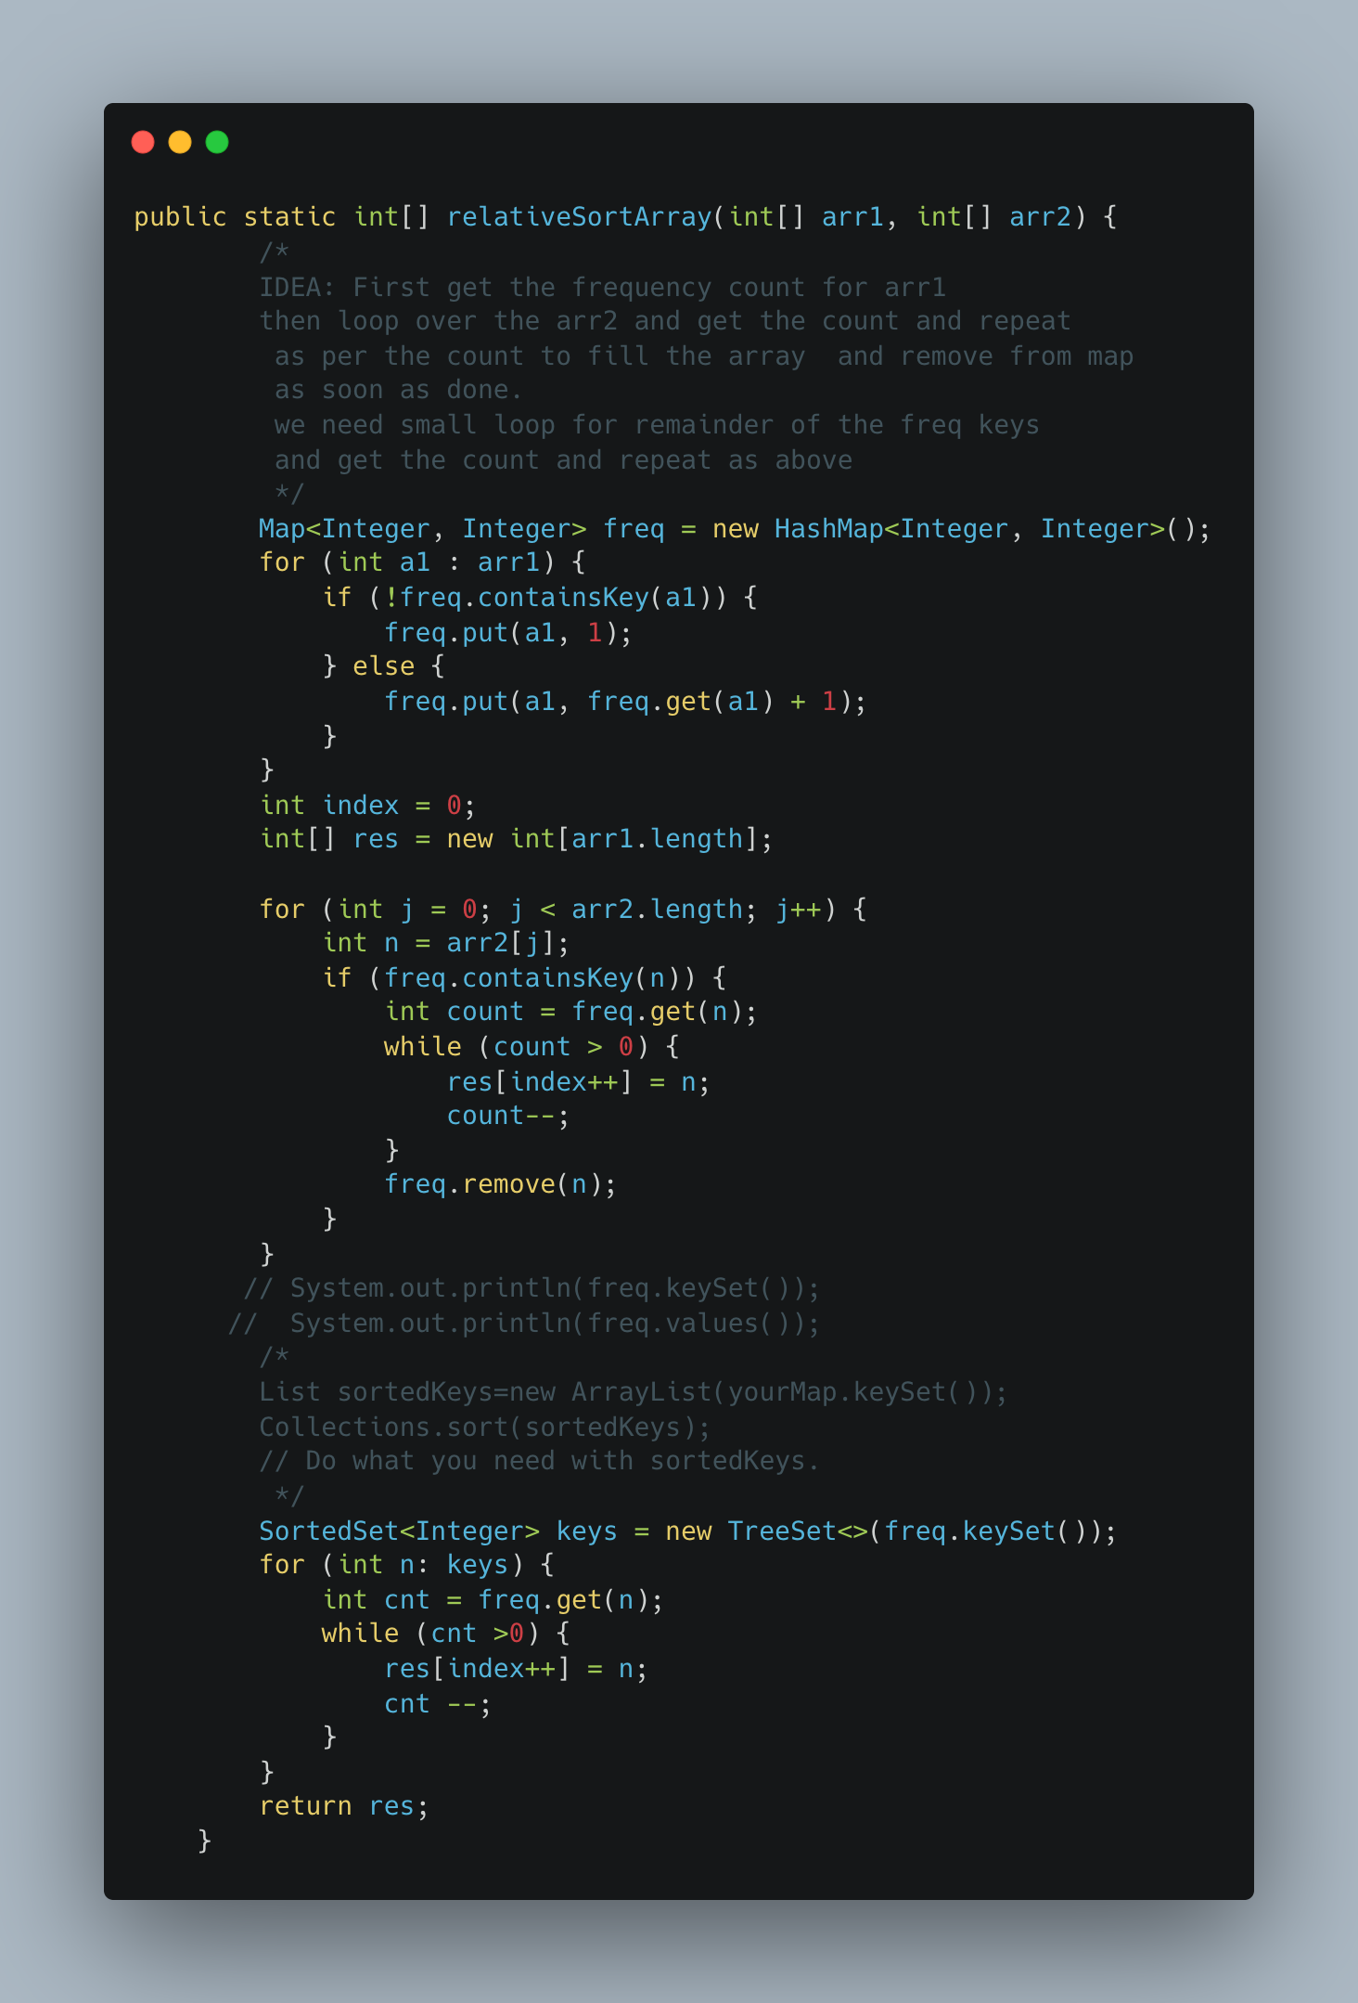

1. [Remove K Digits](https://leetcode.com/problems/remove-k-digits/)

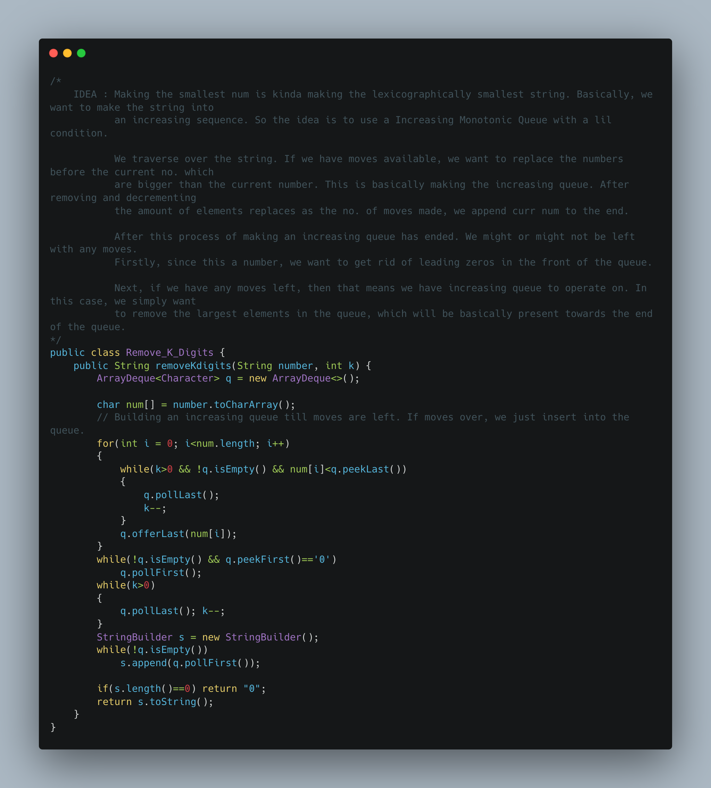

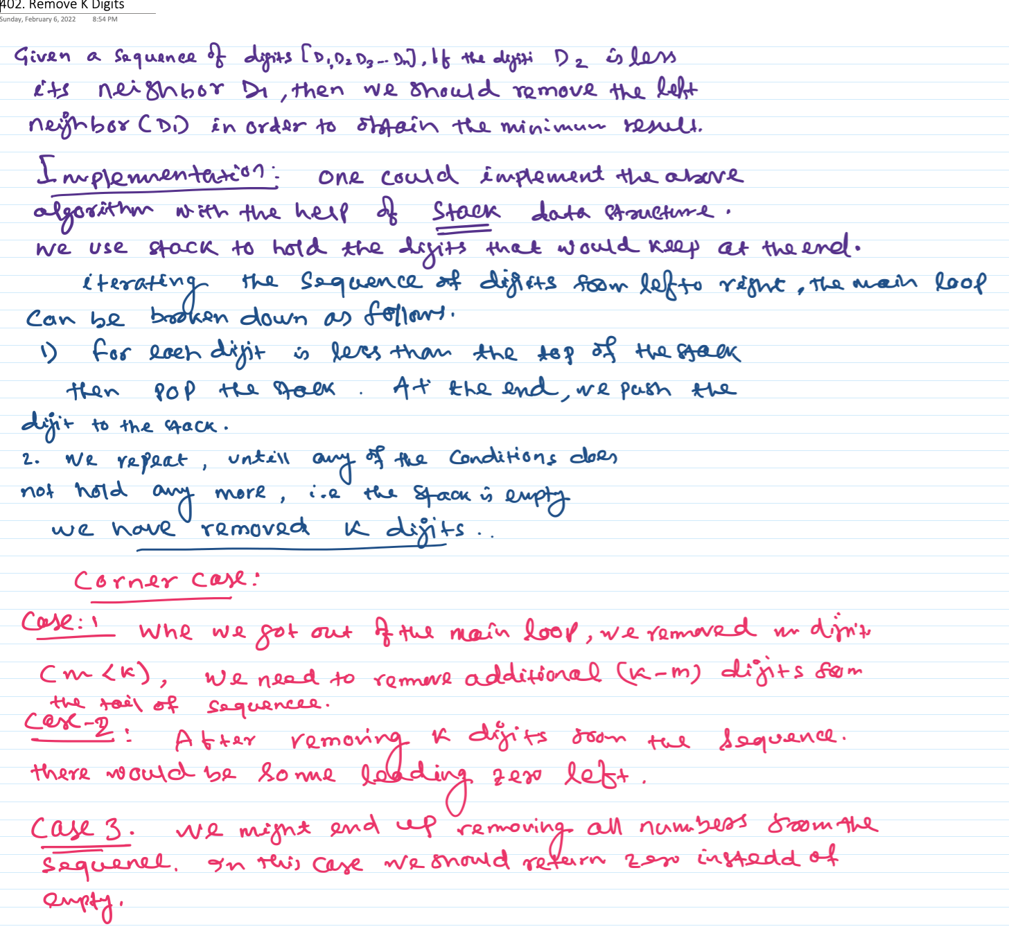

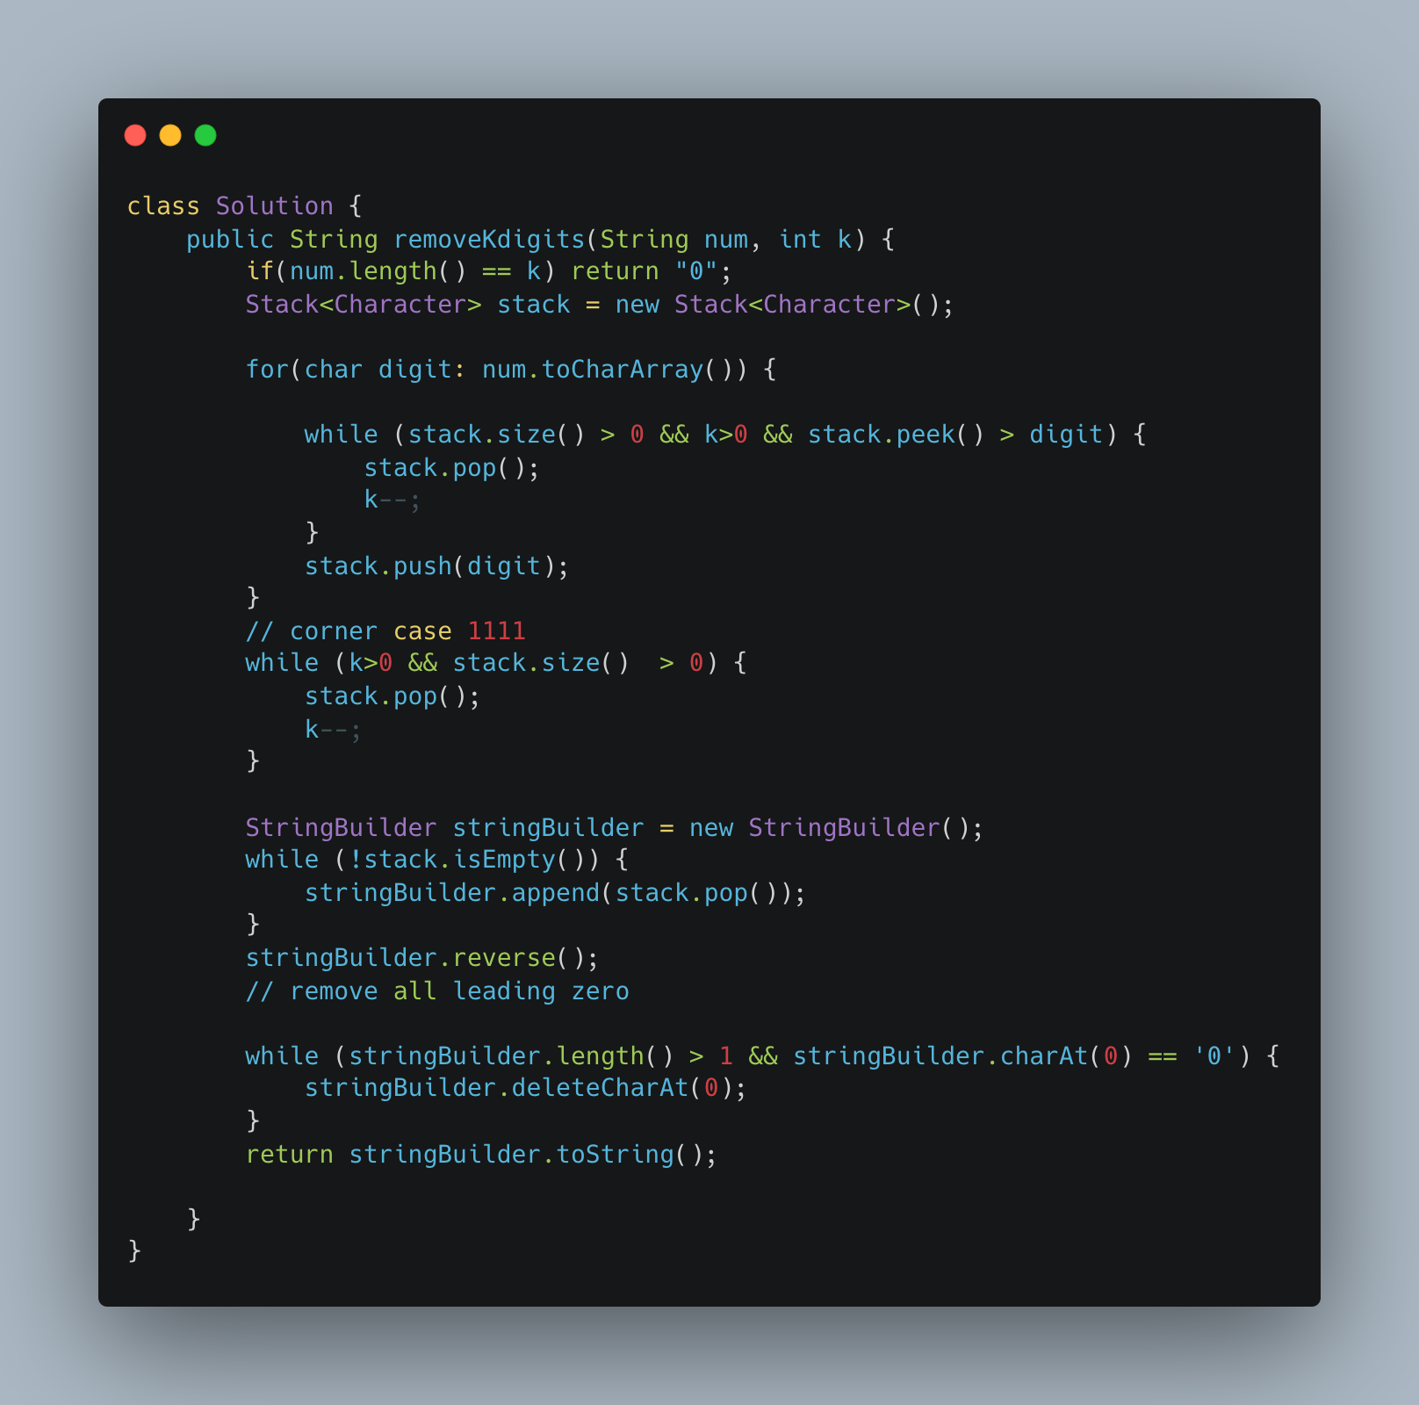

1. [Partition Labels](https://leetcode.com/problems/partition-labels/)

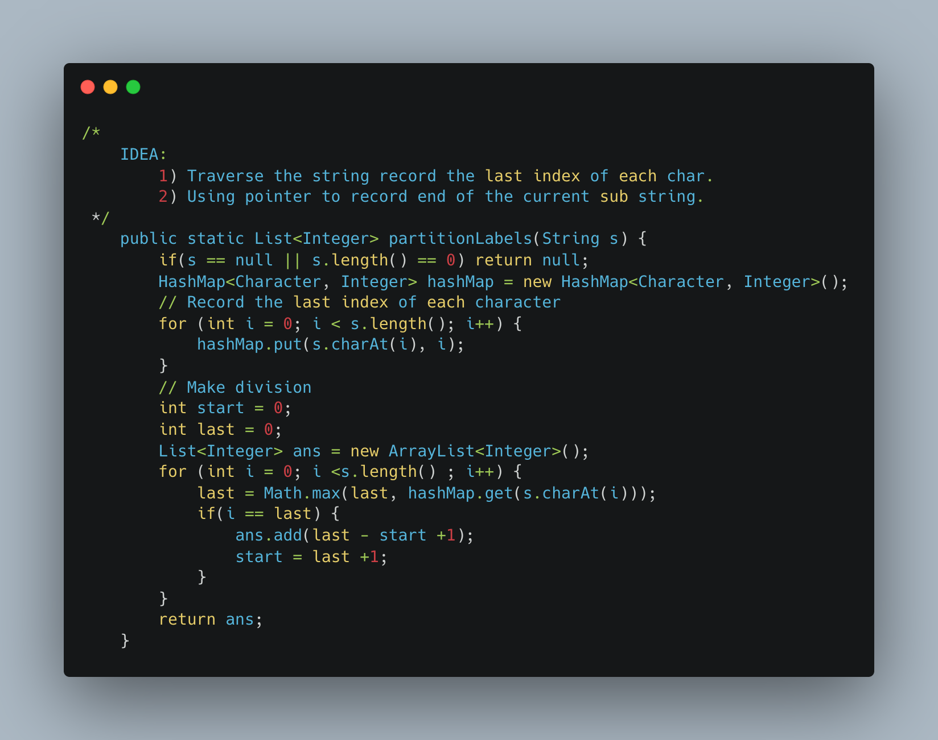

1. Fibonacci Dynamic Programming

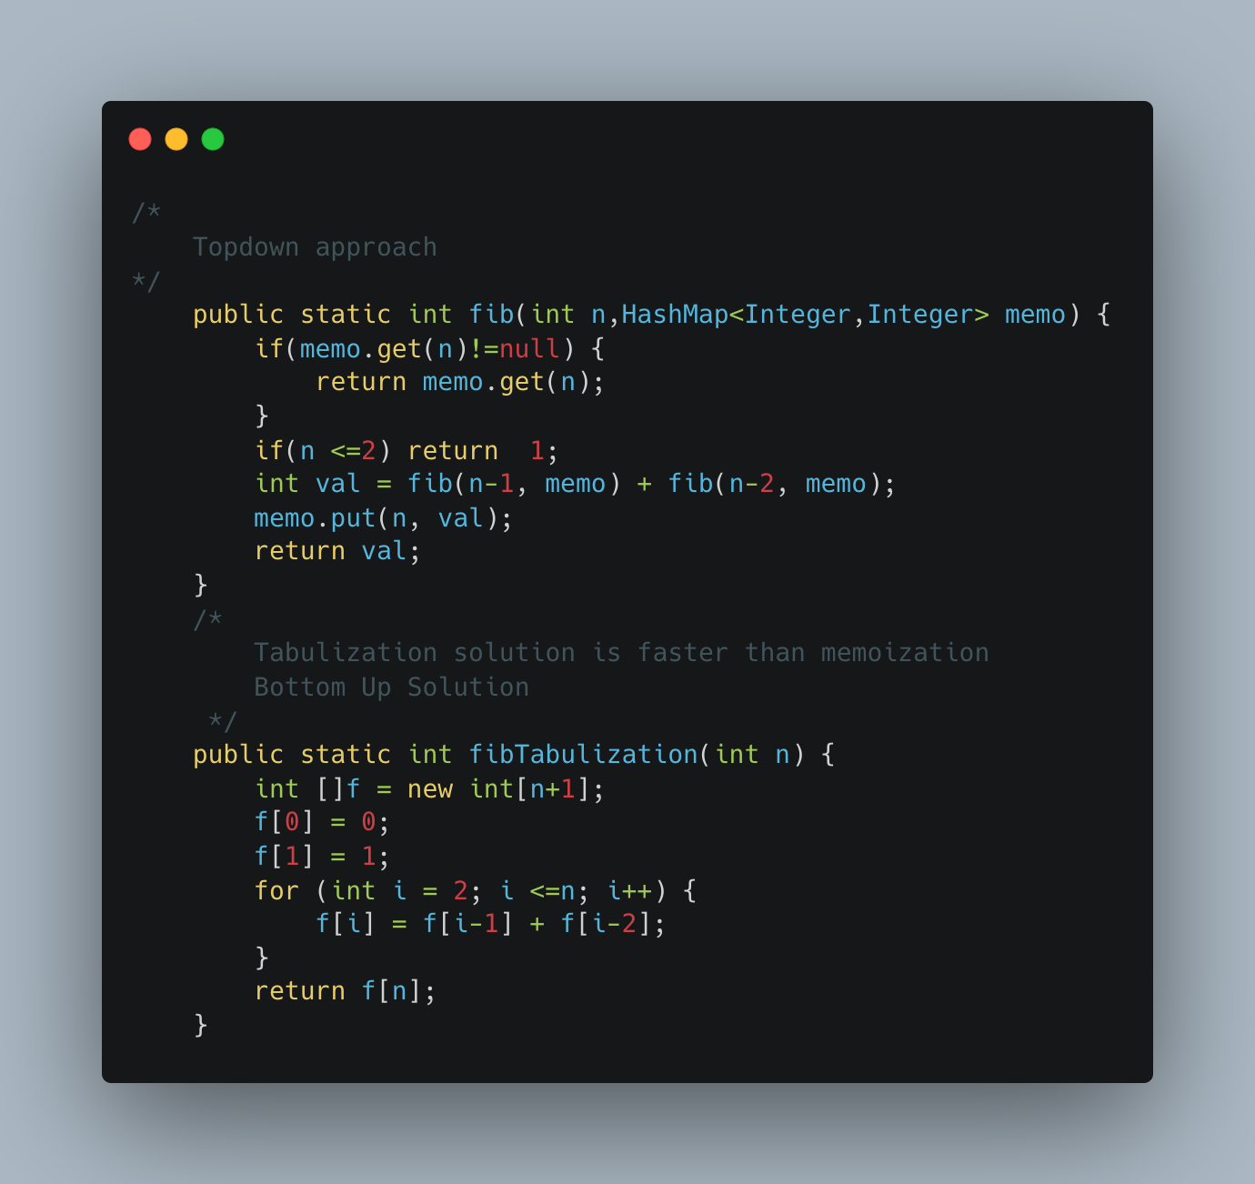

1. Distribute Coins in Binary Tree

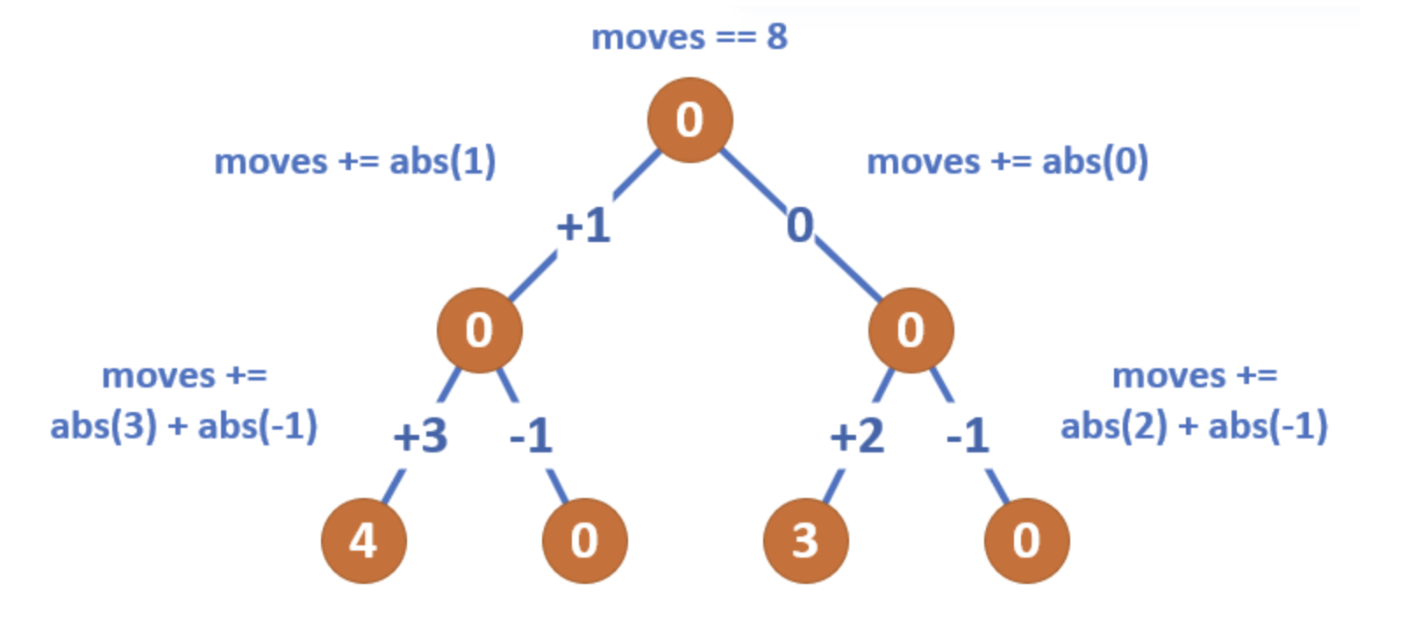

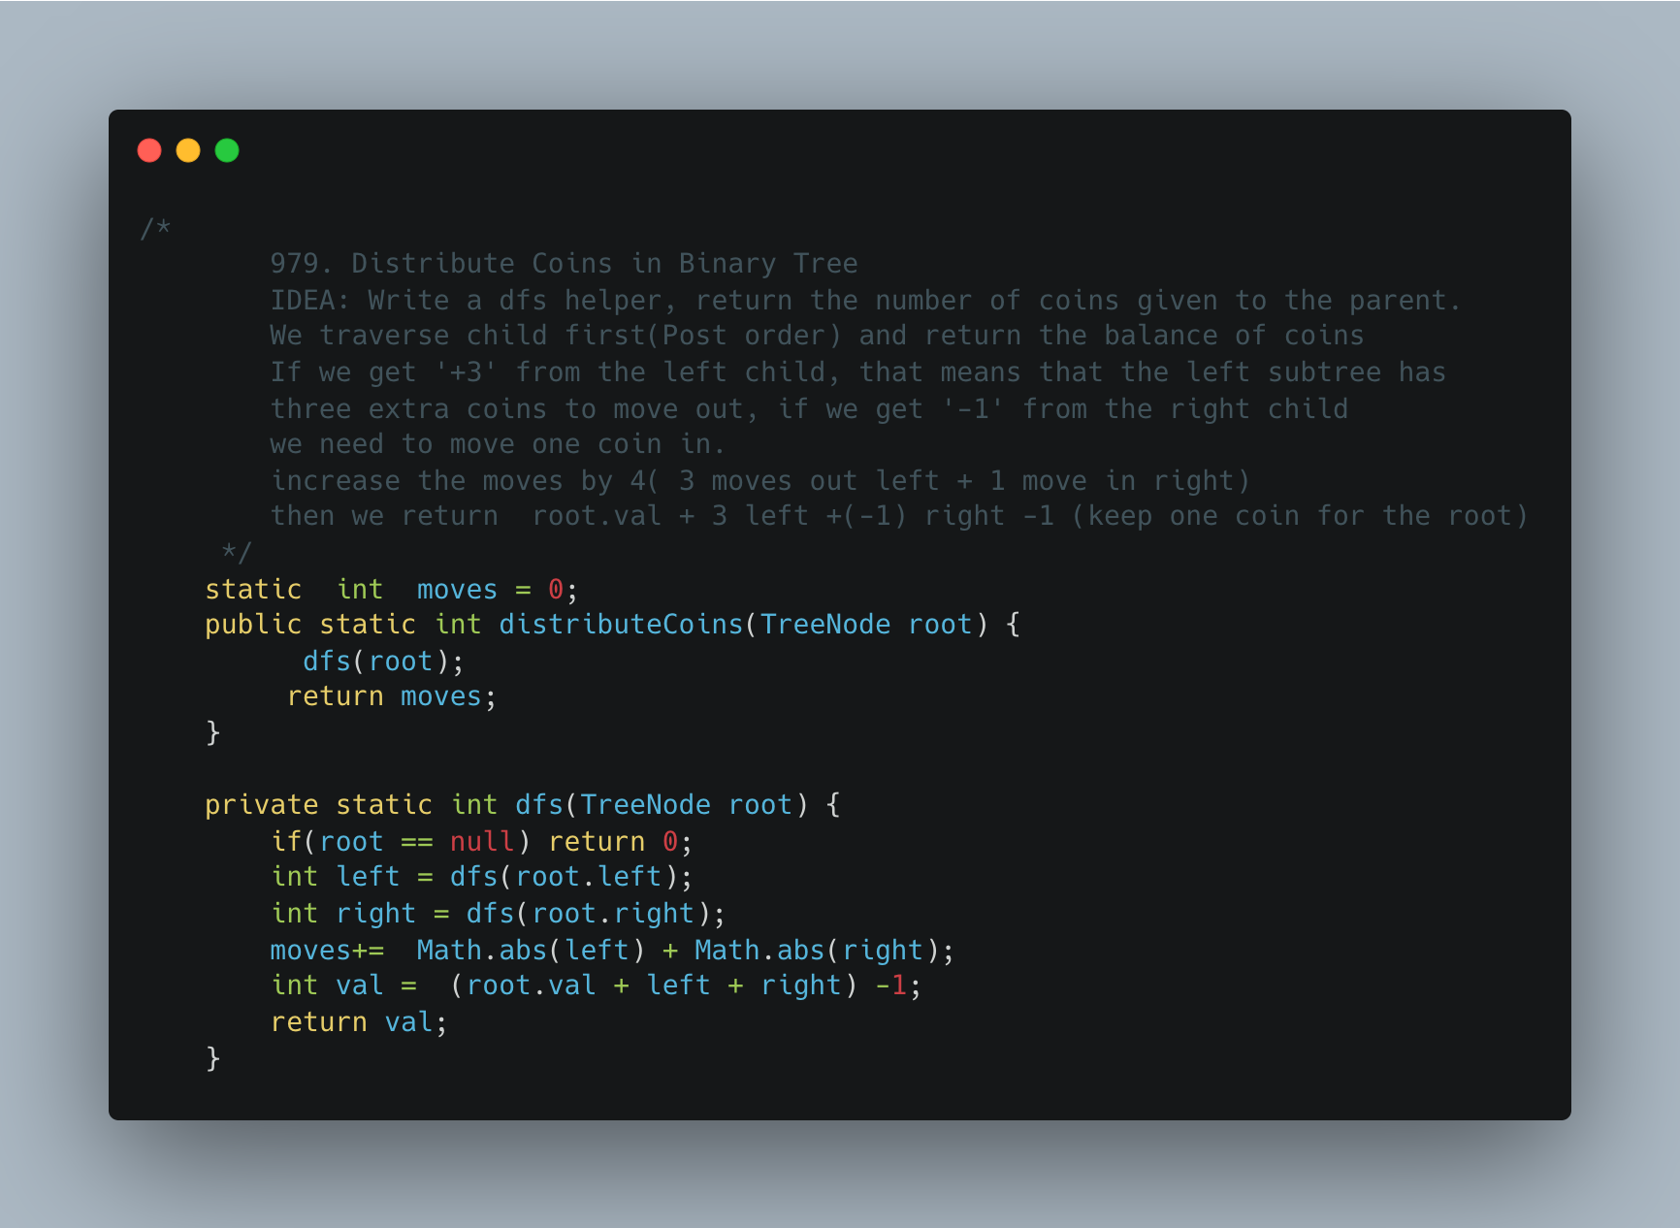

1. [Sorted Matrix](https://practice.geeksforgeeks.org/problems/sorted-matrix2333/1)

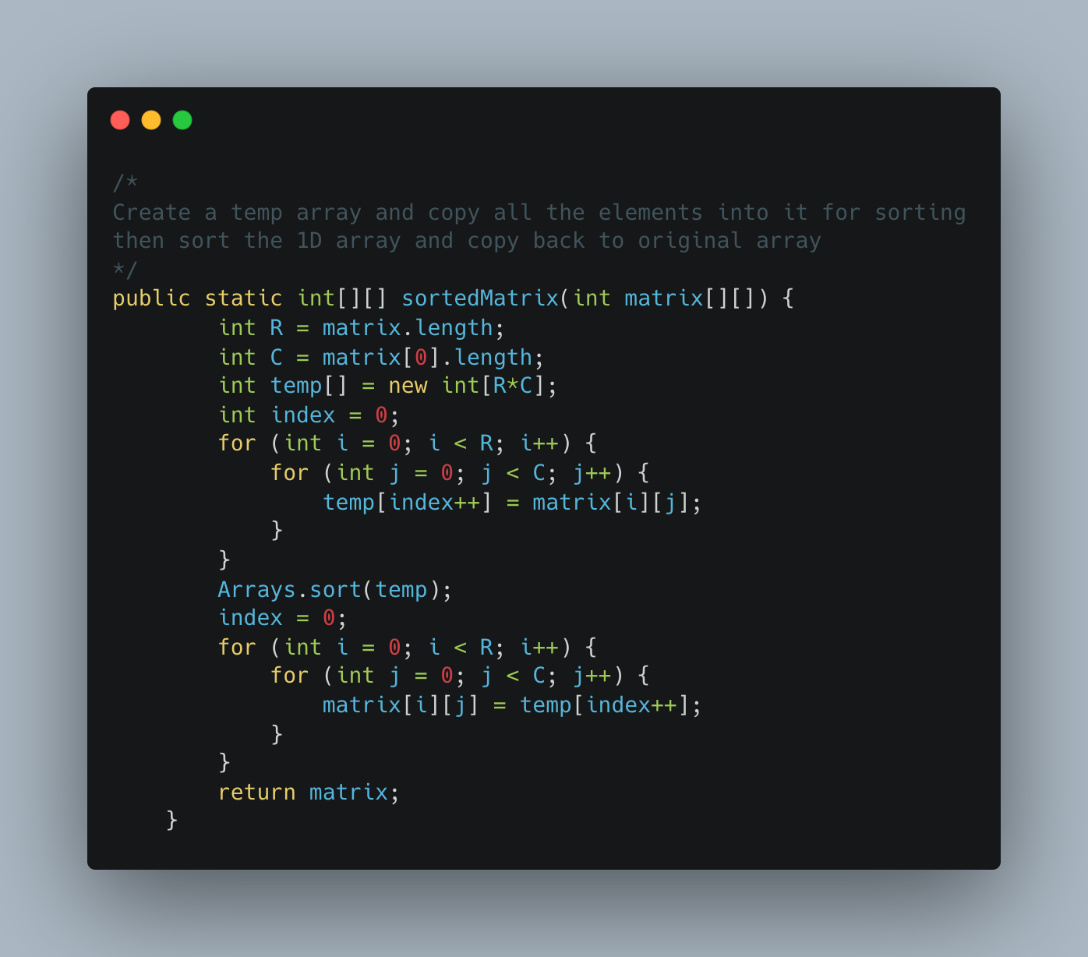

1. [Row with Max 1s](https://practice.geeksforgeeks.org/problems/row-with-max-1s0023/1)

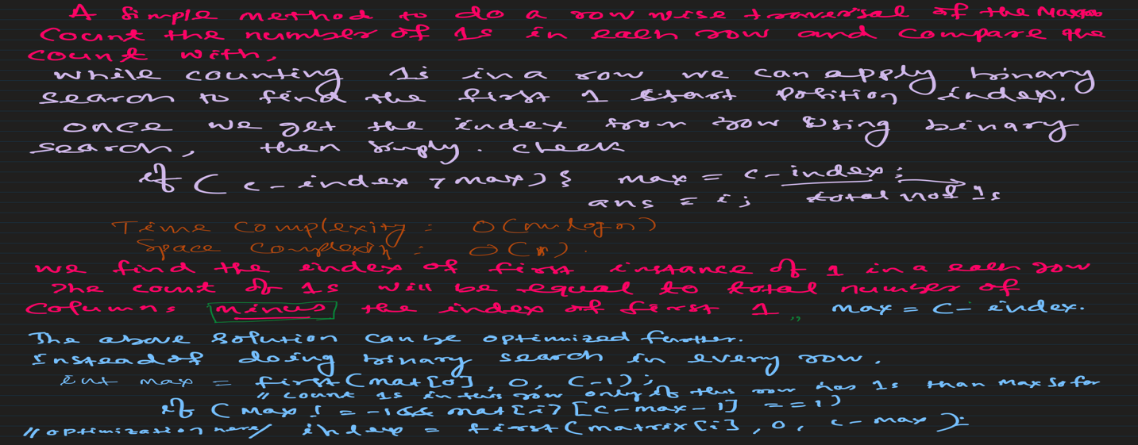

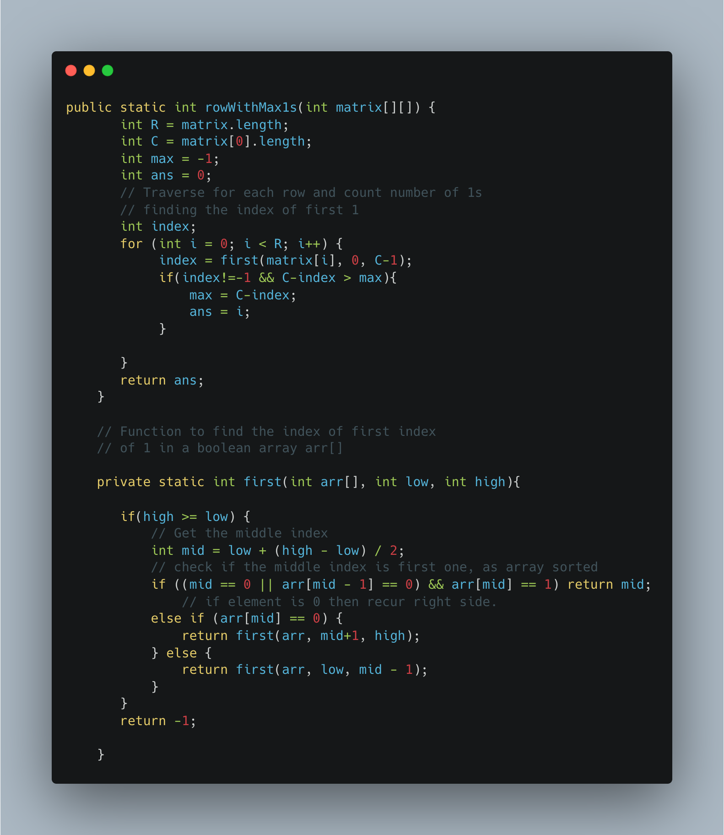

1. [Search a 2D Matrix](https://leetcode.com/problems/search-a-2d-matrix/)

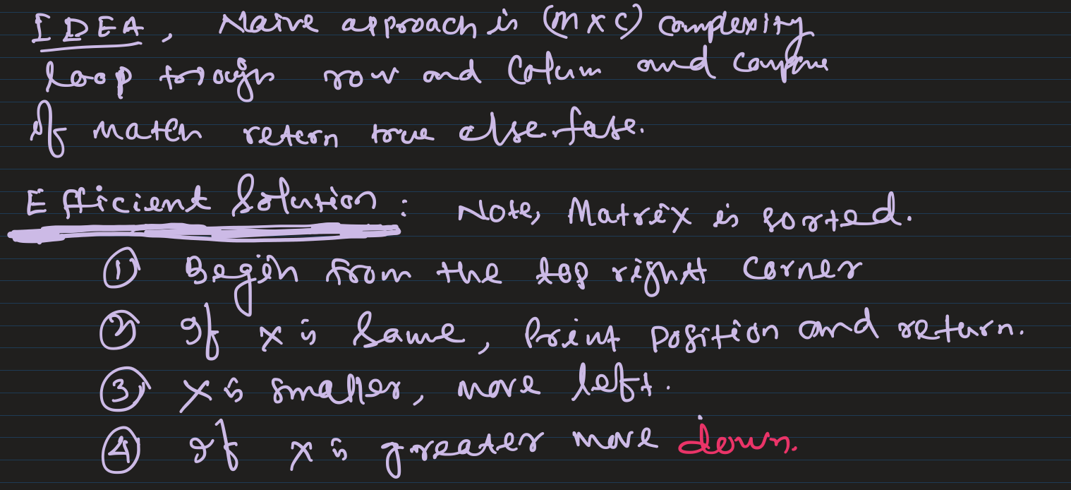

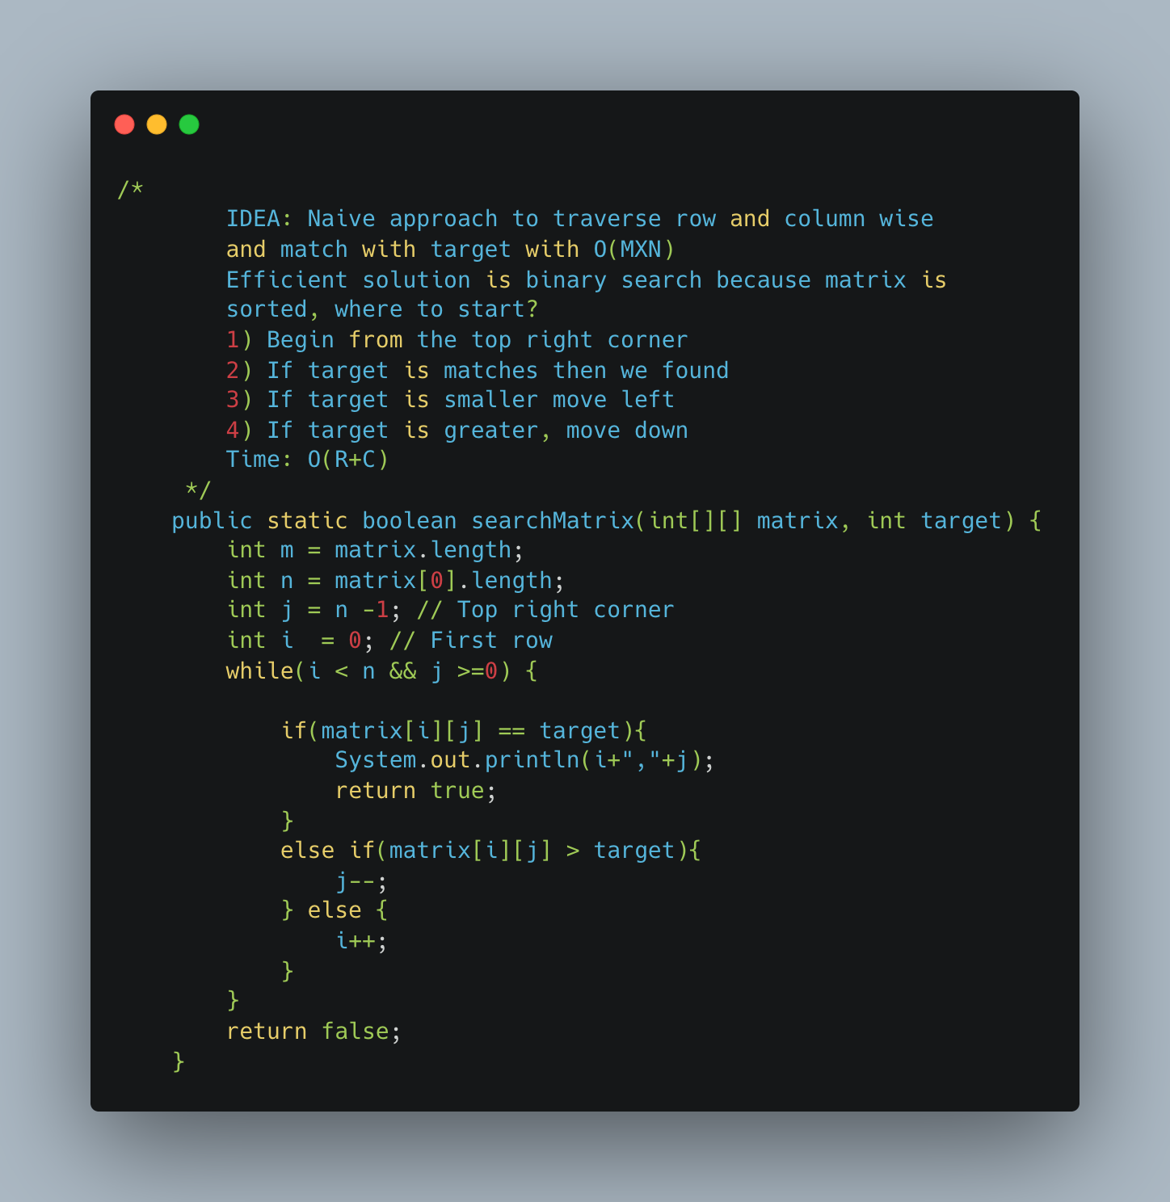

1. [Spirally Traversing a Matrix](https://practice.geeksforgeeks.org/problems/spirally-traversing-a-matrix-1587115621/1)

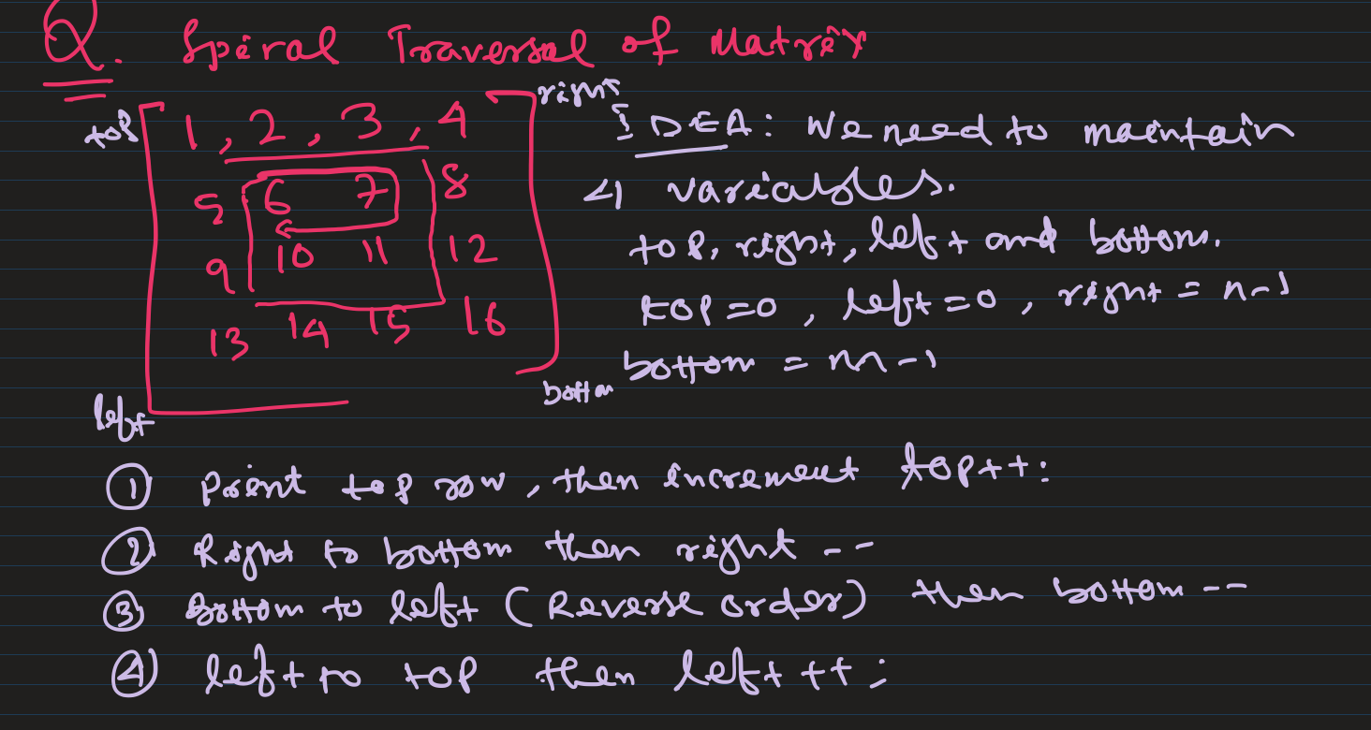

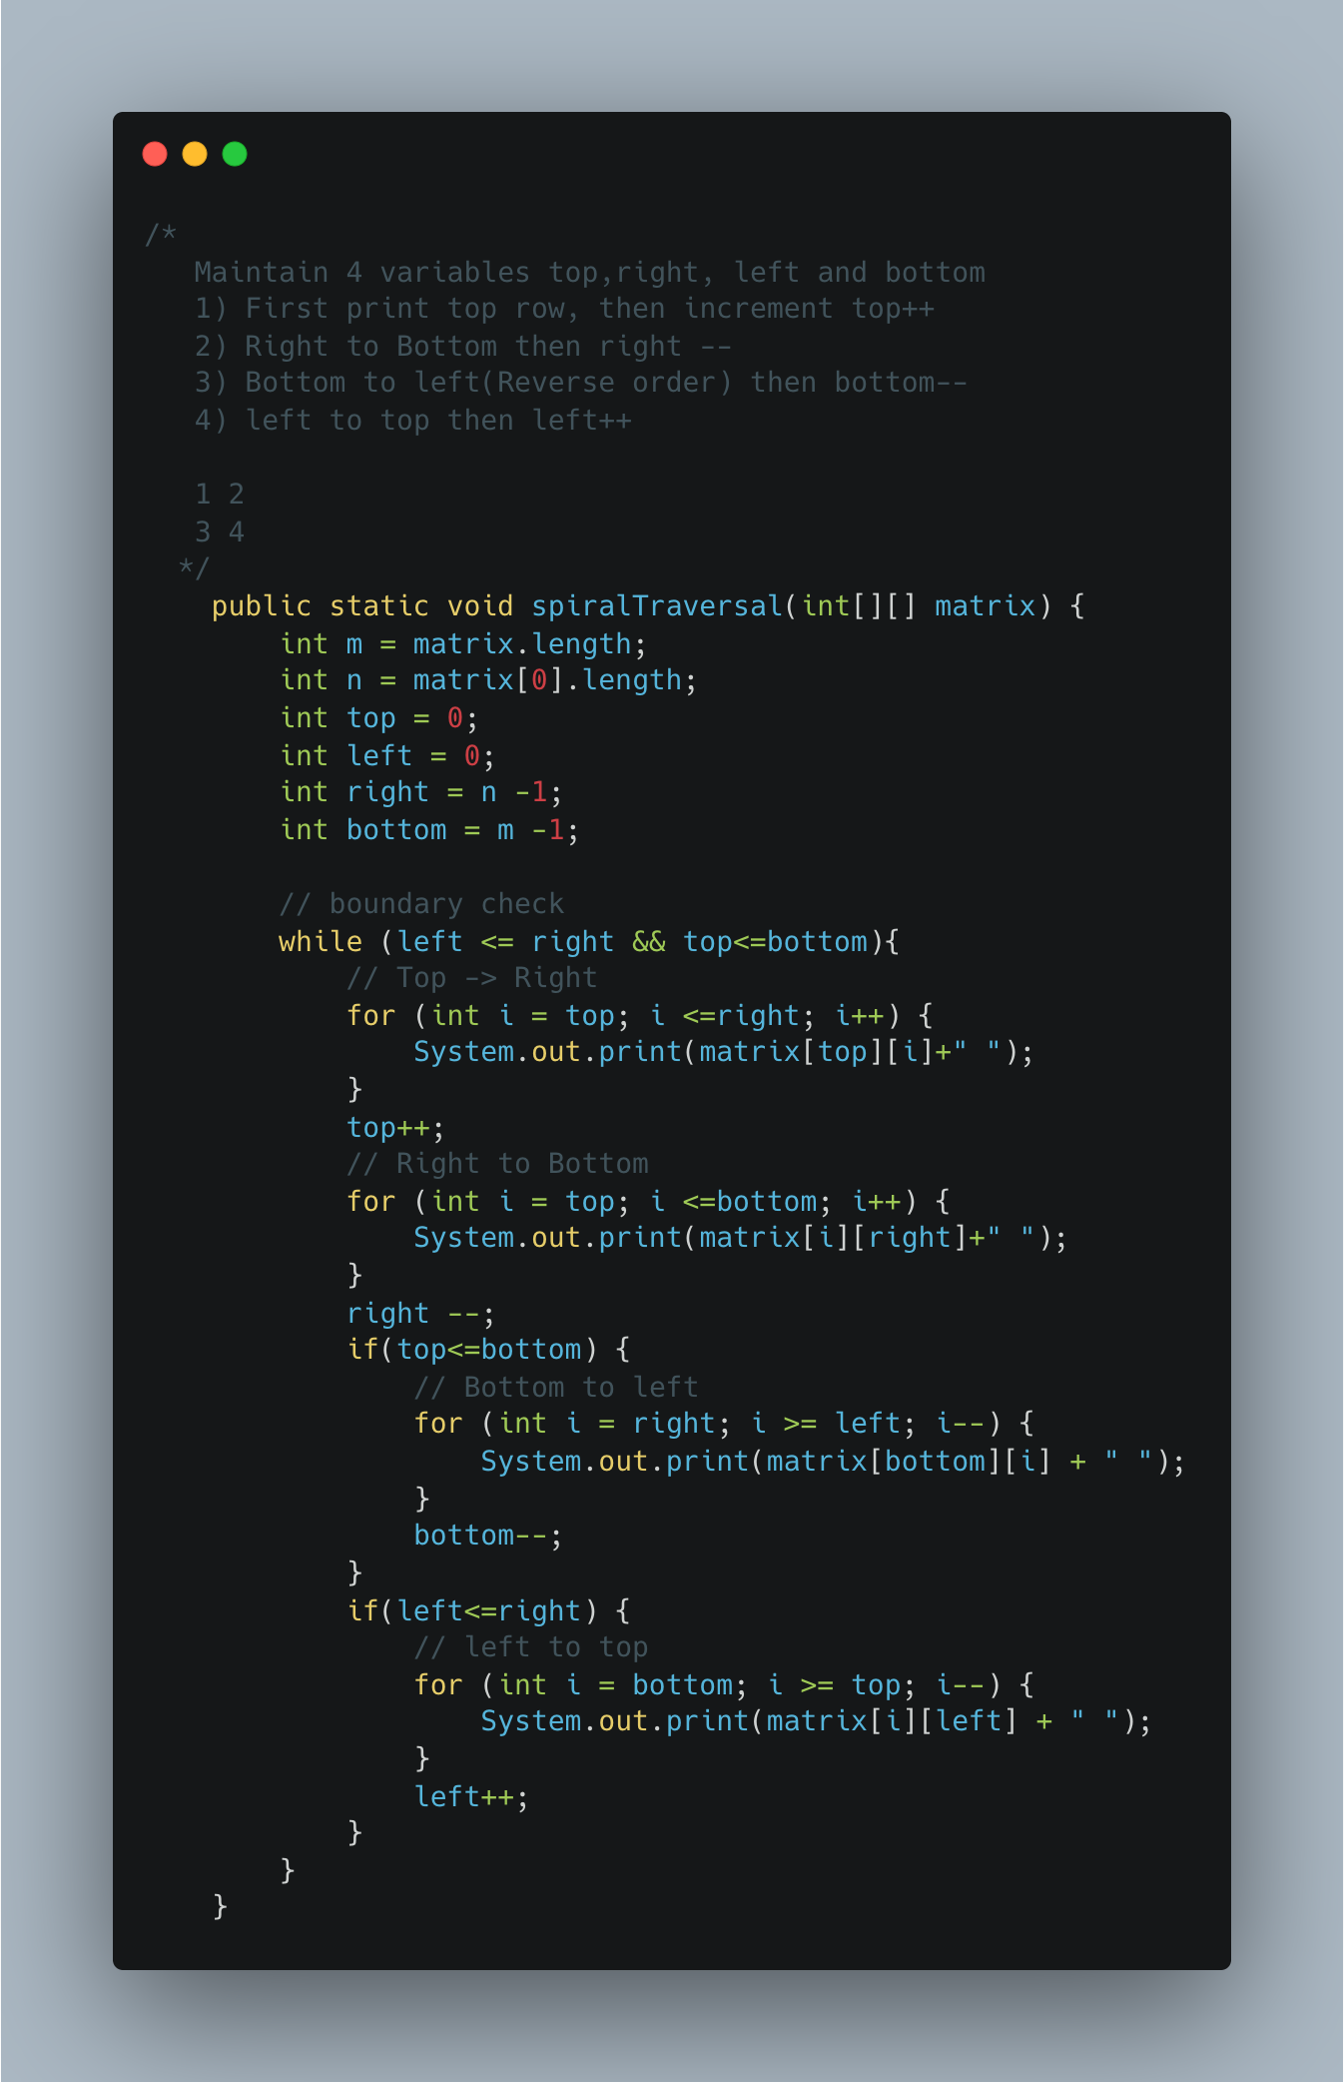

1. Transpose a Matrix

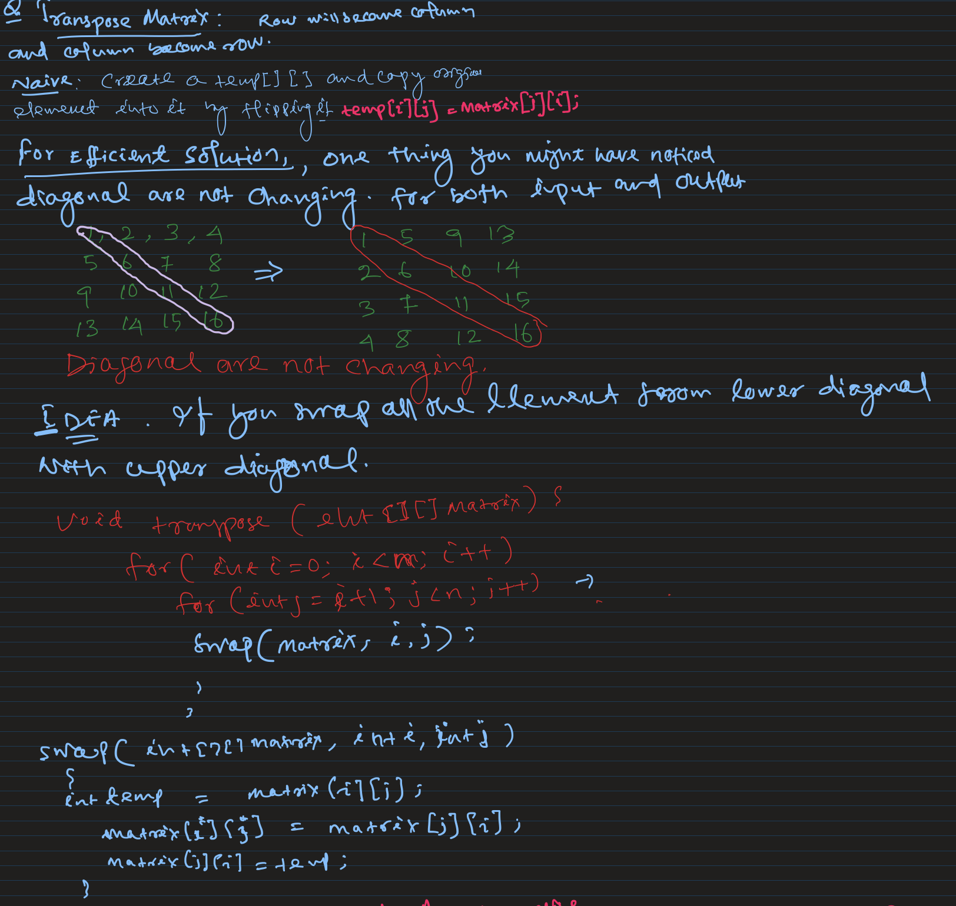

1. Rotate Matrix by 90* Anticlockwise

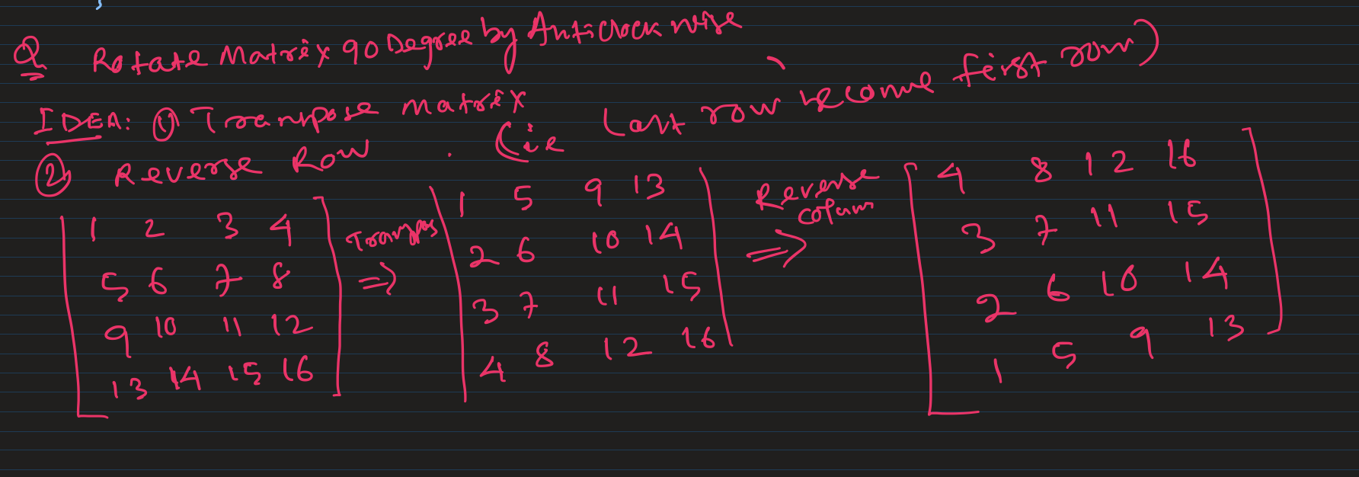

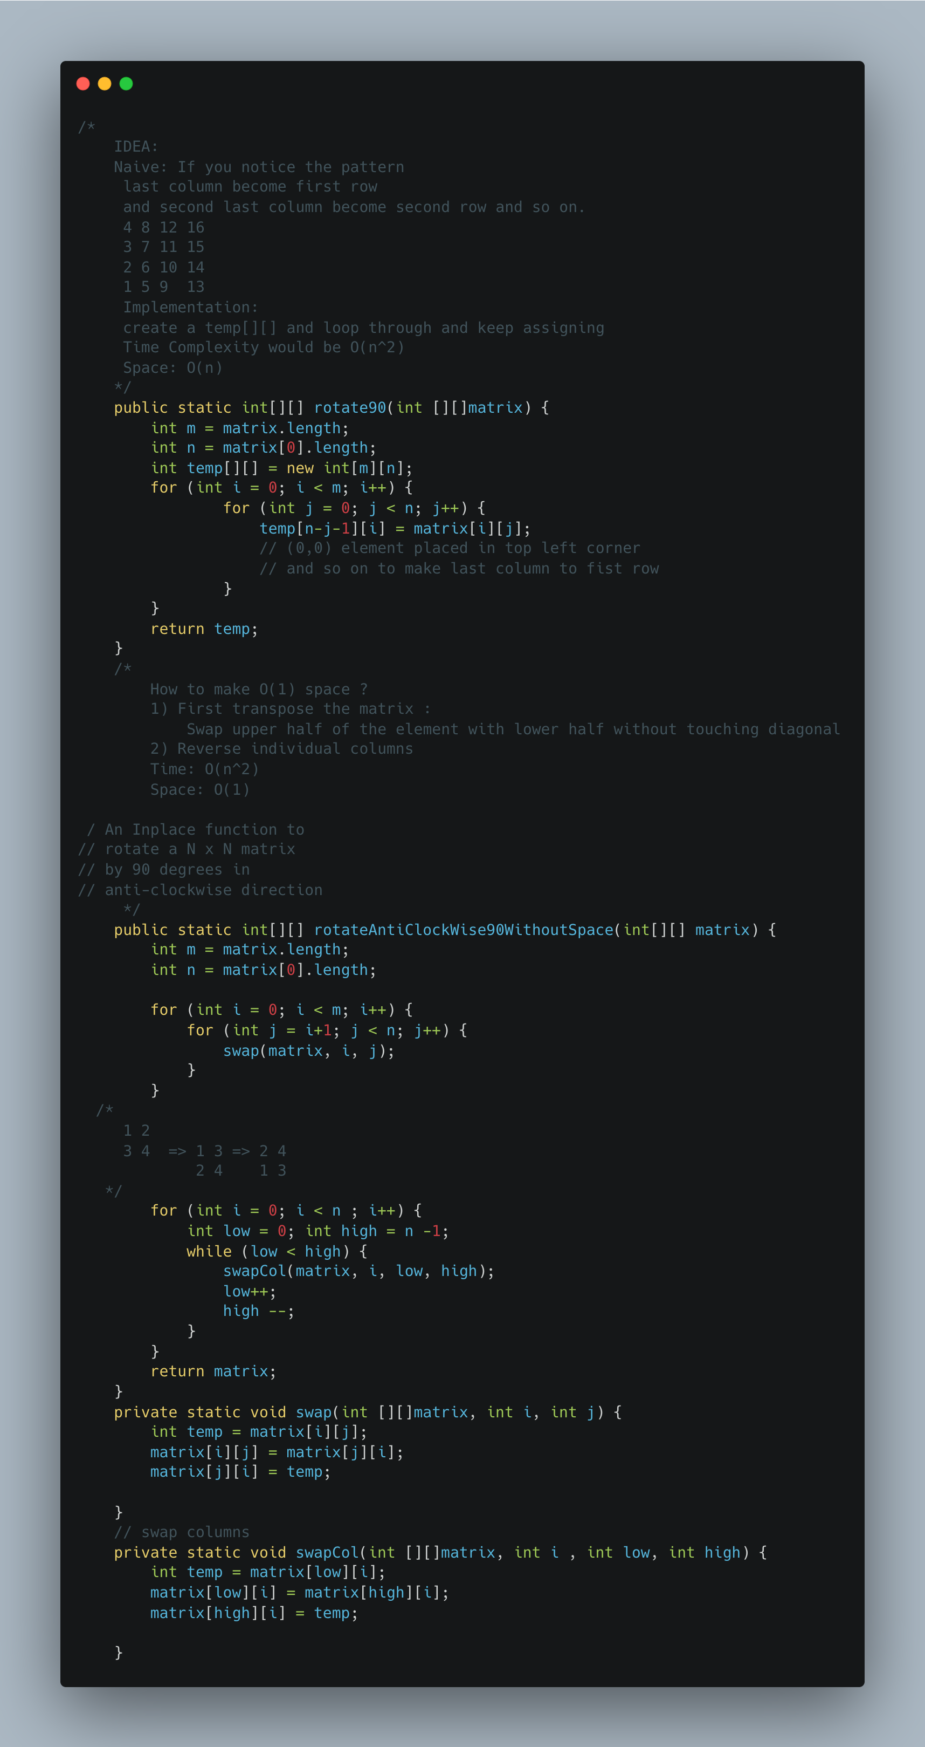

1. [Rotate a matrix by 90 Degree Clockwise](https://www.geeksforgeeks.org/rotate-a-matrix-by-90-degree-in-clockwise-direction-without-using-any-extra-space/)

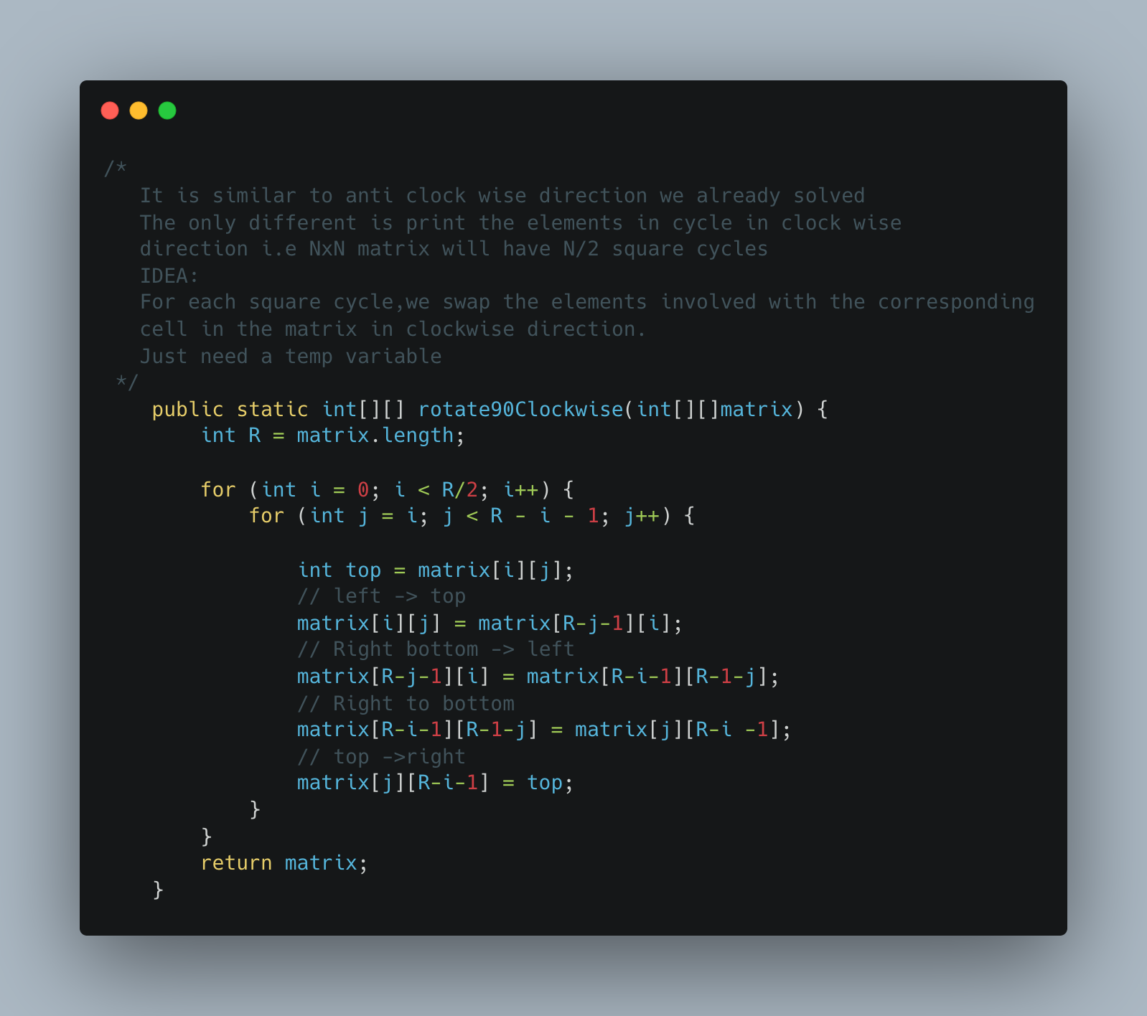

1. [Lemonade Change](https://leetcode.com/problems/lemonade-change/)

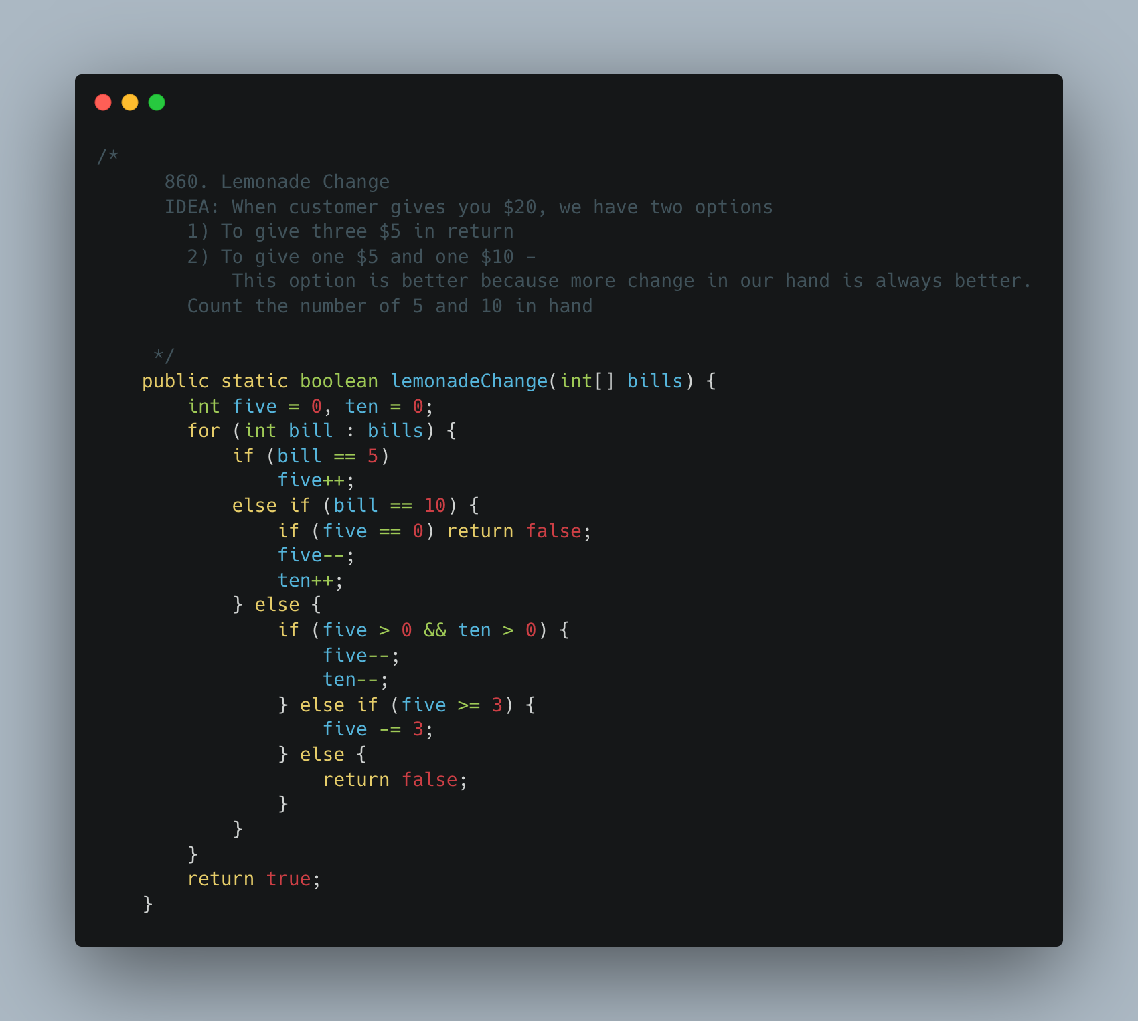

1. [Keys and Rooms](https://leetcode.com/problems/keys-and-rooms/)

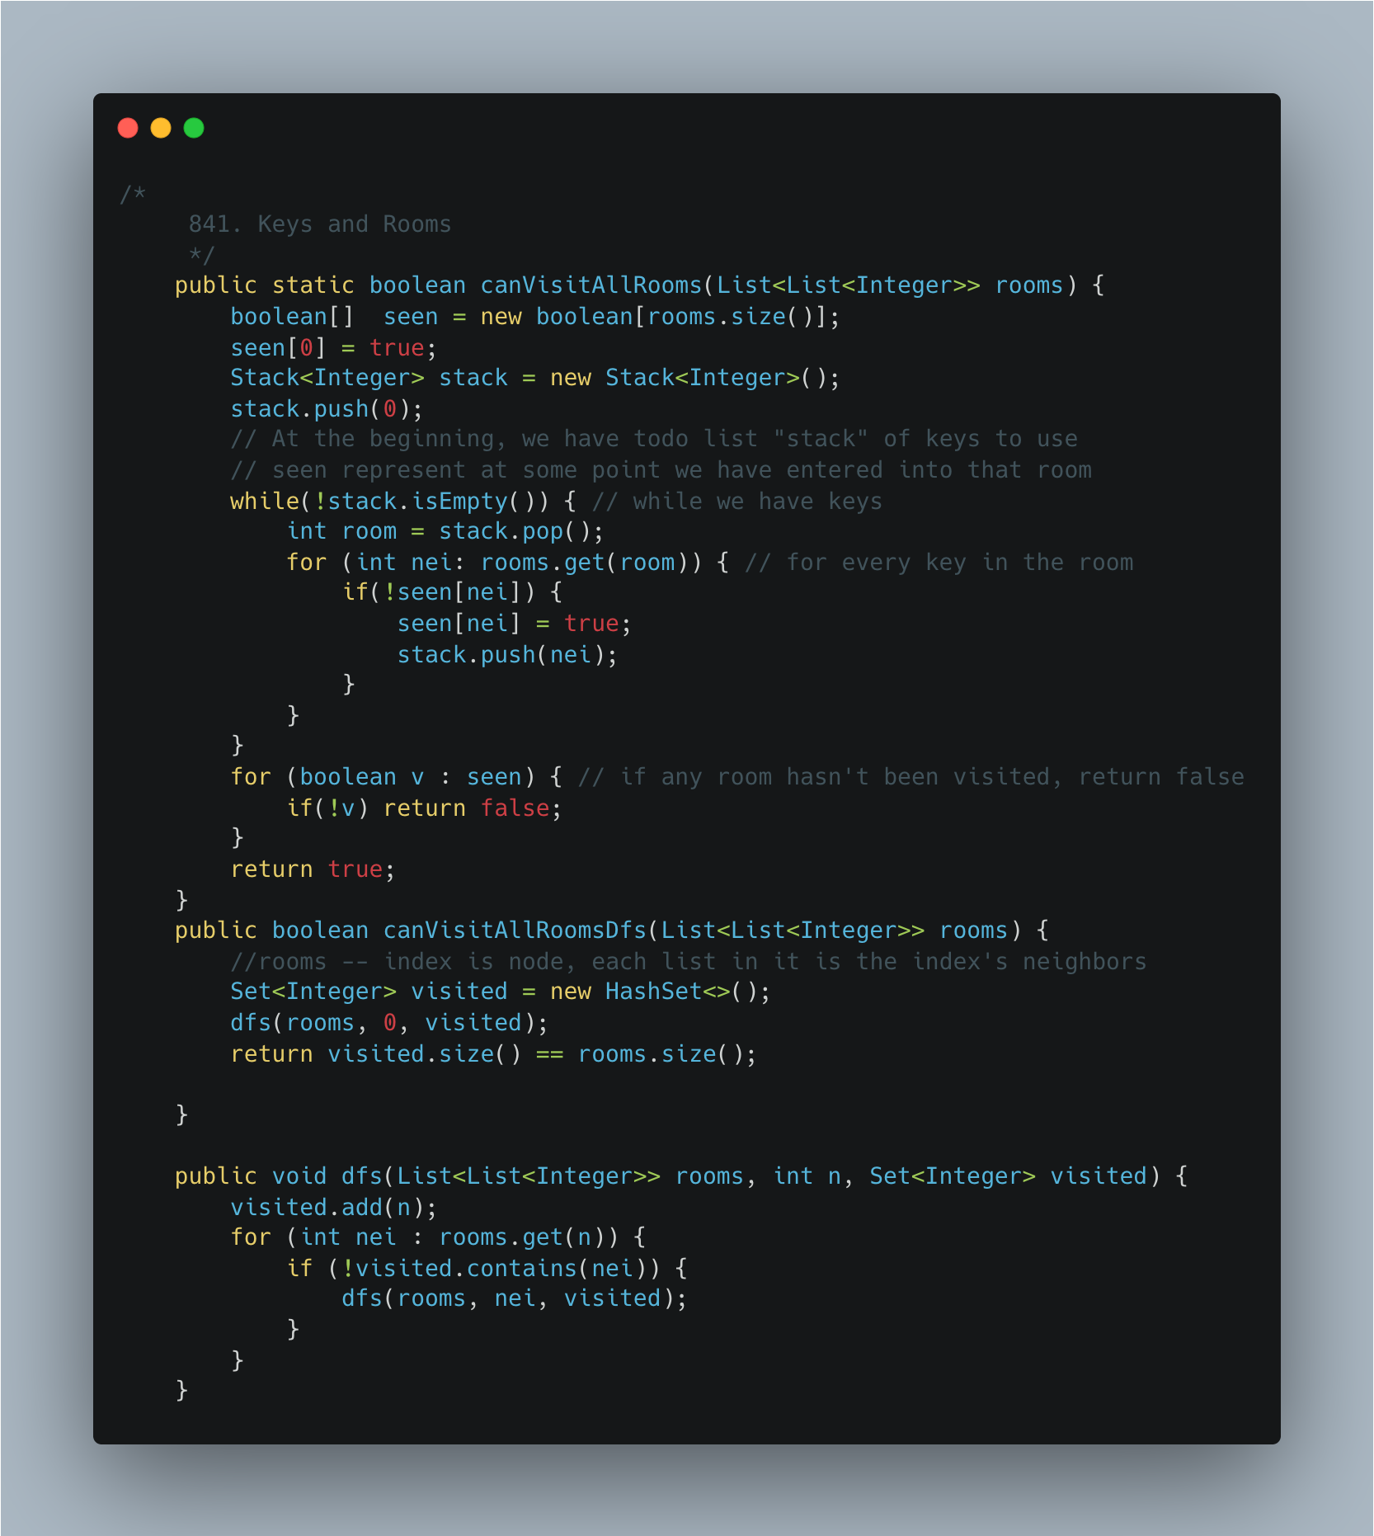

1. [Largest Rectangle](https://leetcode.com/problems/largest-rectangle-in-histogram/)

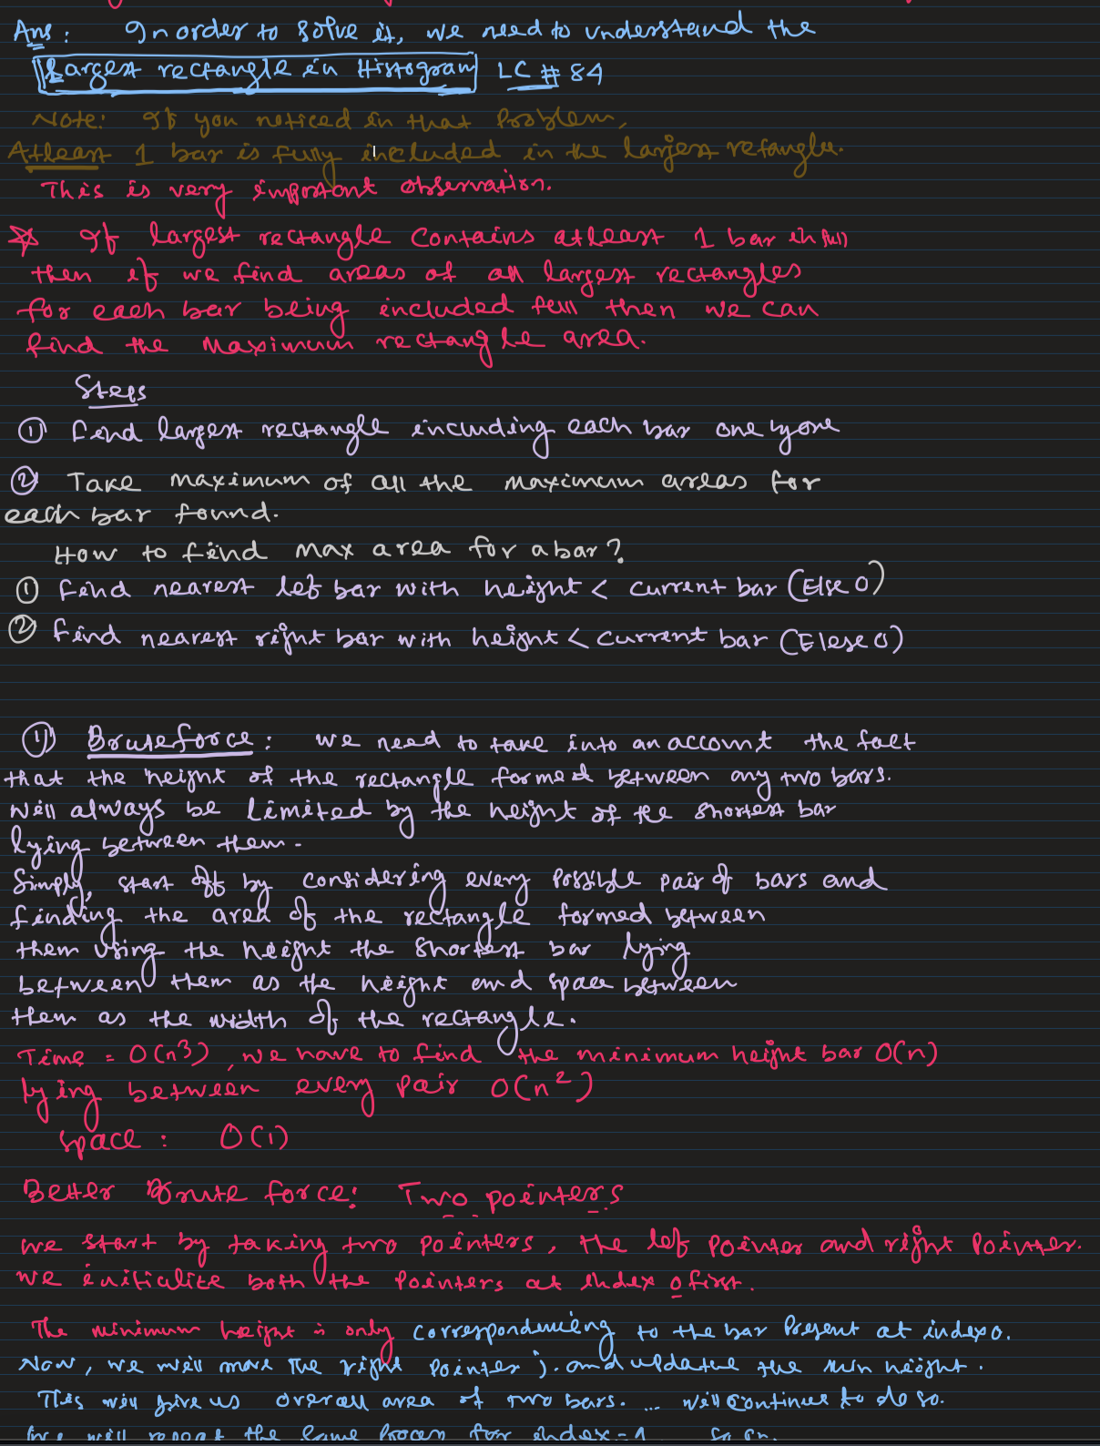

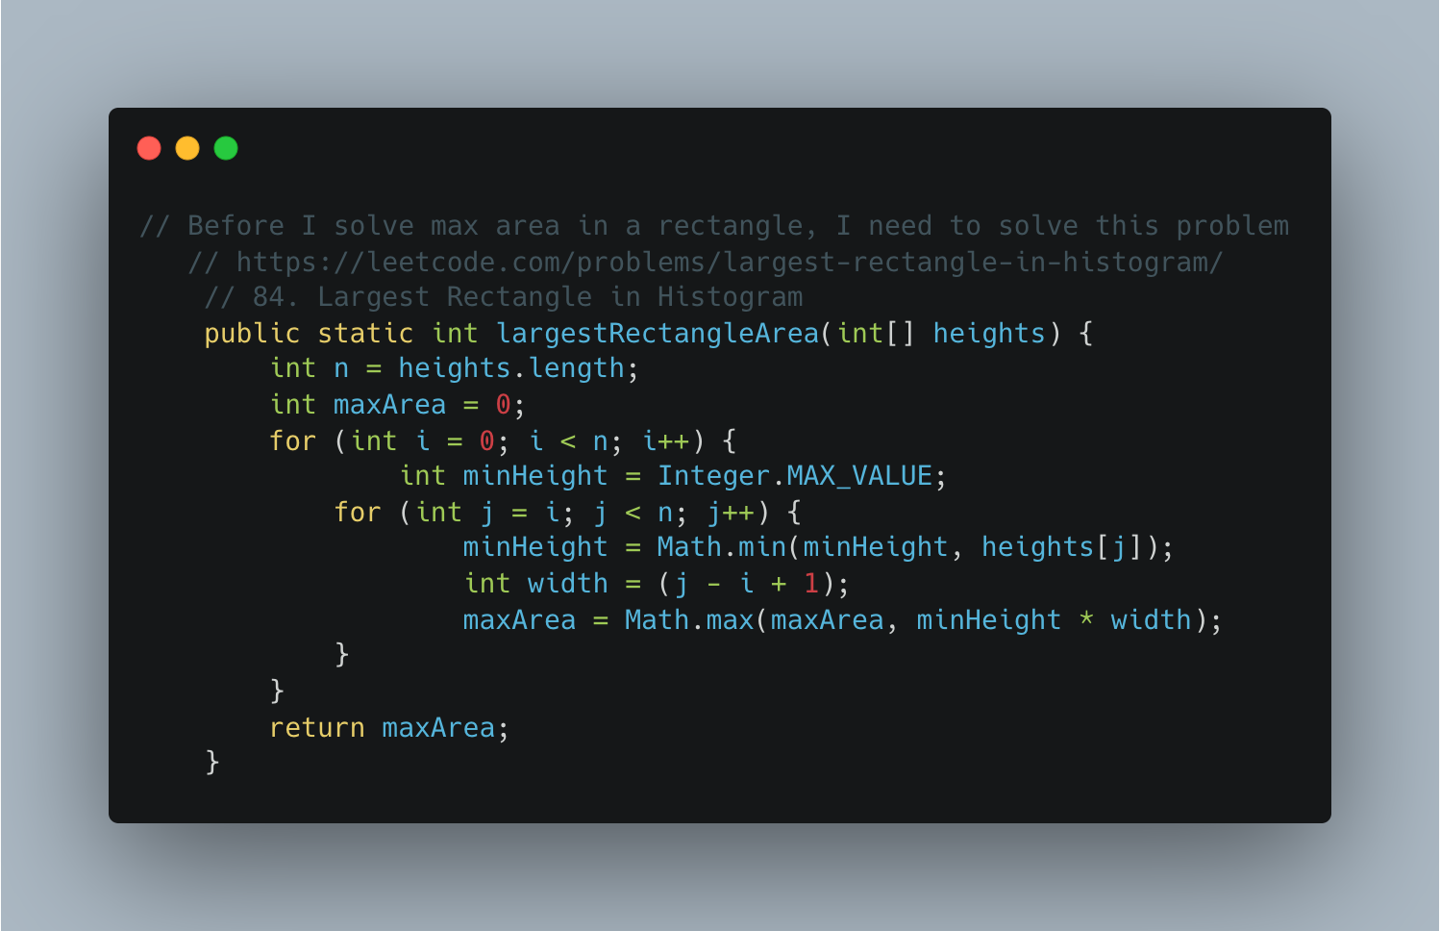

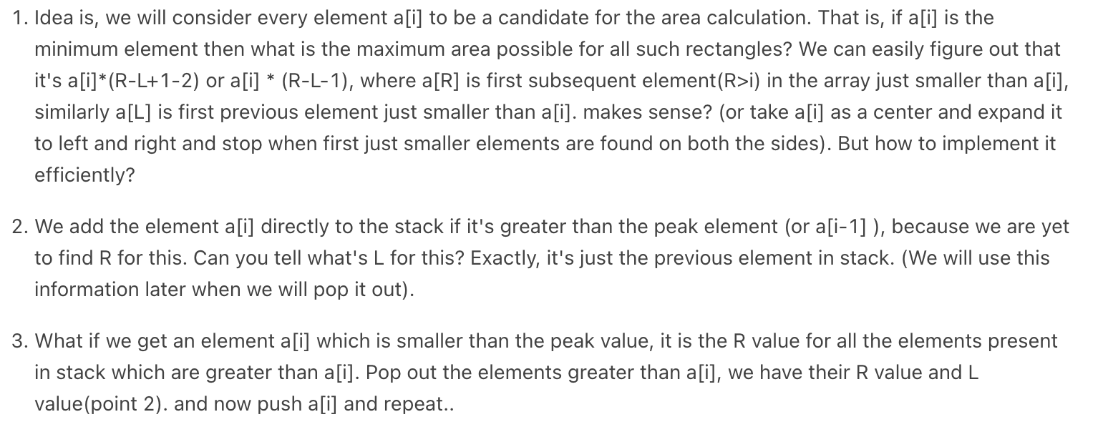

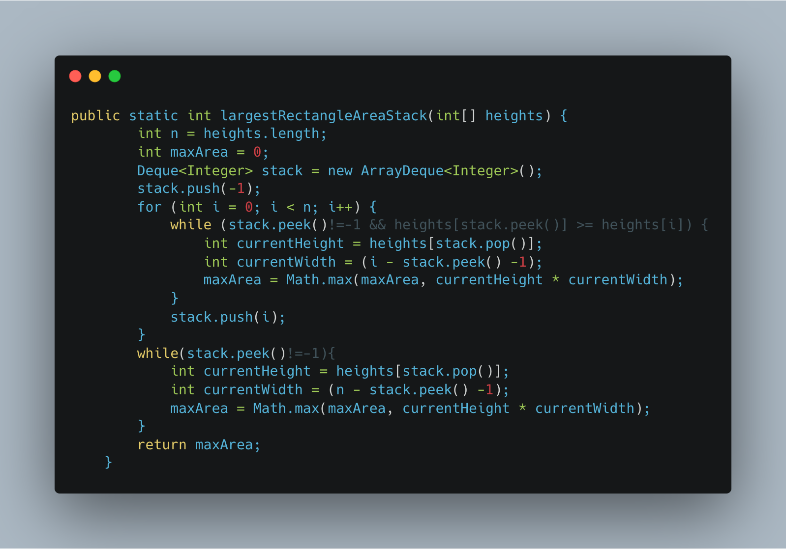

1. [Max Rectangle](https://practice.geeksforgeeks.org/problems/max-rectangle/1)

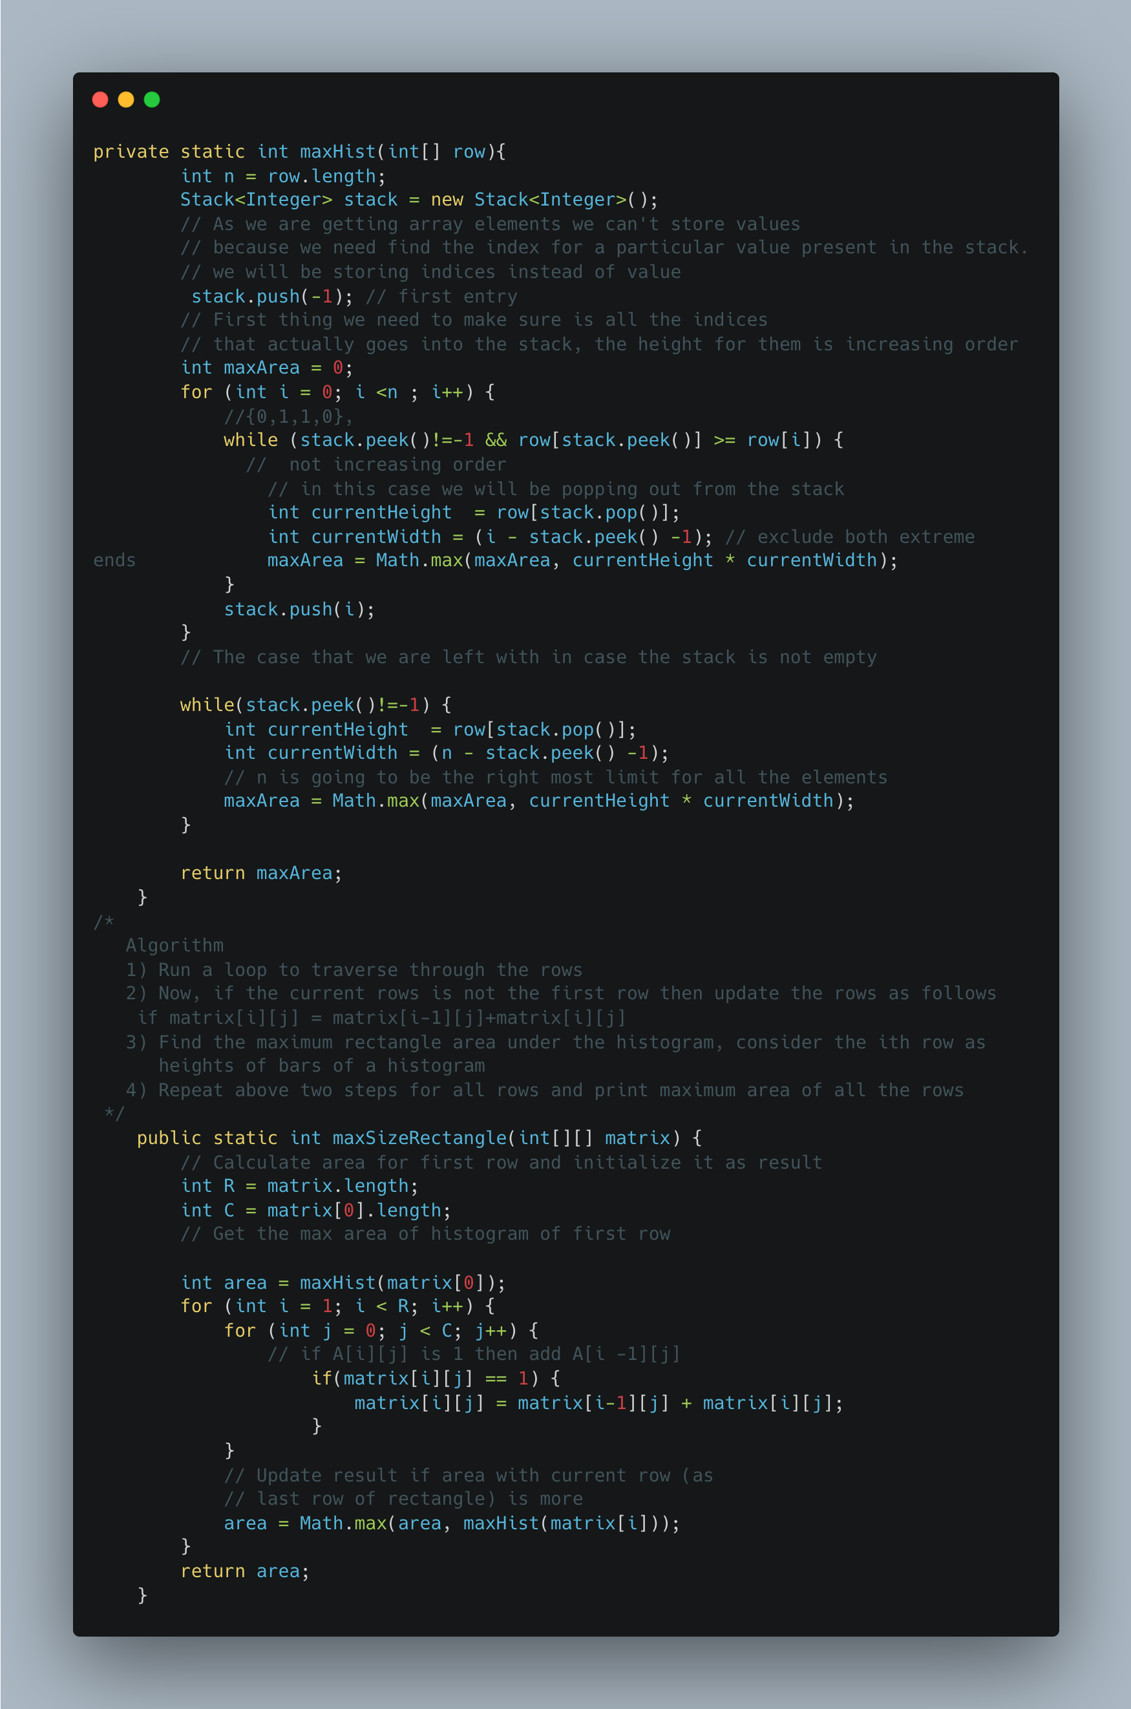

1. Find Median of row wise sorted matrix

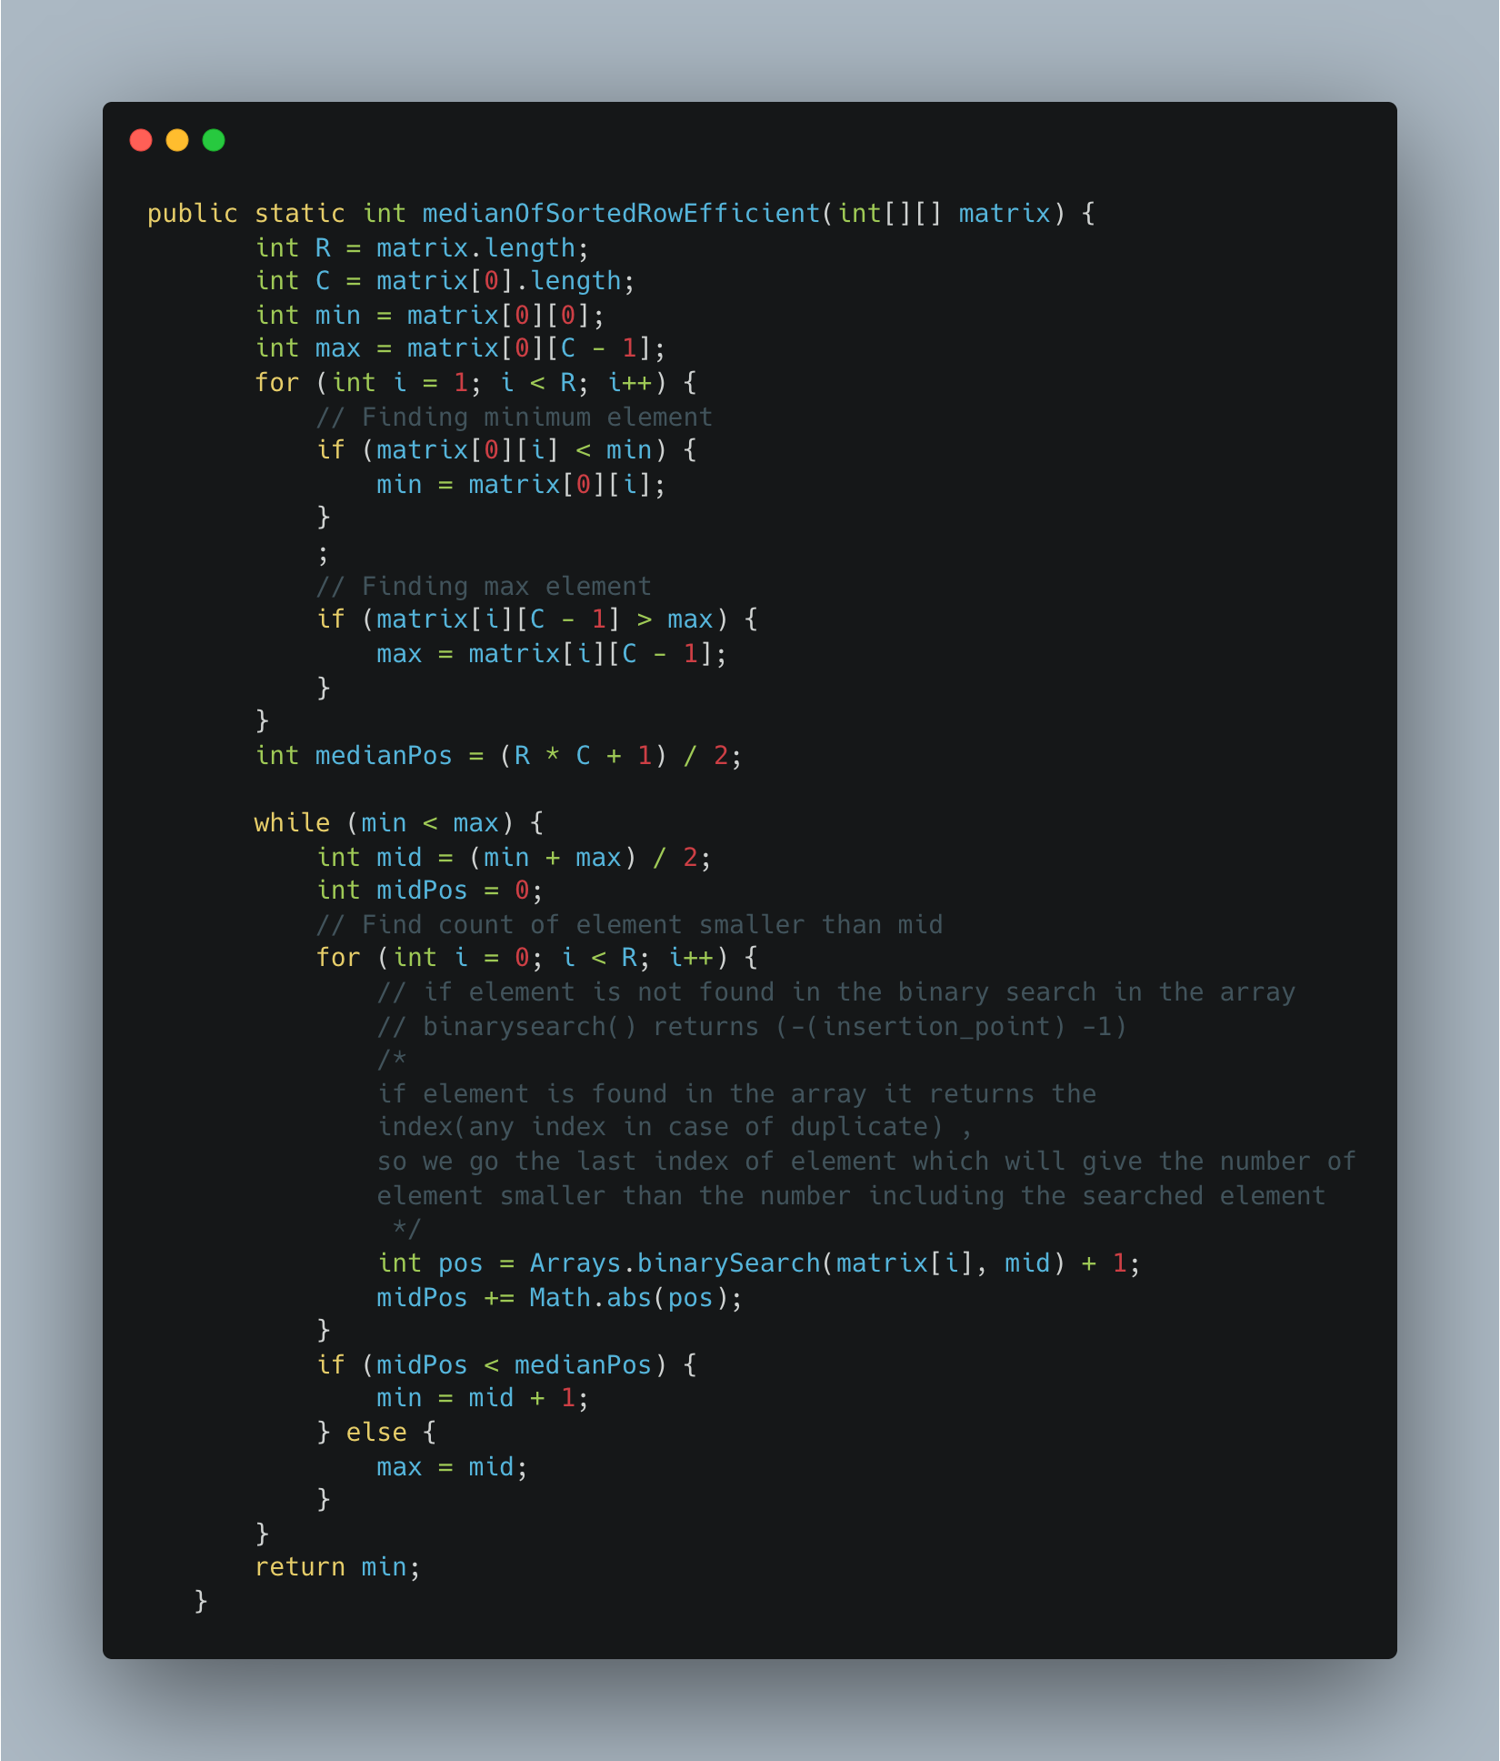

1. Find a subarray with given sum

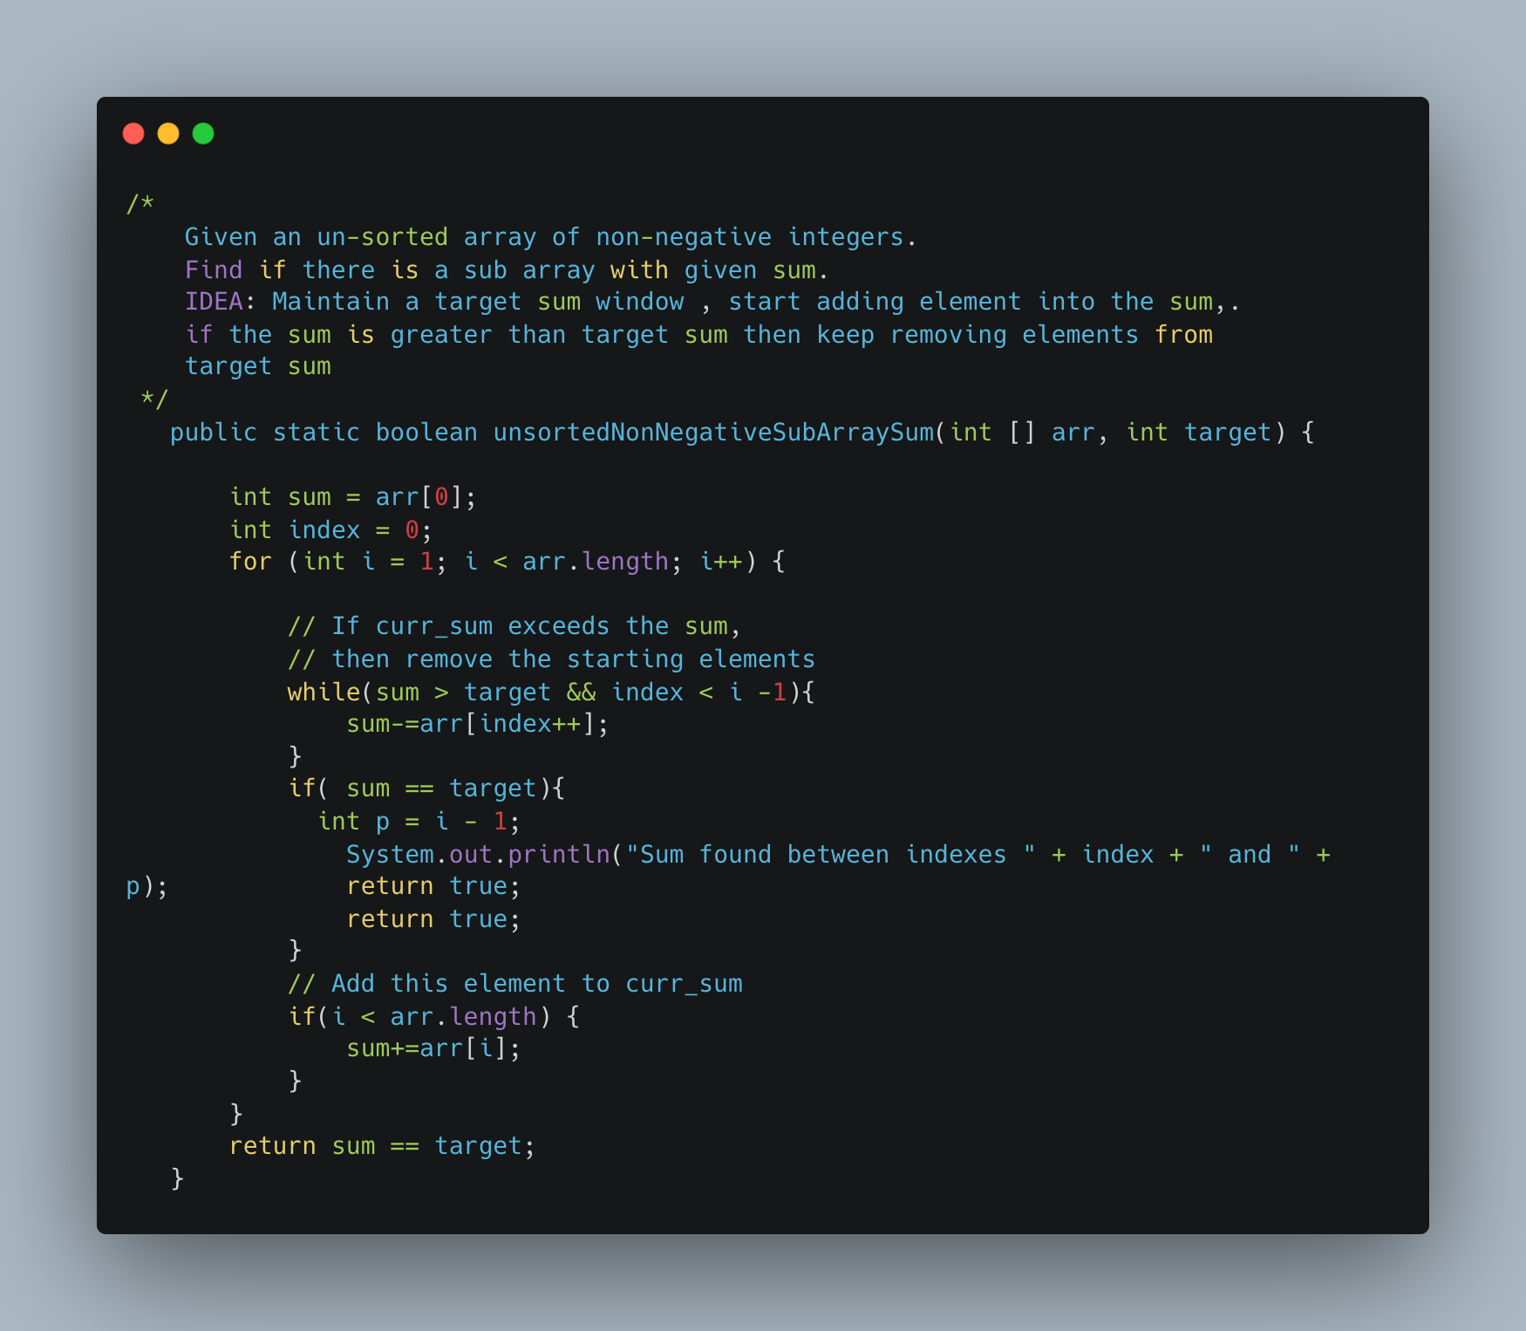

1. [Find Valid Matrix Given Row and Column Sums](https://leetcode.com/problems/find-valid-matrix-given-row-and-column-sums/)

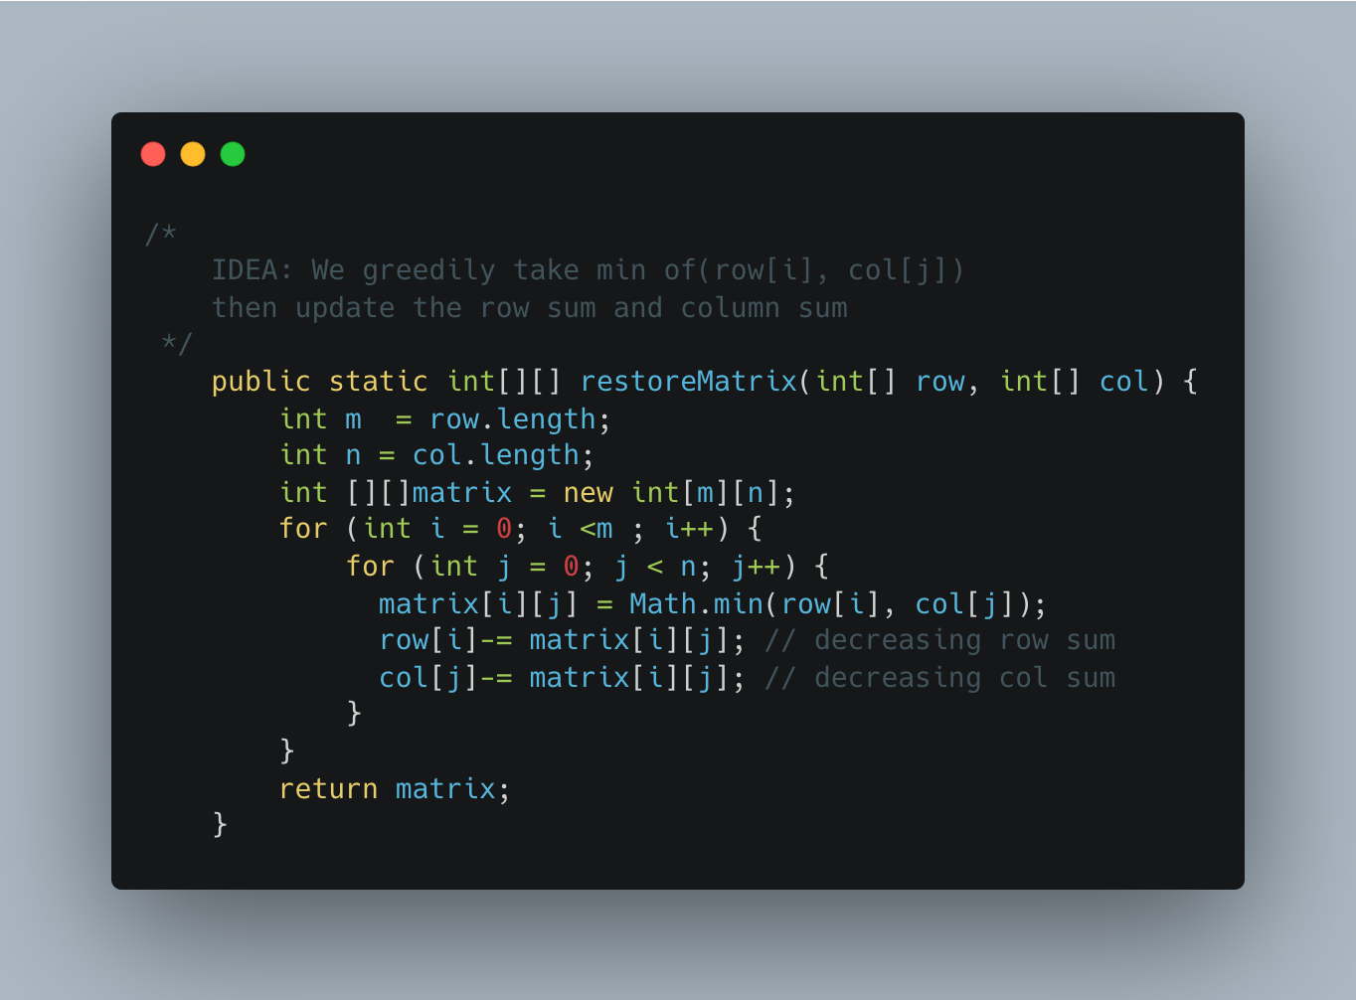

1. [Reorder Data in log Files](https://leetcode.com/problems/reorder-data-in-log-files/)

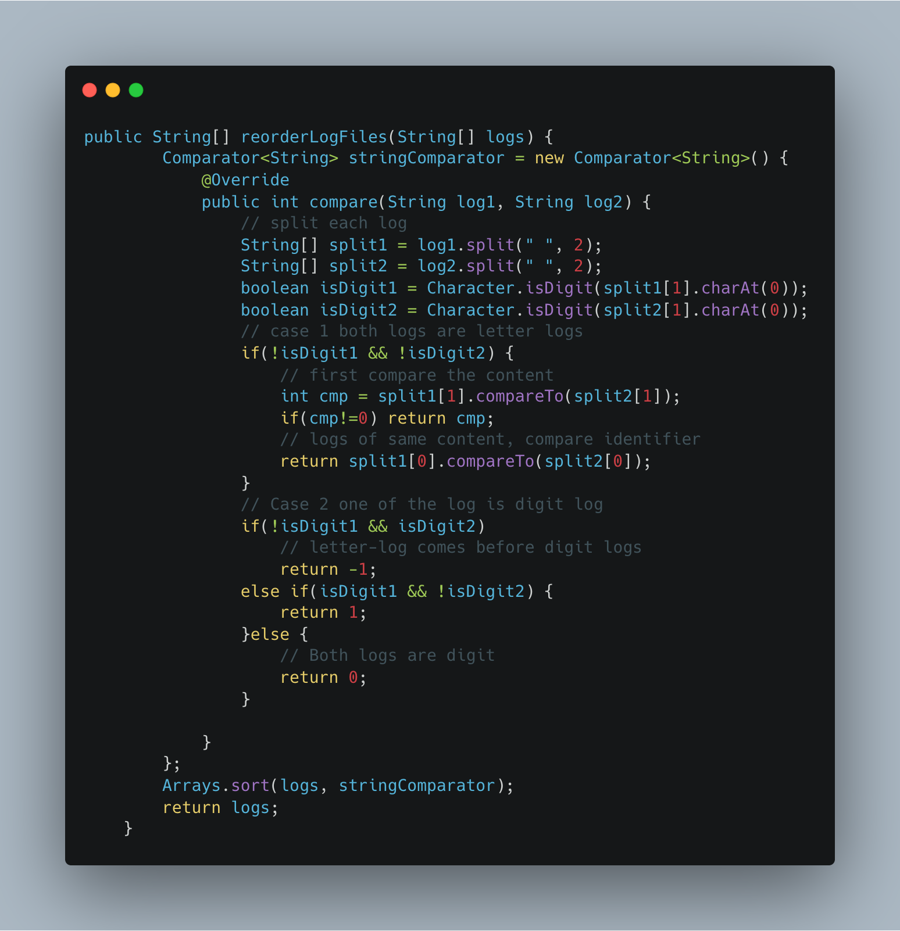

1. [Capacity to Ship Packages Within D Days](https://leetcode.com/problems/capacity-to-ship-packages-within-d-days/)

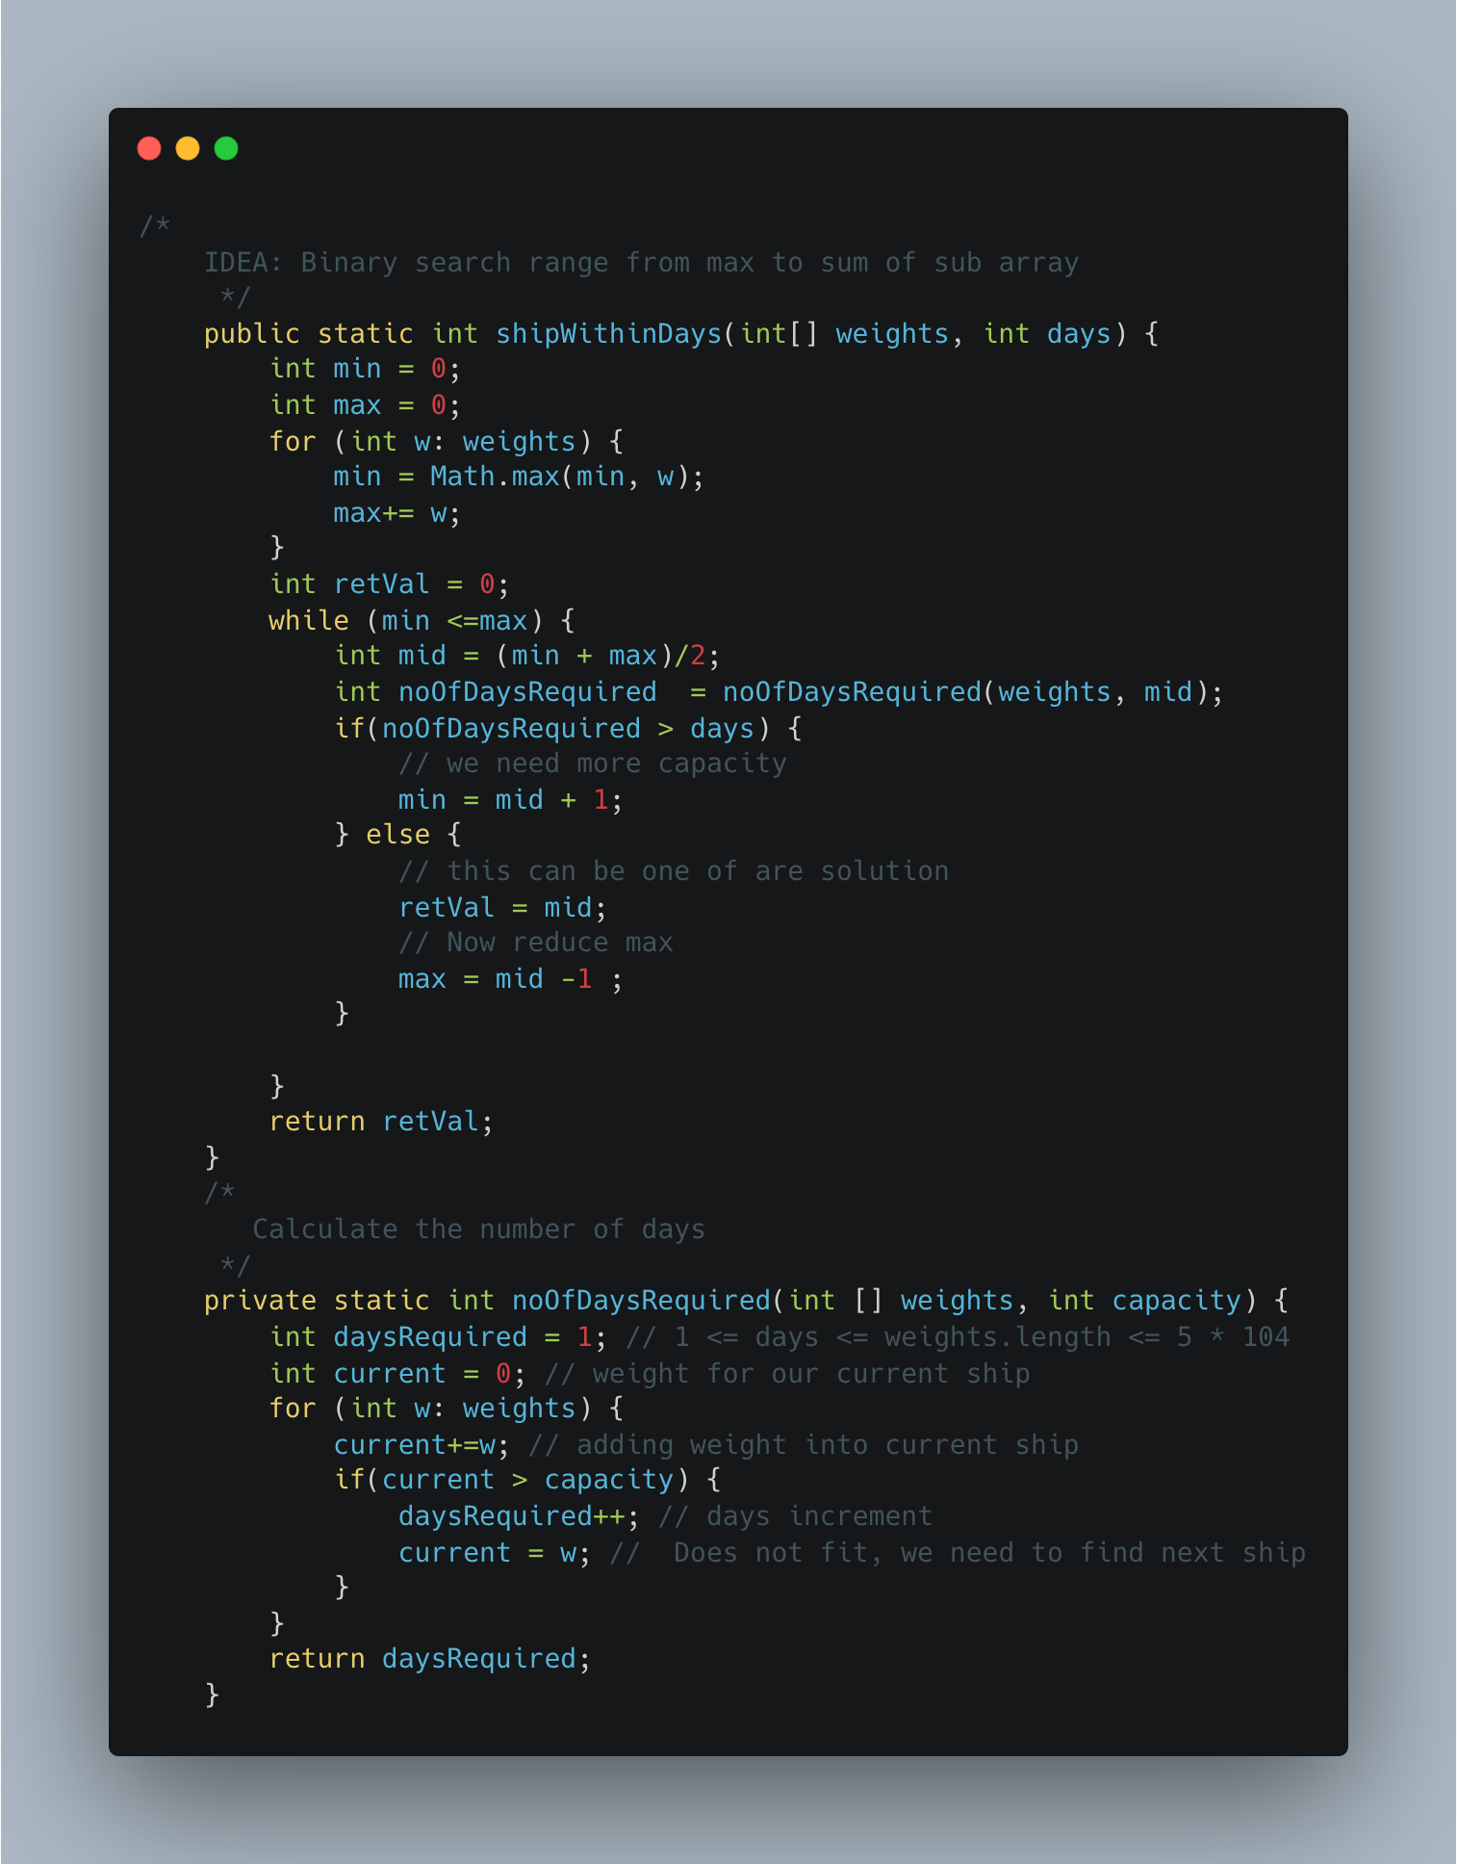

**STRINGS**

1. [1189. Maximum Number of Balloons](https://leetcode.com/problems/maximum-number-of-balloons/)

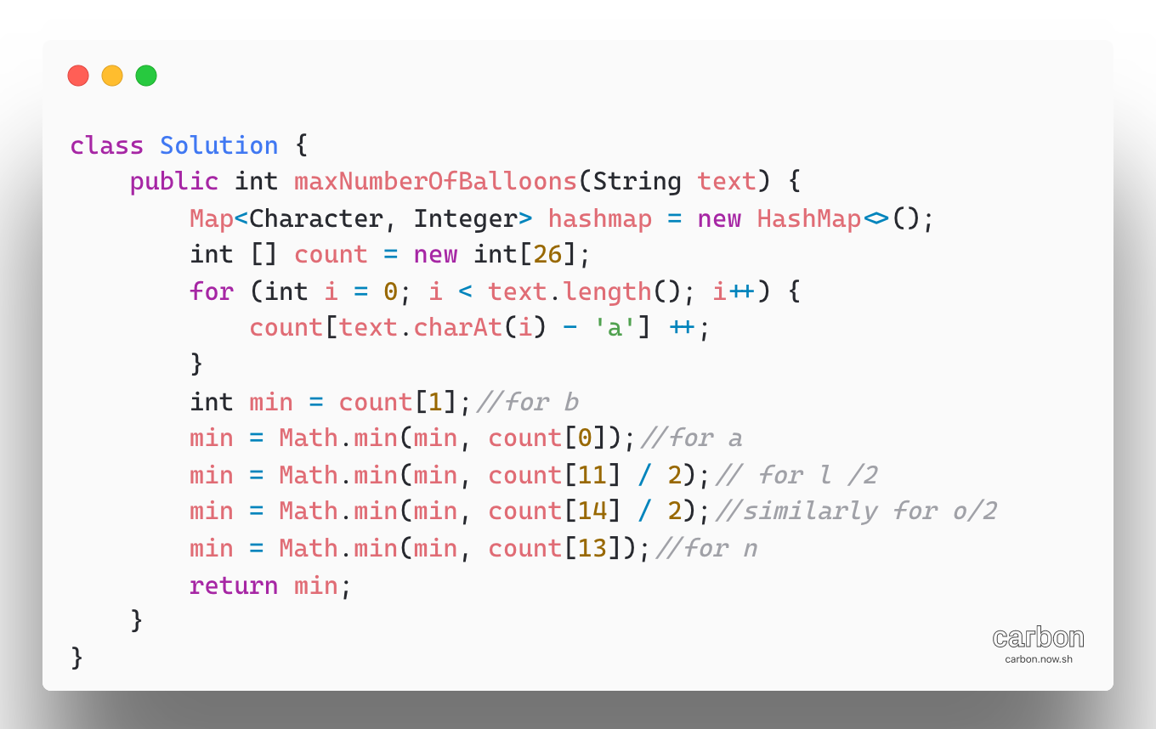

**STACK**

1. [**Longest Valid Parentheses**](https://leetcode.com/problems/longest-valid-parentheses/)

Approach 1:

Instead of finding every possible string and checking its validity, we can use of a stack while scanning the given string to:

* Our stack holds Integer index instead of character
* Check if the string is scanned so far is valid
* Find the length of longest valid string

To do so, we start by pushing -1 onto the stack.

For every ‘(‘ encountered we push the its index into the stack

For every ‘)’ encountered, we pop the topmost element. Then, the length of the currently encountered valid string of parentheses will be the between the current element’s index and the top element of the stack.

If, while popping the element, the stack becomes empty, we will push the current elements’ index onto the stack. In this way, we can continue to calculate the length of the valid substrings and return the length of the longest valid string at the end

Complexity:

Time: O(n)

Space: O(n)

Approach 2:

Algorithm, in this approach, two traversals of the string we make use of two pointers left and right.

First, we traverse the string from left to towards the right and for every ‘(‘encountered

We increment the left counter and for every ‘)’ encountered, we increment the right counter.

* If left and right counters become equal, we calculate the length of the valid string and keep track of maximum length substring found so far.

Max(ans, right*2);

* Else If right greater than left, we reset left = right = 0

Before traversing from right to left, reset left = right = 0

Above logic will be remain same

Left >= right reset

Max( ans, left*2)

